

Lower The
Thermostat
You come home to a cold house and turn the thermostat right up, hoping it will warm up faster. In 1986, the researcher Willett Kempton published a study showing that many people hold a mistaken “valve” theory of thermostats, believing a higher setting heats the home more quickly, when in fact it mostly just heats it for longer and to a higher temperature. Understanding your heating controls is one of the easiest ways to cut energy without losing comfort. This workbook asks you to master your thermostat, and to commit to the next three things you will change.
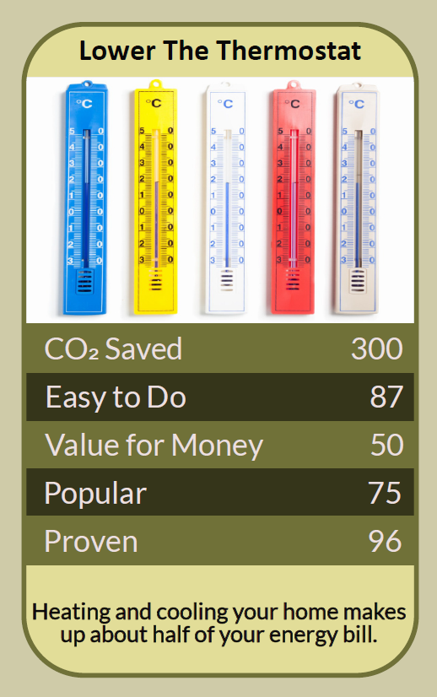


Before you begin  How To Use This Workbook | 

This workbook stands alone. You need nothing else to use it except your thermostat, any radiator valves, a room thermometer, the heating manual if you have it and a week of cold-weather days.
It asks you to write, not just read.
Before you begin, choose one heating control. It might be your main thermostat, your boiler timer or the radiator valve in one room. If anyone in your home is very young, older, or has a health condition that makes cold dangerous, keep their rooms warm and get advice before lowering any setting. You'll carry that one control through the exercise.

Write your first thoughts here, so you can come back to them later

This worksheet is part of the Climate Challenge series of action workbooks.

Part one  The Teaching | 

The idea at the heart of this workbook comes from Willett Kempton, then at Michigan State University, whose 1986 paper “Two Theories of Home Heat Control” appeared in the journal Cognitive Science. Kempton interviewed householders and found that many treated the thermostat like a valve or accelerator, turning it higher to get more heat faster, rather than as a switch that simply keeps the home at a chosen temperature.
Underneath it sits a slightly uncomfortable claim. Many of us control one of the biggest energy users in our homes using a mental model that's wrong. Getting the model right lets us use less energy without feeling colder.
A thermostat is a switch, not an accelerator. Most home thermostats simply turn the heating on when the room is below the set temperature, and off when it reaches it. Turning it up to 28°C doesn't usually heat the room any faster than setting it to 19°C; it just means the heating keeps running until the room gets much hotter, wasting energy.
Every degree counts. Heating uses more energy the bigger the difference between inside and outside. The Energy Saving Trust advises setting your thermostat to the lowest comfortable temperature, often between 18°C and 21°C, and notes that turning it down by even one degree can make a real difference to your bill and footprint.
Heat when you need it. Use the timer or programmer so the heating comes on shortly before you need warmth and goes off when you leave or go to bed. For most homes with gas boilers, heating only when needed uses less energy than leaving the heating on low all day. Heat pumps are different: they usually work best running steadily at a lower temperature, so follow your installer's advice.
Heat rooms, not the whole house. Thermostatic radiator valves, the numbered dials on many radiators, let you set different temperatures in different rooms. Turn them down in rooms you rarely use, keep bedrooms cooler than living rooms, and close doors to keep the heat where you want it.
Smarter controls help. Programmable and smart thermostats can learn your routine, switch off when you're out and adjust for the weather. Some boilers can be set to run at lower temperatures, which makes them more efficient. They only help, though, if they're set up to match how you actually live.
Warm enough is a health matter. Cold homes can harm health, especially for babies, older people and anyone who is ill or less mobile. Public health guidance in England suggests keeping the rooms you live in at around 18°C or warmer, and homes left very cold are more prone to damp and mould. The aim is to waste less heat, not to be cold.
The practical use of Kempton's research is to replace the valve theory with the switch theory. Set your thermostat to the lowest comfortable temperature and leave it there. Use the timer to heat your home only when you need it, set each room's radiator valve to suit how it's used, and use smart features if you have them. If it's safe for everyone in your home, try one degree lower and see whether anyone notices.

Part two  The Exercise | 

Take the control you chose at the start and carry it through the steps below over the coming week. Write in full sentences. Nobody else reads this.
Describe your heating controls. What controls does your heating have: a thermostat, a timer, radiator valves, a smart app? What are they set to now, and who in the household changes them? Score how well you understand how your heating controls work, from 1 (not at all) to 10 (completely).
How certain do you feel about that score? ① ② ③ ④ ⑤ ⑥ ⑦ ⑧ ⑨ ⑩

Test your theory. Before reading on, write down what you believe happens when you turn the thermostat up high. Then read your heating manual or the maker's website. Were you using the valve theory or the switch theory? What did you learn?

Map your rooms. List each room, how it's used and when, and the temperature it really needs. Note the setting on each radiator valve. Which rooms are heated more than they need to be?

Set a schedule. Write a heating timetable for a typical weekday and weekend day: when the heating should come on, when it should go off, and what temperature you'll set. Then programme it into your timer or smart thermostat.

Try one degree lower. If it's safe for everyone in your home, lower your thermostat by one degree for a week. Use a room thermometer to check the actual temperature, and note how comfortable people felt. If you can, read your gas or electricity meter at the start and end of the week.

Make your plan. Write three actions: the thermostat setting and schedule you'll keep, one change to your radiator valves or room use, and one bigger step, such as a smart thermostat or asking your installer to lower your boiler's flow temperature. Name who else needs to agree, and when you'll start.

How well do you understand your controls now? ① ② ③ ④ ⑤ ⑥ ⑦ ⑧ ⑨ ⑩

Part three  Questions For Discussion | 

Work through these questions independently if you must, but they are generally more beneficial when discussed.

- In many households, people disagree about the thermostat. How should a household decide on a fair temperature for everyone?
- Kempton found that many people misunderstand how thermostats work. Should heating controls be designed so that the right way to use them is obvious?
- Smart thermostats collect data about when you're at home. Is that a fair trade for saving energy? What would make you trust it?
- Some tenants can't control their own heating, because it's set by a landlord or a shared system. What rights should they have?
- “Turn your thermostat down” can sound harsh to someone who already can't afford to heat their home. How should energy-saving advice take that into account?
- Should new homes and heating systems be required to have room-by-room controls, so that people can heat only the spaces they use?

Want To Take This Further With Other People?
You've done the testing and the thinking on your own. What's missing now is someone who sees your heating differently — and who might help you set up the controls, agree a household temperature or compare bills with you.

Share your settings online  Join an online climate action community and post your heating schedule, your one-degree-lower week and your three-step plan. Others will share how they set up their controls and what made the biggest difference. |  | Find people near you  Ask a local energy advice service or community energy group for help with your heating controls. Talk with your household about a shared heating plan. Check in on older neighbours during cold spells.

Find your next challenge

This workbook is general guidance, not medical advice. Keep living rooms at a safe temperature, especially for babies, older people and anyone unwell.

climatechallenge.uk

