

Downsize
Housing
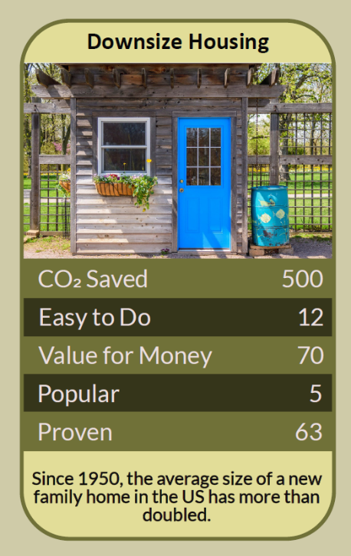

The children have left, the spare rooms are filling with boxes, and the radiators in rooms nobody uses are still warming the walls. In 2019 Katherine Ellsworth-Krebs and colleagues showed that in wealthy countries homes are getting bigger while households are getting smaller, so each of us is heating more space than ever. The size of the home we live in can matter more than many of the energy-saving changes we make inside it. This workbook asks you to look honestly at how you use your home, think about what you really need from it, and explore whether a smaller or shared home might suit you better, now or in the future.

Before you begin  How To Use This Workbook | 

This workbook stands on its own. You need a walk round your home, a pen, some quiet time to think and, if you share your home, a conversation with the people you live with. Each part builds on the one before, so work through it in order.
It asks you to write, not just read.
Before you begin, think of your current home. This is your decision and nobody should feel pressured to leave a home they love. Before any big change, take independent financial and legal advice, and if you're thinking about a lodger, check your mortgage, tenancy and insurance first. You'll carry your home through the exercise.

Write it here, so you have it to hand

Part one  The Teaching | 

In December 2019 the journal Nature Energy published a study led by Dr Katherine Ellsworth-Krebs of the University of St Andrews. It looked at how homes and households have changed in wealthy countries and found two trends pulling in the same direction: homes are getting bigger, and fewer people are living in each one, so the floor space heated for every person keeps growing.
The slightly uncomfortable claim underneath it is this: insulation, new boilers and efficient light bulbs all help, but the amount of space we heat for each person can matter even more. The authors suggested that for 'empty nesters', downsizing or taking in a lodger would cut energy use more effectively than energy-efficiency improvements alone.
Most home energy goes on heating space. Heating is the biggest use of energy in most UK homes. Every extra room is extra air, walls and windows to keep warm. Two people in a four-bedroom house usually use far more energy each than two people in a flat, however careful they are.
Spare rooms and squeezed rooms. Research by Nationwide in 2025 found that around 53% of owner-occupied homes in England were under-occupied, meaning they had two or more spare bedrooms, while around 8% of homes in the social rented sector were overcrowded. Our housing is not short of rooms; it is short of rooms in the right places.
Downsizing isn't the only option. You could take in a lodger: the government's Rent a Room scheme lets you earn up to £7,500 a year tax-free from letting furnished accommodation in your home. Homeshare schemes match people who have a spare room with someone who offers help around the house in return for low-cost accommodation. Some people split a house into two homes, or simply stop heating rooms they don't use, while taking care to avoid damp.
Smaller can be better. A smaller home usually means lower bills, less cleaning and maintenance, and often a home closer to shops, transport and friends. Moving before you need to, rather than in a crisis, also gives you the chance to choose a home that will suit you as you get older.
Home is more than floor space. Homes hold memories, gardens, neighbours and a sense of who we are. Moving costs money and effort, and the right answer is different for everyone. The point isn't to make anyone move, but to make the size of our homes something we choose rather than something that just happens.
The practical use of Ellsworth-Krebs's work is to add one question to the way we think about our homes: how much space do we really need, and could it be shared? Look at how you live, think about the years ahead, and choose the option that's right for you, whether that's moving, sharing or simply using your home differently.

Part two  The Exercise | 

Take your home through the steps below. There's no deadline; take the time you need. Write in full sentences. Nobody else reads this.
Audit your rooms. List every room in your home, how often it's used, by whom, and whether it's heated. Then score from one to 10 how well you think the size of your home matches the way you live now.
How certain do you feel about that score? ① ② ③ ④ ⑤ ⑥ ⑦ ⑧ ⑨ ⑩

Name what home means. Write down what you value most about your home: the memories, the garden, the neighbours, room for visitors or hobbies. Which of these are about the building, and which could come with you?
Look ahead ten years. Think about how your life might change over the next ten years: work, family, health, money. What size and kind of home would suit you then? Would stairs, a garden or distance from services become harder?

Explore the options. Find out about at least three options, such as moving somewhere smaller, taking a lodger, joining a homeshare scheme, adapting or splitting your home, or heating fewer rooms. Note the pros and cons of each for you.
Talk it through. Talk with the people you live with, and anyone else whose views matter to you, about what you've found. What did they think? Did it change how you feel?

Choose your next step. Decide on one next step, even if it's to stay and use your home differently. Write down what you'll do, when, and what help or advice you'll need.
And how certain do you feel now? ① ② ③ ④ ⑤ ⑥ ⑦ ⑧ ⑨ ⑩

Part three  Questions For Discussion | 

Work through these questions independently if you must, but they are generally more beneficial when discussed.

- Why do so many people stay in homes larger than they need, and are those good reasons?
- Should there be more help, such as lower moving costs, for people who want to move somewhere smaller?
- Is it fair that some homes have several empty bedrooms while other families are overcrowded?
- Would you consider sharing your home with a lodger or homesharer? What would make it easier?
- What kinds of new homes should be built to make downsizing attractive, especially for older people?
- How do we talk about home size and climate change without making people feel judged about their homes?

Want To Take This Further With Other People?
You've thought about your own home. What's missing is the people around you facing the same questions, and the homes and schemes that could make the choices easier.

Share your space  Find out about homeshare and lodger schemes in your area, and talk to people who've tried them. Sharing a home can bring company and income as well as lower energy use. |  | Talk about later life  Start a conversation with family, friends or a community group about where people want to live as they get older, including smaller homes, cohousing and shared living.

Find your next challenge

climatechallenge.uk

