

Insulate
Your Home
You turn the heating up, the radiator gets hot, and half an hour later the room is still chilly by the window. That warmth hasn't vanished: you paid for it, and it slipped out through the roof, the walls, the floor and the gaps around the doors. UK retrofit professionals work to a principle called “fabric first”, built into PAS 2035, the British Standards Institution's specification for retrofitting homes: fix the building's skin before you buy new kit to heat it. Heating our homes is one of the biggest sources of carbon emissions in the country, and much of that heat simply leaks away. This workbook asks you to find out exactly where your home is losing heat, and to commit to the next three things you will do about it.
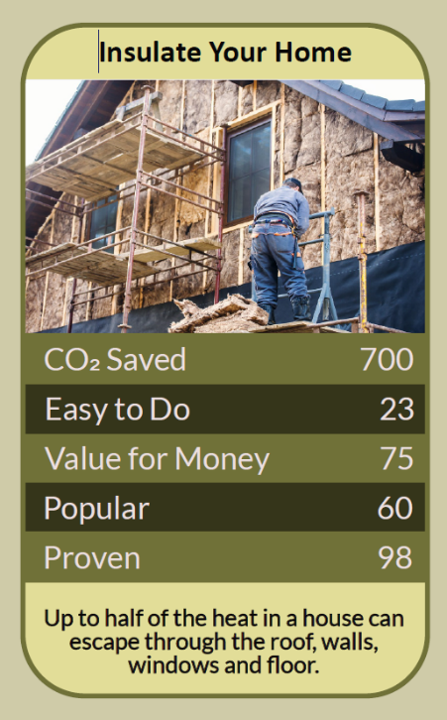


Before you begin  How To Use This Workbook | 

This workbook stands alone. You need nothing else to use it except your own home, a torch, a ruler and about an hour of looking closely at the place you live.
It asks you to write, not just read.
Before you begin, choose one room in your home. Pick the room you use most that feels coldest — the one where you reach for a jumper or a blanket. If you rent, that's fine: much of this workbook is about noticing and asking, not drilling. You'll carry that one room through the exercise.

Write your first thoughts here, so you can come back to them later

This worksheet is part of the Climate Challenge series of action workbooks.

Part one  The Teaching | 

The idea at the heart of this workbook is “fabric first”. It underpins PAS 2035, the British Standards Institution's specification for retrofitting homes, first published in 2019, which sets the rules for government-funded retrofit work in the UK. Its message is simple: improve the building's fabric — its roof, walls, floors, windows and doors — before you change how you heat it.
Underneath it sits a slightly uncomfortable claim. Most of us don't have a heating problem; we have a leaking problem. We pay to warm the air inside our homes and then let the street have it. A shiny new boiler or heat pump in a leaky house just heats the neighbourhood more efficiently.
Heat always moves to the cold. Cold doesn't “get in”; warmth gets out. Heat flows from warm to cool through every surface and every gap, and it flows faster the bigger the temperature difference. That's why the same house costs far more to heat in January than in October, and why the coldest-feeling surfaces — a single-glazed window, an outside wall behind the sofa — are usually where your money is going.
Know where it goes. The Energy Saving Trust estimates that an uninsulated home loses around a quarter of its heat through the roof, and walls typically lose even more, often around a third. Floors, windows, doors and draughts account for the rest. Every home is different, but the pattern tells you where to look: up, then around, then down.
Draughts first, because they're cheap. Sealing gaps around doors, windows, loft hatches, letterboxes, skirting boards and unused chimneys is one of the quickest and cheapest jobs in home energy, and much of it is DIY: brush strips, foam seals, a chimney balloon. It also makes a room feel warmer straight away, because moving air on your skin feels colder than still air at the same temperature.
Then the loft. In most homes with an accessible loft, insulation is the next easy win. Current guidance recommends at least 270mm of mineral wool; if you can see the tops of the joists, there isn't enough. If you need to store things up there, raise boards on legs rather than squashing the insulation, because insulation works by trapping still air, and crushed insulation traps less.
Walls are the big one, and the hard one. Most UK homes built from the 1930s onwards have cavity walls, which can often be filled from outside in a day. Older solid-wall homes need internal or external wall insulation, which costs more, disrupts more and depends far more on being done well. The brickwork gives a clue: if you see only the long sides of the bricks, there's probably a cavity; if long sides alternate with short ends, the wall is probably solid.
Build tight, ventilate right. The more airtight a home becomes, the more carefully its moisture has to be managed. Cooking, showering, drying clothes and simply breathing put litres of water into the air every day. Without extractor fans, trickle vents or a window opened briefly, that moisture condenses on the coldest surfaces and mould follows. Never block air bricks or vents, and never seal up a room with a gas fire, open fire or stove in it without professional advice: those appliances need air to burn safely.
The practical use of fabric first is a running order. Stop the draughts this week. Top up the loft this year. Find out what your walls and floors are made of, and plan the bigger jobs carefully, with properly accredited installers — the National Audit Office found that nearly all external wall insulation fitted under recent government schemes had major problems needing repair, so the quality of the work matters as much as the decision to do it. Finally, check what help is available: the government's Warm Homes Plan, launched in January 2026, and your local council's home energy schemes can help with the cost, especially for lower-income households.

Part two  The Exercise | 

Take the room you chose at the start and carry it through the steps below, walking around it as you go. Write in full sentences. Nobody else reads this.
Describe the room. What is it used for, when, and by whom? How does it feel on a cold evening with the heating on? Where in the room is it coldest? Score its winter comfort from 1 (miserable) to 10 (cosy all winter).
How certain do you feel about that score? ① ② ③ ④ ⑤ ⑥ ⑦ ⑧ ⑨ ⑩

Go on a draught hunt. On a breezy day, move a damp hand or a strip of tissue slowly around window frames, door edges, skirting boards, gaps in floorboards, sockets and pipes on outside walls, and any fireplace. List every place you feel or see air moving, and mark the ones you could seal yourself.

Look up. If it's safe to get into your loft, take a torch and a ruler. How deep is the insulation? Can you see the tops of the joists? Is the loft hatch itself insulated and draught-stripped? If you can't get up there safely, write down who could check for you.

Read the walls and floor. Which walls of this room face outside? Look at the brick pattern outside, then look up your home's Energy Performance Certificate on the government's “Find an energy certificate” service. What does it say about the walls, floor and windows, and what does it recommend?

Check the moisture. Look for condensation on the windows in the morning, dark mould in corners or behind furniture, peeling paint or a musty smell. How is this room ventilated now? Write down what would need to change so that sealing the draughts doesn't create a damp problem.

Make your plan. Write three actions: one you will do this week for under £20, one you will do or arrange this year, and one bigger job you will research properly. For each, name who else needs to be involved — a landlord, a neighbour, an installer, the council — and the date you'll start.

How certain are you that your plan will work? ① ② ③ ④ ⑤ ⑥ ⑦ ⑧ ⑨ ⑩

Part three  Questions For Discussion | 

Work through these questions independently if you must, but they are generally more beneficial when discussed.

- When a landlord insulates a home, the tenant gets the lower bills. Who should pay for the work, and what would make the deal fair to both sides?
- Is it better to insulate every home a little, quickly, or fewer homes deeply and properly? If you ran the national scheme, which would you choose, and who would lose out?
- Nearly all external wall insulation fitted under recent government schemes needed repair. When a public programme goes wrong like that, who carries the responsibility: installers, inspectors, government, or the householders who trusted them?
- Some households use the savings from insulation to keep their homes warmer rather than to cut their bills or their emissions. Is that a failure of the policy, or exactly the point?
- Should the character of an old street — stone fronts, original sash windows — ever outweigh the carbon and comfort gains of insulating it?
- Would you insulate your home if it took fifteen years to pay back? What does your answer say about how you weigh money, comfort and the climate against each other?

Want To Take This Further With Other People?
You've done the looking and the thinking on your own. What's missing now is someone who sees your home, and the problem, differently — and who might share a ladder, a thermal camera or a bulk order of loft roll.

Share your plan online  Join an online climate action community and post your draught-hunt findings and your three-step plan. Others will have tried the products and installers you're considering, and will tell you honestly what worked. Saying your plan out loud is also one of the simplest ways to make sure you follow through. |  | Find people near you  Look for a community energy group, repair café or residents' association nearby. Many run thermal-camera loans, draught-proofing workshops or street-wide schemes that bring installers' prices down. Ask your council what free home energy advice it offers.

Find your next challenge

This workbook is general guidance, not a survey of your home. For bigger jobs, use accredited installers and get more than one quote.

climatechallenge.uk

