

Reuse Your
Lunch Box
It's lunchtime, and within ten minutes the sandwich is gone and what's left is a plastic-windowed box, a crisp packet, a bottle and a napkin, all heading for the bin. We do it so often it doesn't register as a choice. The waste hierarchy, set out in the EU's Waste Framework Directive of 2008 and written into UK law, ranks our options: prevent waste first, reuse second, and only then recycle. Recycling is the option we feel good about, but it sits in the middle of the ladder, and lunch is one of the easiest places to climb higher. This workbook asks you to look honestly at what one ordinary lunch throws away, and to commit to the next three things you will change.

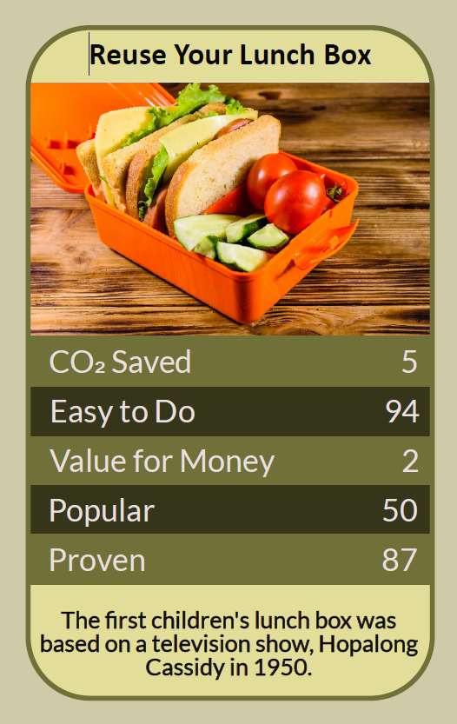

Before you begin  How To Use This Workbook | 

This workbook stands alone. You need nothing else to use it except a week of your own lunches and a few minutes at the end of each one.
It asks you to write, not just read.
Before you begin, choose one lunch you eat regularly. Pick an ordinary weekday lunch — a packed lunch, a meal deal, a takeaway — not a special occasion. If you make lunches for children too, start with your own and bring theirs in later. You'll carry that one lunch through the exercise.

Write your first thoughts here, so you can come back to them later

This worksheet is part of the Climate Challenge series of action workbooks.

Part one  The Teaching | 

The idea at the heart of this workbook is the waste hierarchy. It was set out in the European Union's Waste Framework Directive in 2008 and carried into UK law, and it ranks what to do with anything we might throw away: prevent it, reuse it, recycle it, recover energy from it, and only as a last resort send it to landfill.
Underneath it sits a slightly uncomfortable claim. Recycling, the thing most of us are proudest of, is the third-best option. The most effective packaging is the packaging that was never made, and the next best is the packaging you already own and use again tomorrow.
The order matters. Each step up the hierarchy saves more than the one below it. Recycling a bottle still means collecting, sorting, melting and remaking it, which uses energy and loses material at every stage. Reusing a bottle means washing it. Not needing a bottle at all, because there's a tap and a flask, costs almost nothing.
Recycling leaks. Much lunch packaging can't easily be recycled at all. Crisp packets, sandwich-box windows, plastic films, many coffee cups and food-soiled cardboard often end up in general waste, and what goes in the recycling bin isn't always recycled. Check your own council's rules: you may be surprised how much of your lunch was never going to come back as anything.
A reusable only pays back if you reuse it. A sturdy lunchbox, flask or bottle takes more material and energy to make than a single-use version, so it starts in debt. It pays that debt off every time you use it instead of a disposable one. A box used every day for years is a clear win; a fashionable box used twice and pushed to the back of the cupboard is not.
Start with what you already own. Before buying anything, look in your cupboards. Jars, old takeaway tubs, a biscuit tin, a tea towel to wrap a sandwich and a spare fork from the kitchen drawer are already made, already paid for and already yours. Only buy new to fill a real gap, and buy something that will last.
Keep it clean, keep it safe. Reuse only works if the food stays safe. Wash containers properly after each use, and keep perishable food cool with a fridge or an ice pack. Use food-grade containers, and only heat food in plastic that is labelled microwave-safe; glass or steel avoids the question altogether. Replace anything cracked, stained or holding smells.
Make it the easy option. Habits stick when they take less effort than the alternative. Pack lunch the evening before, keep the box by your keys, and leave a spare cup, fork and cloth wherever you eat. Most failed attempts at reuse aren't failures of will; they're a box left at home on a busy morning.
The practical use of the waste hierarchy is a running order for your lunch. First, notice what you throw away and ask whether you needed it at all. Then reuse what you already own, and make that the easy choice. Recycle what's left properly, following your council's rules. And look for help: many cafés will fill your own cup or container, some offer a discount for doing so, and refill apps such as City to Sea's Refill show nearby places that will top up a water bottle for free.

Part two  The Exercise | 

Take the lunch you chose at the start and carry it through the steps below over the coming week. Write in full sentences. Nobody else reads this.
Describe your lunch. What do you eat, where do you get it, and where do you eat it? List every piece of packaging, cutlery and napkin that comes with it. Score how wasteful it is from 1 (nothing thrown away) to 10 (almost everything thrown away).
How certain do you feel about that score? ① ② ③ ④ ⑤ ⑥ ⑦ ⑧ ⑨ ⑩

Count a week of it. For five working days, keep (or note down) everything your lunch leaves behind. At the end of the week, write the totals: how many boxes, bottles, cups, wrappers, sachets and forks? Which single item turned up most often?

Follow it to the bin. Look up your council's recycling rules. Which of those items can actually go in your recycling bin at home, and which can't? What happens to the ones you throw away at work, at school or in a public bin?

Raid your cupboards. Search your kitchen for containers, jars, a flask, a bottle, cutlery and cloths you could use instead. Write down what you found, what would replace which disposable item, and the one real gap, if any, you'd need to fill.

Name the awkward bits. What would make reuse hard for you: washing up, carrying things, no fridge at work, buying lunch on the go, being the only one doing it? For each, write one way around it, and who could help — a colleague, a café, your workplace, your household.

Make your plan. Write three actions: one you will do tomorrow, one you will do this month, and one bigger change you'll ask someone else for, such as a workplace fridge, a team mug shelf or a café that accepts your container. Name who's involved and when you'll start.

How certain are you that your plan will stick? ① ② ③ ④ ⑤ ⑥ ⑦ ⑧ ⑨ ⑩

Part three  Questions For Discussion | 

Work through these questions independently if you must, but they are generally more beneficial when discussed.

- The meal deal is cheap, quick and wrapped in plastic. Should the people who sell it carry more of the cost of the waste, or is it up to the people who buy it?
- Is one person reusing a lunchbox a meaningful act, or a distraction from the bigger changes that only businesses and governments can make? Could it be both?
- If reuse takes more time and planning, is it fair to expect it of someone working long shifts or caring for others? What would make it fair?
- Should workplaces and schools be expected to make reuse easy, with fridges, washing-up space and mug shelves? Whose job is it to ask for them?
- Some cafés refuse customers' own containers on hygiene grounds. Where is the right balance between food safety and cutting waste?
- A reusable box that's barely used can be worse than the disposables it replaced. How do we stop “going green” from turning into simply buying more things?

Want To Take This Further With Other People?
You've done the counting and the thinking on your own. What's missing now is someone who sees your lunch, and your habits, differently — and who might join you in asking for a fridge, a mug shelf or a café that says yes to your box.

Share your week online  Join an online climate action community and post your week's waste count and your three-step plan. Others will have found the containers that last and the shortcuts that make reuse easy. Saying your plan out loud is also one of the simplest ways to make sure you follow through. |  | Find people near you  Start with the people you eat lunch with: colleagues, classmates or your household. Look too for a local zero-waste or refill shop, a community group or a repair café. Ask nearby cafés whether they'll fill your own cup or container.

Find your next challenge

This workbook is general guidance. Follow food safety advice when storing, carrying and reheating food.

climatechallenge.uk

