

Downsize
Your Car
Most mornings, a car built for five people and a fortnight's luggage carries one person a few miles to work, then sits parked all day. Transport planners use a framework called Avoid–Shift–Improve, first set out by German researchers in the 1990s: avoid needless journeys, shift what you can to cleaner travel, and improve the vehicles you still need. Bigger cars use more energy and materials, take up more space and are more dangerous to people outside them. This workbook asks you to look honestly at how you really use your car, and to commit to your next three steps.
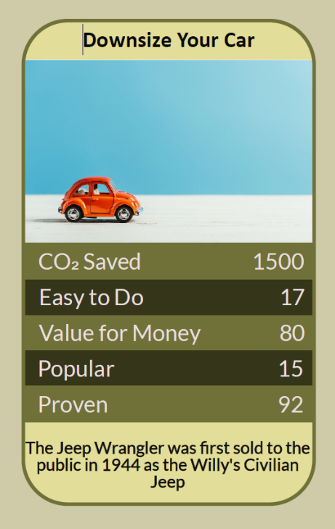


Before you begin  How To Use This Workbook | 

This workbook stands alone. You need nothing else to use it except a week of your own journeys, a notebook in the car and a recent fuel or charging receipt.
It asks you to write, not just read.
Before you begin, choose one car. Pick the car you drive most — your own, a household car or a company car. If you don't own one, choose the car you use most often or one you're thinking of buying. You'll carry that one car through the exercise.

Write your first thoughts here, so you can come back to them later

This worksheet is part of the Climate Challenge series of action workbooks.

Part one  The Teaching | 

The idea at the heart of this workbook is Avoid–Shift–Improve. It was first set out by German transport researchers in the 1990s, and it is now used by governments, cities and international transport organisations to plan for lower-carbon travel. It says there are three ways to cut the impact of how we get around, in order of power: avoid journeys you don't need, shift journeys to walking, cycling, public transport or shared travel, and improve the vehicles you still use.
Underneath it sits a slightly uncomfortable claim. Most of us choose our car for the rare journey, not the usual one. We pay every day, in money, fuel and space, for a holiday that happens once a year or a tip run that happens twice.
The order matters. A journey you don't make costs nothing. A journey you walk, cycle or take by train costs a fraction of one by car. Only after those come the improvements to the car itself. Downsizing belongs in the third step, but asking the question often reveals trips you could avoid or shift as well.
Weight is the hidden cost. Moving a heavier car takes more energy every time it accelerates or climbs a hill, and a taller, wider car pushes more air aside at speed. A bigger car also takes more steel, plastic and, in an electric car, battery materials to build. Much of a car's footprint is fixed before it's ever driven.
Buy for the usual, hire for the rare. Look at the journeys you make most weeks: how many people, how far, how much luggage. That's the car you need. For the few trips a year that need more seats or space, a hire car, a car club, a borrowed vehicle or a van for the day is usually far cheaper than carrying the extra size all year round.
Electric isn't a licence to go big. Switching to an electric car cuts exhaust emissions, but size still counts. A large electric SUV needs a bigger battery, more electricity per mile and more materials to make, and heavier cars of any kind wear their tyres, brakes and roads faster. The best electric car is a modest one.
Size has costs for other people. Taller, blunter, heavier vehicles are more likely to seriously injure pedestrians and cyclists in a collision, and they take up more road and parking space in streets that weren't built for them. Choosing a car is partly a choice about everyone who shares the road with it.
Fewer cars beats smaller cars. For many households the biggest step is not a smaller second car but no second car at all. Most cars sit parked for well over 90% of the time. A car club, a lift share or a good bike can cover the occasional trip that the second car was kept for.
The practical use of Avoid–Shift–Improve is a running order for your car. First, cut or combine the journeys you don't need. Next, move the short, regular ones to walking, cycling or public transport. Then, when the time comes to replace your car, buy the smallest one that fits your usual week rather than your rarest one, and plan in advance how you'll cover the exceptions. Smaller cars usually cost less to buy, fuel, insure and maintain, so the change often pays for itself.

Part two  The Exercise | 

Take the car you chose at the start and carry it through the steps below over the coming week. Write in full sentences. Nobody else reads this.
Describe your car. What is it, how many seats does it have, and roughly how big is it? Why did you, or whoever chose it, pick this car? Score how well its size matches the journeys you make in an ordinary week, from 1 (far too big) to 10 (exactly right).
How certain do you feel about that score? ① ② ③ ④ ⑤ ⑥ ⑦ ⑧ ⑨ ⑩

Log a week of journeys. For seven days, note every trip: where to, how far, how many people and how much luggage. At the end of the week, count how many trips carried just one person and how many were under two miles.

Find the rare trips. List the journeys over a whole year that you feel really need this car's size: holidays, tip runs, visiting family, sports kit. How many days a year is that? For each, write one other way it could be done: hire, borrow, car club, delivery, train and taxi.

Avoid and shift. Go back to your week's log. Which trips could you have dropped, combined with another, or made on foot, by bike, by bus or by train? What stopped you, and what would need to change for you to try one this week?

Count the real cost. Write down what this car costs you each year: fuel or charging, insurance, tax, servicing, tyres, parking and the value it loses. Then look up the same costs for a smaller car that would fit your usual week, or for having no car at all and using hire and car clubs. What's the difference?

Make your plan. Write three actions: one journey you will avoid or shift this week, one change you will make this year, and what you will choose when this car is next replaced. Name anyone else who needs to agree, such as a partner or employer, and the date you'll start.

How certain are you that your plan will happen? ① ② ③ ④ ⑤ ⑥ ⑦ ⑧ ⑨ ⑩

Part three  Questions For Discussion | 

Work through these questions independently if you must, but they are generally more beneficial when discussed.

- Paris now charges far more to park heavy SUVs than ordinary cars. Should parking charges and vehicle tax rise with a car's size or weight, and who would that hit hardest?
- Many people buy a large car because it feels safer for their family. Is that a fair choice if it makes the road more dangerous for everyone outside the car?
- If an electric SUV produces no exhaust, does its size still matter? How would you explain your answer to someone who has just bought one?
- Should advertising for large, high-emission cars be restricted, as some cities have done with other fossil-fuel advertising?
- In places with poor buses and no safe cycle routes, is it fair to ask people to drive less or drive smaller? Whose job is it to change that first?
- How much of choosing a car is about how we want to be seen? How would you know whether that had shaped your own choice?

Want To Take This Further With Other People?
You've logged the journeys and done the thinking on your own. What's missing now is someone who sees your travel, and the choices around it, differently — and who might share a lift, a car or a weekend hire with you.

Share your journey log online  Join an online climate action community and post your week's journey log and your three-step plan. Others will have downsized, gone car-free or joined a car club, and will tell you honestly what it was like. Saying your plan out loud is also one of the simplest ways to make sure you follow through. |  | Find people near you  Look for a car club, lift-share scheme, cycling group or local transport campaign near you. Talk to neighbours and colleagues about sharing journeys or a car. Ask your council about safer walking and cycling routes and better buses.

Find your next challenge

This workbook is general guidance, not financial advice. Check running costs and safety ratings for any car you consider.

climatechallenge.uk

