

Reuse Your
Water Bottle
You're thirsty on the way somewhere, so you buy a bottle of water, drink it in five minutes and throw away a container built to last for centuries. The Ellen MacArthur Foundation calls this the linear economy — take, make, waste — and since 2012 it has argued for a circular economy that keeps things in use for as long as possible. In the UK, tap water is cheap, safe and already piped to almost every building. This workbook asks you to notice when and why you still buy bottled drinks, and to commit to the next three things you will change.

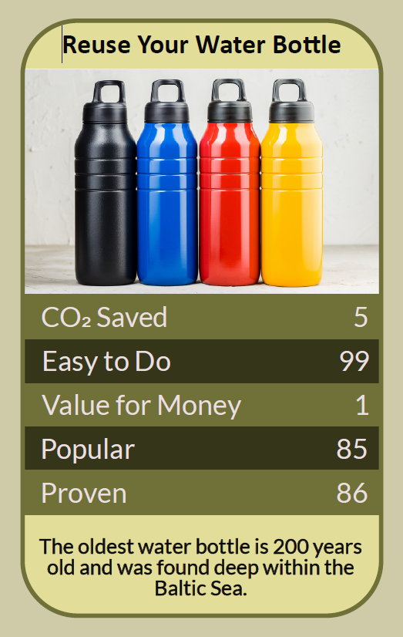

Before you begin  How To Use This Workbook | 

This workbook stands alone. You need nothing else to use it except a week of your own drinking habits and a few minutes at the end of each day.
It asks you to write, not just read.
Before you begin, choose one regular moment when you buy a drink in a bottle. It might be the commute, the gym, a long drive, the office or a day out with the children. Choose an ordinary, everyday moment, not a festival or a holiday. You'll carry that one moment through the exercise.

Write your first thoughts here, so you can come back to them later

This worksheet is part of the Climate Challenge series of action workbooks.

Part one  The Teaching | 

The idea at the heart of this workbook is the circular economy, set out by the Ellen MacArthur Foundation in its first report, Towards the Circular Economy, in 2012. It contrasts the linear economy, where we take materials, make products and throw them away, with a circular one, where products and materials are kept in use for as long as possible.
Underneath it sits a slightly uncomfortable claim. A single-use water bottle is a durable material used for minutes, carrying something that was already available almost free from a tap. Recycling it is better than binning it, but the circular economy's first rule is that keeping a product in use beats breaking it down and remaking it.
Take, make, waste. A plastic bottle is made from oil and gas, shaped, filled, chilled, transported and sold, and its useful life is often less than an hour. Every step uses energy and materials, and most of that effort is spent on the container, not the water inside it.
The tightest loop wins. In a circular economy, the smaller the loop, the more value is kept. Refilling the same bottle keeps everything; recycling a bottle means collecting, sorting, shredding, melting and remaking it, losing energy and some material along the way. Many bottles are never recycled at all and end up burned, buried or littered.
The tap is already there. Tap water in the UK is tested and regulated to high standards, and it reaches almost every home, school and workplace. Bottled water can cost hundreds of times more per litre than tap water. If you don't like the taste, chilling tap water in a jug in the fridge often helps.
A reusable bottle starts in debt. A sturdy steel, glass or plastic bottle takes more material and energy to make than a single-use one, so it only pays that back by being used again and again. One bottle carried every day for years is a clear win. A drawer full of free promotional bottles isn't.
Keep it clean. Wash your bottle every day with hot soapy water, let it dry with the lid off, and give the lid and any straw a proper scrub. Use it for water rather than milk or sugary drinks if you can't wash it straight away. Replace a bottle that is cracked, scratched inside or holding smells.
Make refilling the easy option. Habits stick when they take less effort than the alternative. Keep your bottle by your keys, fill it before you leave, and know where you can top it up on the way. In England and Wales, pubs, bars and other venues licensed to sell alcohol must give free tap water to customers who ask, and many cafés will happily fill a bottle too.
The practical use of the circular economy is a running order for every drink. First, carry your own bottle and refill it from the tap. Next, find places to top it up when you're out, using apps such as City to Sea's Refill, which maps places offering free water. Only then recycle the bottles you do still buy. A UK deposit return scheme for drinks bottles and cans is due to start in October 2027, putting a small refundable deposit on each one: a reminder that a bottle is worth something even when it's empty.

Part two  The Exercise | 

Take the moment you chose at the start and carry it through the steps below over the coming week. Write in full sentences. Nobody else reads this.
Describe the moment. Where are you, what do you usually buy, and why do you buy it rather than bring something? Is it thirst, habit, convenience, taste or a treat? Score how often you buy a bottled drink in this moment, from 1 (almost never) to 10 (every time).
How certain do you feel about that score? ① ② ③ ④ ⑤ ⑥ ⑦ ⑧ ⑨ ⑩

Count a week of bottles. For seven days, note every bottled or canned drink you buy, wherever you are: what it was, what it cost and where the empty went. At the end of the week, add up the number of bottles and the total cost.

Taste the tap. Fill a glass from the tap, chill a jug in the fridge for an hour, and try them side by side with a bottled water if you have one. Write down honestly what you notice. If you prefer the bottle, what exactly is it you prefer?

Map your refill points. Think about your usual week: home, work or school, the gym, the shops, the routes in between. List every place you could fill a bottle for free, including any you find on a refill app. Where are the gaps?

Name the awkward bits. What would make carrying and refilling a bottle hard for you: remembering it, washing it, its weight, carrying a bag, the taste, feeling awkward asking? For each, write one way around it, and who could help — a colleague, a café, your workplace, your household.

Make your plan. Write three actions: one you will do tomorrow, one you will do this month, and one bigger change you'll ask someone else for, such as a water fountain at work, school or the gym. Name who's involved and when you'll start.

How certain are you that your plan will stick? ① ② ③ ④ ⑤ ⑥ ⑦ ⑧ ⑨ ⑩

Part three  Questions For Discussion | 

Work through these questions independently if you must, but they are generally more beneficial when discussed.

- Bottled water sells something most of us already get almost free from a tap. Why do you think so many people still buy it, and is that a problem for companies, governments or customers to solve?
- Should every public place — stations, parks, high streets, shopping centres — be required to offer free drinking water? Who should pay for it?
- A deposit return scheme puts a refundable price on every bottle. Will it change behaviour, or mostly make recycling tidier? Is that enough?
- If refilling a bottle feels awkward or embarrassing in some places, whose responsibility is it to change that feeling?
- Reusable bottles have become fashion items, with people owning several. When does a sustainable product turn into just another thing to buy?
- In some parts of the world, bottled water is the only safe option. What does that tell us about who gets to treat tap water as ordinary?

Want To Take This Further With Other People?
You've done the counting and the thinking on your own. What's missing now is someone who sees your habits differently — and who might join you in asking for a water fountain, a refill point or a workplace that makes the tap the easy choice.

Share your week online  Join an online climate action community and post your week's bottle count and your three-step plan. Others will know the bottles that last, the best refill spots and the tricks that make it a habit. Saying your plan out loud is also one of the simplest ways to make sure you follow through. |  | Find people near you  Start with the people you see every day: colleagues, classmates, your gym or your household. Look for a local refill scheme, zero-waste shop or community group. Ask nearby cafés and shops whether they'll display a refill sticker.

Find your next challenge

This workbook is general guidance. If you're unsure about your tap water, contact your water supplier.

climatechallenge.uk

