

Track Your
Electricity Use
Electricity is invisible: you flick a switch, something happens, and weeks later a bill arrives with a single number on it. In 2006, Sarah Darby of the University of Oxford's Environmental Change Institute reviewed decades of studies and found that clear, direct feedback on energy use typically led households to save between 5% and 15%. You can't change what you can't see. This workbook asks you to track your own electricity for a week, find where it really goes, and commit to the next three things you will change.

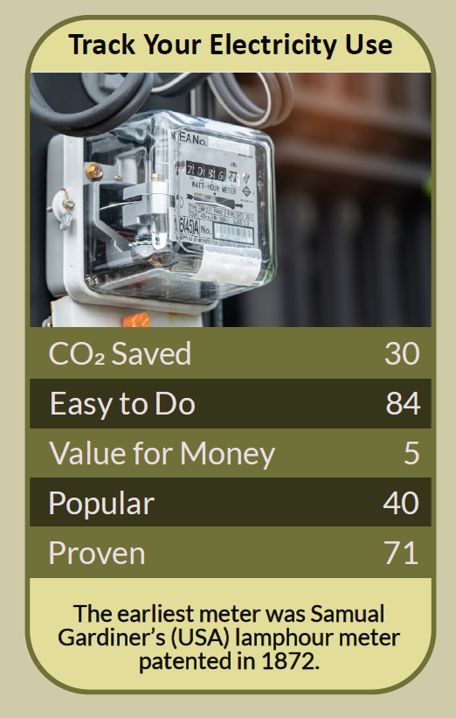

Before you begin  How To Use This Workbook | 

This workbook stands alone. You need nothing else to use it except your electricity meter or in-home display, your latest bill and a few minutes each day for a week.
It asks you to write, not just read.
Before you begin, choose one appliance or routine you suspect uses a lot. It might be the tumble dryer, an electric shower, a second fridge, a games console left on, or the evening rush of cooking and washing. Choose something ordinary that you could actually change. You'll carry that one suspect through the exercise.

Write your first thoughts here, so you can come back to them later

This worksheet is part of the Climate Challenge series of action workbooks.

Part one  The Teaching | 

The idea at the heart of this workbook is feedback. In 2006, Sarah Darby of the Environmental Change Institute at the University of Oxford published The Effectiveness of Feedback on Energy Consumption, a review of studies from around the world. She found that direct feedback — seeing your energy use as it happens, from a meter or display — typically led to savings of 5% to 15%, while bills alone did much less.
Underneath it sits a slightly uncomfortable claim. Most of us waste electricity not because we don't care, but because we can't see it. We would never leave a tap running all night, yet we leave devices running all night without a thought, because nothing drips.
Learn the unit. Electricity is measured in kilowatt-hours (kWh). A kWh is a 1,000-watt appliance running for one hour. Multiply an appliance's power in watts by the hours it runs and divide by 1,000, and you have its kWh. Multiply by the unit rate on your bill, and you have its cost. Once you can do that sum, every appliance has a price tag.
Power is not the same as use. A kettle draws a lot of power but only for a few minutes. A fridge-freezer draws little, but never stops. What matters is power multiplied by time. That's why small things left on all day can add up to more than big things used briefly.
Find your baseload. Your baseload is what your home uses when nobody is doing anything: fridges, routers, chargers, standby lights, heating pumps and gadgets that are never quite off. Because it runs 24 hours a day, every day, a modest baseload can account for a surprisingly large share of your annual bill.
Know your big users. In most homes, a few appliances do most of the work: anything that heats or cools, such as electric heaters, showers, tumble dryers, ovens, immersion heaters and older fridges and freezers. Cutting their use, or replacing the least efficient, usually beats switching off every light.
Timing matters too. The grid's carbon intensity rises and falls through the day as wind, solar and gas plants come on and off. Britain's National Energy System Operator publishes a free carbon-intensity forecast, and time-of-use tariffs charge less at quieter times. Moving flexible jobs such as laundry, dishwashing or car charging can cut both carbon and cost.
Feedback fades unless you use it. Studies of in-home displays find that people look at them a lot at first and then stop. Feedback works best when it is tied to a goal: a target for the week, a comparison with last month, or a specific appliance you're trying to tame. Data alone doesn't change habits; decisions do.
The practical use of feedback is a simple loop: measure, notice, change, measure again. Start with your meter or smart meter display and your bill. Find your baseload and your biggest users. Choose one change, then check the numbers a week later to see whether it worked. If you don't have a smart meter, you can ask your supplier about one, or simply read your meter at the same time each day.

Part two  The Exercise | 

Take the suspect you chose at the start and carry it through the steps below over the coming week. Write in full sentences. Nobody else reads this.
Find your starting point. Look at your latest bill or your supplier's app. How many kWh did you use last month or last year, and what is your unit rate? Before measuring anything, guess which three things use the most electricity in your home. Score how well you think you know where your electricity goes, from 1 (no idea) to 10 (I could list it).
How certain do you feel about that score? ① ② ③ ④ ⑤ ⑥ ⑦ ⑧ ⑨ ⑩

Read the meter every day. For seven days, read your meter or display at the same time each day and write down the number. Work out how many kWh you used each day. Which day was highest, and what was different about it?

Measure your baseload. Late one evening, once the household is settled and nothing is being used, read your display or meter, then read it again an hour later. That's your baseload per hour. Multiply by 24 and by 365 for a year's worth, then walk round and list everything that was still switched on.

Test your suspect. Find your suspect's power in watts from its rating plate, its manual or a plug-in energy monitor. Estimate how many hours a week it runs, then work out its kWh and cost per week and per year. Was it bigger or smaller than you expected?

Check the timing. When in the day does your household use the most electricity? Look up your area's carbon-intensity forecast for a day this week. Which jobs could you move to a lower-carbon or cheaper time, and which can't move?

Make your plan. Write three actions: one you will do today, one you will do this month, and one bigger change to research, such as a time-of-use tariff, a smart meter or replacing an old appliance. Set a target for next week's daily kWh, and the date you'll check it.

How well do you now know where it goes? ① ② ③ ④ ⑤ ⑥ ⑦ ⑧ ⑨ ⑩

Part three  Questions For Discussion | 

Work through these questions independently if you must, but they are generally more beneficial when discussed.

- Smart meters tell your supplier, as well as you, when you use electricity. Is that a fair trade for better feedback and cheaper tariffs? What would make you trust it?
- Time-of-use tariffs reward households that can shift when they use electricity. Who finds that easy, who finds it hard, and is it fair?
- Should every appliance be required to show how much electricity it's using, the way a car shows its fuel?
- If feedback only saves 5% to 15%, is tracking your electricity worth the effort, or should the responsibility lie with suppliers, manufacturers and government?
- When something gets cheaper or more efficient, people often use more of it. How would you stop the savings from your plan being swallowed up?
- Is there a point where tracking your energy becomes anxious or obsessive? What would a healthy relationship with your energy use look like?

Want To Take This Further With Other People?
You've done the measuring and the thinking on your own. What's missing now is someone who sees your numbers differently — and who might compare readings with you, lend you an energy monitor or keep you to your target.

Share your numbers online  Join an online climate action community and post your daily readings, your baseload and your three-step plan. Others will have found the hidden energy users in their homes and the changes that made the biggest difference. Saying your target out loud is one of the simplest ways to make sure you hit it. |  | Find people near you  Look for a community energy group, library or council scheme near you; many lend plug-in energy monitors for free. Compare readings with a neighbour or friend in a similar home. Ask your council what free home energy advice it offers.

Find your next challenge

This workbook is general guidance. Never open meters, sockets or fuse boxes; use plug-in monitors only as the maker directs.

climatechallenge.uk

