

Eat Seasonal
Fruit
Walk into any supermarket in January and you'll find strawberries, blueberries and grapes, as if summer never ends. In the 1990s, Professor Tim Lang coined the phrase “food miles” to make us ask how far our food has travelled, and since then research has shown that how fruit is grown and moved matters even more than the distance. Eating with the seasons is one of the simplest ways to get both right. This workbook asks you to look at the fruit you actually buy, and to commit to the next three things you will change.

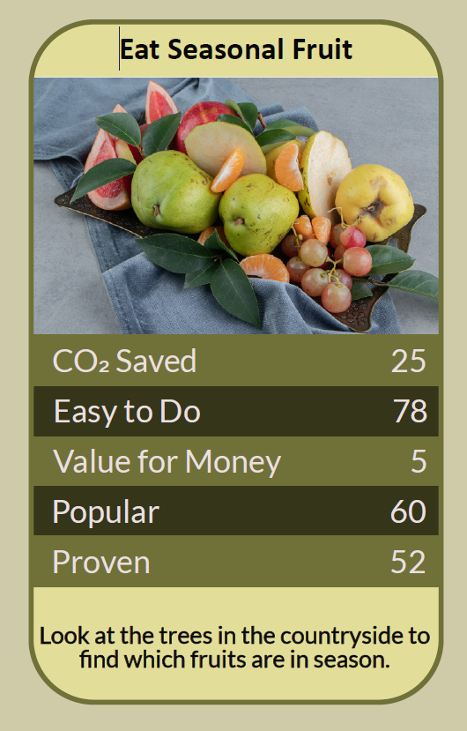

Before you begin  How To Use This Workbook | 

This workbook stands alone. You need nothing else to use it except a week of your own shopping and the labels on the fruit you buy.
It asks you to write, not just read.
Before you begin, choose one fruit you buy often. It might be strawberries, bananas, apples, grapes or blueberries — whatever ends up in your basket most weeks. Choose a fruit you genuinely enjoy; this is about eating well, not eating less fruit. You'll carry that one fruit through the exercise.

Write your first thoughts here, so you can come back to them later

This worksheet is part of the Climate Challenge series of action workbooks.

Part one  The Teaching | 

The idea at the heart of this workbook is food miles. The phrase was coined in the early 1990s by Tim Lang, later Professor of Food Policy at City University London, to describe the distance food travels from where it's grown to where it's eaten, and to ask what that distance costs the planet and the people who grow it.
Underneath it sits a slightly uncomfortable claim. Distance alone isn't the whole story. How the fruit was grown and how it travelled can matter far more than how far it came, and the season is often the best guide to getting both right.
Most food miles are small. For most foods, transport is a small part of the total carbon footprint; growing the food usually matters much more. A 2018 study of global food by Joseph Poore and Thomas Nemecek at the University of Oxford found that transport makes up only a small share of food's emissions overall. Fruit shipped by sea across the world can have a lower footprint than you might expect.
Except when it flies. The big exception is air freight. Fragile fruit with a short shelf life, such as some berries, figs and exotic fruit sold out of season, is sometimes flown in, and flying produces many times the emissions of shipping. Labels rarely say how fruit travelled, but short-lived fruit from far away, out of season, is the most likely to have flown.
Heat counts as much as distance. Fruit grown out of season close to home may need heated greenhouses, and studies have found that this can produce more emissions than growing the same crop in a sunnier country and shipping it. Local is good; local and in season is better.
Seasonal can be global. Eating seasonally doesn't mean only eating British fruit. Oranges and other citrus are in season around the Mediterranean in winter, and arrive by road or sea. The question to ask is whether a fruit is in season where it was grown, and how it got here.
In season tastes better and costs less. Fruit picked ripe at the height of its season usually tastes better, and when there's plenty of it, it's often cheaper. British strawberries in June, plums in late summer and apples in autumn are at their best and most plentiful.
Save the season. Summer fruit doesn't have to vanish in winter. Freezing, stewing, bottling and jam-making let you eat this year's glut months later. Frozen and tinned fruit are good, low-waste choices, and stored British apples and pears last well into the new year.
The practical use of food miles is a running order for your fruit bowl. First choose fruit that is in season here. Next choose fruit that is in season where it was grown and came by sea or road. Use frozen, tinned and preserved fruit to bridge the gaps. Save the air-freighted and out-of-season fruit for the occasional treat. And whatever you choose, eat what you buy: fruit thrown away wastes everything it took to grow and move it.

Part two  The Exercise | 

Take the fruit you chose at the start and carry it through the steps below over the coming week. Write in full sentences. Nobody else reads this.
Describe your fruit habit. Which fruit do you buy most weeks, where do you buy it, and at what times of year? Why that fruit: taste, habit, price, the children's preference? Score how seasonal you think your fruit eating is, from 1 (the same all year) to 10 (it changes with every season).
How certain do you feel about that score? ① ② ③ ④ ⑤ ⑥ ⑦ ⑧ ⑨ ⑩

Read the labels. For one week, note the country of origin of every fruit you buy. Which came furthest? Which were fragile, short-lived and out of season here, and so might have been flown? Was anything thrown away before it was eaten?

Map your fruit's year. Find out when your chosen fruit is in season in the UK, if it grows here at all. Where does it come from in the other months, and how is it likely to travel? Write out the months when it's at its best.

Find the swaps. For each month your fruit is out of season, name an in-season alternative you'd enjoy, or a frozen, tinned or preserved version. Which swap would be easiest to start with, and which would you miss most?

Save a season. Think about one fruit that is cheap and plentiful at some point in the year near you: from a shop, a market, a pick-your-own farm, a friend's tree or a hedgerow. How could you freeze, stew or preserve some of it to eat later?

Make your plan. Write three actions: one you will do on your next shop, one you will do this season, and one bigger change, such as joining a veg-box scheme, a community orchard or a preserving session. Name anyone else involved and when you'll start.

How certain are you that your plan will stick? ① ② ③ ④ ⑤ ⑥ ⑦ ⑧ ⑨ ⑩

Part three  Questions For Discussion | 

Work through these questions independently if you must, but they are generally more beneficial when discussed.

- Many farmers in poorer countries earn their living growing fruit for export to the UK. If we buy less imported fruit, who pays the price, and how should that weigh against the carbon?
- Is fruit out of season a reasonable everyday expectation, or a luxury we've stopped noticing?
- Should fruit labels say how it travelled, by air, sea or road, or show its carbon footprint? Would you change what you buy if they did?
- Supermarkets promise the same fruit all year round. Who taught us to expect that, and who could change the expectation?
- Most of us don't eat enough fruit. Could asking people to eat seasonally put some of them off eating fruit at all? How would you avoid that?
- Community orchards, allotments and hedgerows once supplied a lot of seasonal fruit. What would it take to bring that back where you live?

Want To Take This Further With Other People?
You've done the label-reading and the thinking on your own. What's missing now is someone who sees your shopping differently — and who might share a glut, a pick-your-own trip or an afternoon of jam-making with you.

Share your swaps online  Join an online climate action community and post your label-reading results and your three-step plan. Others will have favourite seasonal recipes, preserving tips and the best ways to bridge the winter months. Saying your plan out loud is also one of the simplest ways to make sure you follow through. |  | Find people near you  Look for a farmers' market, a veg-box scheme, a pick-your-own farm or a community orchard near you. Ask friends and neighbours with fruit trees whether they have more than they can use. Share a preserving session and split the jars.

Find your next challenge

This workbook is general guidance. Only forage fruit you can identify with certainty, and wash fruit before eating.

climatechallenge.uk

