

Go
Vegetarian
Think about the meals you ate this week: the bacon sandwich, the chicken curry, the Sunday roast. In 2018 Joseph Poore and Thomas Nemecek gathered data from nearly 40,000 farms in 119 countries and found that meat and dairy use 83% of the world's farmland while providing just 18% of our calories. What we put on our plates turns out to be one of the biggest environmental choices we make every day. This workbook asks you to look at what you really eat, cook and taste some vegetarian meals, and decide how far you want to go.
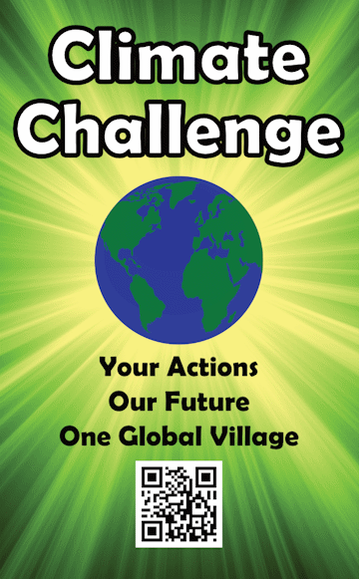
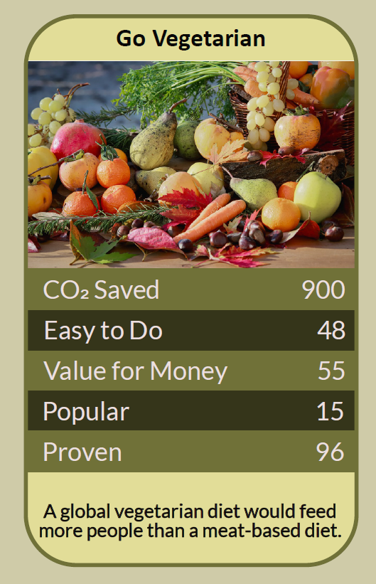

Before you begin  How To Use This Workbook | 

This workbook stands on its own. You need a week of honest notes about your meals, a kitchen, a pen and an open mind, and each part builds on the one before, so work through it in order.
It asks you to write, not just read.
Before you begin, choose one meal you eat often that contains meat or fish. Pick an everyday favourite, not a special occasion. If you are pregnant, have a medical condition, are feeding young children, or have a difficult relationship with food, talk to your GP or a dietitian before making big changes. You'll carry that one meal through the exercise.

Write it here, so you have it to hand

Part one  The Teaching | 

In June 2018 the journal Science published a study by Joseph Poore of the University of Oxford and Thomas Nemecek of the Swiss agricultural research institute Agroscope. They built the largest database of its kind, covering almost 40,000 farms in 119 countries and 40 foods that make up 90% of what the world eats, and compared the environmental impact of each food from farm to shop.
The slightly uncomfortable claim underneath it is this: what you eat matters far more than how it is farmed or how far it travels. Even the lowest-impact meat and dairy they found caused much more environmental harm than the least sustainable vegetables and cereals. Swapping meat for plants does more than almost any other change in the kitchen.
A lot of land for a little food. Meat and dairy use 83% of the world's farmland and produce about 60% of agriculture's greenhouse gas emissions, yet provide only 18% of our calories and 37% of our protein. Poore and Nemecek estimated that without meat and dairy the world could be fed on less than a quarter of the farmland it uses now, leaving room for forests and wildlife to return.
What, not where. Buying local feels like the greenest choice, but for most foods transport is only a small part of the footprint. Most of the impact comes from the land, feed, fertiliser and, for cattle and sheep, the methane released as they digest. Local beef still has a far bigger footprint than imported beans.
Real diets, real differences. In 2023 Peter Scarborough and colleagues at Oxford compared the real diets of about 55,000 people in the UK, published in Nature Food. Vegans' diets produced around 75% less climate-heating emissions, land use and water pollution than those of people eating more than 100 g of meat a day, and vegetarian and low-meat diets came in between. Every step down the scale counts.
Eating well without meat. A vegetarian diet leaves out meat and fish but usually keeps eggs and dairy, so getting enough protein, calcium and vitamin B12 is straightforward. Beans, lentils, chickpeas, tofu, nuts, seeds, eggs, cheese and wholegrains all bring protein, and pulses, leafy greens and fortified cereals help with iron. The NHS says a varied vegetarian diet can provide all the nutrients you need.
Swaps, not sacrifice. Few people change overnight. Many start with one meat-free day a week, the idea behind Meat Free Monday, launched by Paul, Mary and Stella McCartney in 2009, or by making their favourite dishes with beans or lentils instead of mince. Pulses are often cheaper than meat, so the swap can save money too.
Food is personal. What we eat is tied to family, culture, faith and comfort. Going vegetarian doesn't mean judging anyone else's plate. It means choosing, meal by meal, food that tastes good and asks less of the land.
The practical use of Poore and Nemecek's work is to point us to the biggest lever in our kitchens. You don't have to become perfect overnight. Start with one meal, find a version you love, and let it become the new normal. Then do it again.

Part two  The Exercise | 

Take the meal you chose at the start and carry it through the steps below. You'll need about two weeks and a kitchen. Write in full sentences. Nobody else reads this.
Keep a food diary. For one week, write down your main meals and note which contain meat or fish. How many meat meals did you eat? Then score from one to 10 how hard you think it would be to go vegetarian.
How certain do you feel about that score? ① ② ③ ④ ⑤ ⑥ ⑦ ⑧ ⑨ ⑩

Look at your chosen meal. Describe the meal you chose: what's in it, how often you eat it, and what you love about it. Is it the meat itself, or the flavour, texture, sauce or memories that make it special?
Find a swap. Find a vegetarian version of your meal, such as lentil bolognese, bean chilli, chickpea curry or a mushroom pie. Write down the recipe you'll try and where you found it.

Cook and taste it. Cook the vegetarian version, ideally for other people too. Write down how it tasted, what everyone said, how long it took and what it cost compared with the usual meal. What would you change next time?
Try a vegetarian week. Eat vegetarian for a whole week, or as many days as you can. Note what was easy, what was hard, what you missed and anything new you enjoyed. How did you feel?

Choose your next step. Decide how far you want to go from here: one meat-free day a week, meat only at weekends, fully vegetarian, or something else. Write down your choice, why you made it, and how you'll keep it going.
And how certain do you feel now? ① ② ③ ④ ⑤ ⑥ ⑦ ⑧ ⑨ ⑩

Part three  Questions For Discussion | 

Work through these questions independently if you must, but they are generally more beneficial when discussed.

- If what we eat matters more than where it comes from, why does 'buy local' feel like such a strong green message?
- Should schools, hospitals and workplaces make vegetarian dishes the default choice, with meat on request?
- What would a big shift away from meat mean for farmers, and how should they be supported?
- Is eating less meat a personal choice, or something governments should encourage through prices and taxes?
- How do family, culture and faith shape what we eat, and how can change respect them?
- Is it better for many people to eat less meat, or for a few to give it up completely?

Want To Take This Further With Other People?
You've cooked and tasted on your own. What's missing is the table: the people you eat with, who can share recipes, try new dishes and keep each other going.

Cook together  Host a vegetarian potluck or supper club where everyone brings a favourite meat-free dish and its recipe. Swap the recipes and pick one to cook at home that week. |  | Change the menu  Ask your workplace, school or community café to add more vegetarian dishes, or to make one the first choice on the menu. A single menu change can shift thousands of meals.

Find your next challenge

climatechallenge.uk

