

Holiday
Local
The holiday starts long before you arrive: the early taxi, the airport queue, the hours in the air. In 2018 a team led by Manfred Lenzen at the University of Sydney worked out the carbon footprint of tourism across 189 countries and found it made up about 8% of the world's greenhouse gas emissions, with flying the biggest single part. Yet some of the most memorable places many of us will ever visit are a train ride away. This workbook asks you to look at how you holiday now, find what lies within reach, and plan one break closer to home.

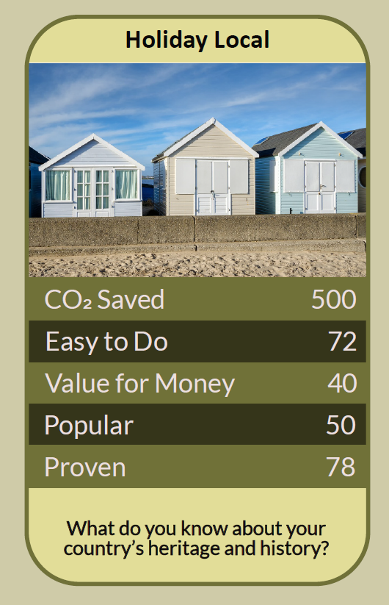

Before you begin  How To Use This Workbook | 

This workbook stands on its own. You need a map, a pen, some honest memories of past holidays and one break or day out to plan, and each part builds on the one before, so work through it in order.
It asks you to write, not just read.
Before you begin, choose one holiday or break. It could be the trip you take most years, one you're planning now, or the kind of break you'd like to take next. This isn't about guilt over visiting family abroad or a trip you've saved years for; it's about the holidays we take out of habit. You'll carry that one break through the exercise.

Write it here, so you have it to hand

Part one  The Teaching | 

In May 2018 the journal Nature Climate Change published a study led by Professor Manfred Lenzen of the University of Sydney. His team traced the carbon footprint of tourism, including travel, shopping, food and accommodation, across 189 countries from 2009 to 2013. They found it rose from 3.9 to 4.5 billion tonnes of carbon dioxide equivalent, about 8% of global emissions, with air travel the biggest contributor.
The slightly uncomfortable claim underneath it is this: for most holidays, the biggest part of the footprint is the getting there, and many of us choose where to go by habit and the price of a flight rather than by what we actually want from a break. Rest, sunshine, good food and a change of scene are often much closer than we think.
The journey is the footprint. Using UK government conversion factors, a domestic flight produces around 230 g of carbon dioxide equivalent per passenger for every kilometre, while a national rail journey produces around 31 g, roughly an eighth. Long-haul flights cover such great distances that a single return trip can outweigh months of careful choices at home.
Slow travel is part of the holiday. A train journey lets you read, talk, eat and watch the landscape change. Arriving by rail, coach, bike or on foot also means arriving in the middle of a place rather than at an airport on its edge, and the journey itself becomes something to remember rather than something to endure.
There's more nearby than you think. Britain's national parks, National Landscapes, coast paths, canals, islands, market towns and cities hold more than most of us will see in a lifetime. Many people know distant resorts better than the countryside two hours from their own front door.
Local money stays local. Spending on a nearby holiday, in a family-run guest house, a village café or a local guide, supports jobs and businesses in your own region, and much of it circulates there again. Choose independent places to stay and eat, and more of what you spend stays in the community you visit.
Be a good guest. Popular places can be loved to death, with crowded paths, full car parks and housing turned into holiday lets. Travel out of peak season where you can, use public transport, and follow the Countryside Code: respect everyone, protect the environment and enjoy the outdoors.
It's not all or nothing. Holidaying locally doesn't mean never going abroad. Taking fewer, longer trips, choosing the train for journeys to Europe, and making one break a year a local one all make a real difference.
The practical use of all this is to make your next break a choice rather than a habit. Work out what you really want from a holiday, find where you can get it within easy reach, and treat the journey as part of the adventure. The way out isn't staying at home; it's discovering how much is waiting just down the line.

Part two  The Exercise | 

Take the holiday you chose at the start and carry it through the steps below. You'll need a map and, in the end, one trip. Write in full sentences. Nobody else reads this.
Look at your usual holiday. Describe the break you chose: where you go, how you get there, how far it is and what you most enjoy about it. Then score from one to 10 how much of what you enjoy depends on going far away.
How certain do you feel about that score? ① ② ③ ④ ⑤ ⑥ ⑦ ⑧ ⑨ ⑩

Count the journey. Work out the return distance in kilometres. As a rough guide, multiply it by 230 for flying and by 31 for the train to get grams of carbon dioxide per person. Then multiply by the number of people travelling. What do you notice?
Name what you want. List what you actually want from a holiday: rest, sun, sea, hills, history, food, adventure, time together, time alone. Which of these really depend on distance, and which don't?

Draw your radius. Find at least five places you could reach in three hours or less by train, coach, bike or on foot. Note which ones offer the things on your list. Which one surprises you most?
Plan a local break. Choose one place from your list and plan a break or day out: how you'll get there, where you'll stay, where you'll eat and what you'll do. Choose local and independent places where you can.

Take it, then weigh it. Make the trip, even if it's only a day out, and write down what it was really like. What did you miss about your usual holiday, what did you gain, and what will you do next time?
And how certain do you feel now? ① ② ③ ④ ⑤ ⑥ ⑦ ⑧ ⑨ ⑩

Part three  Questions For Discussion | 

Work through these questions independently if you must, but they are generally more beneficial when discussed.

- Why does a holiday abroad often feel more 'real' than one in your own country?
- Should train travel be made cheaper than flying for the same journey, and who should pay for that?
- Is it fair to ask people to fly less when many have family in other countries?
- When does tourism help a place, and when does it start to harm the people who live there?
- Should frequent flyers pay more than people who fly once a year or not at all?
- What would you want visitors to see, eat and do if they came to holiday where you live?

Want To Take This Further With Other People?
You've planned one break on your own. What's missing is the people you travel with, and the local knowledge of people who already love the places you're about to discover.

Swap your best local finds  Ask friends, family and neighbours for their favourite places within a few hours of home, and share yours. Build a list together of trips that need no airport. |  | Plan a group trip by train  Organise a break or day out by rail with a group, club or family. Travelling together cuts the cost, makes the journey part of the fun, and shows how easy it can be.

Find your next challenge

climatechallenge.uk

