

Recycle
Electronics
An old phone in the kitchen drawer, a broken toaster in the garage, a laptop nobody has switched on for years: most homes are quietly storing a small mine of copper, gold and rare metals. The Global E-waste Monitor 2024, from the United Nations Institute for Training and Research and the International Telecommunication Union, found that the world threw away 62 million tonnes of electronics in 2022 and properly recycled less than a quarter of it. This workbook asks you to find the electricals hiding in your home, give working ones a second life, and make sure the rest is recycled safely.
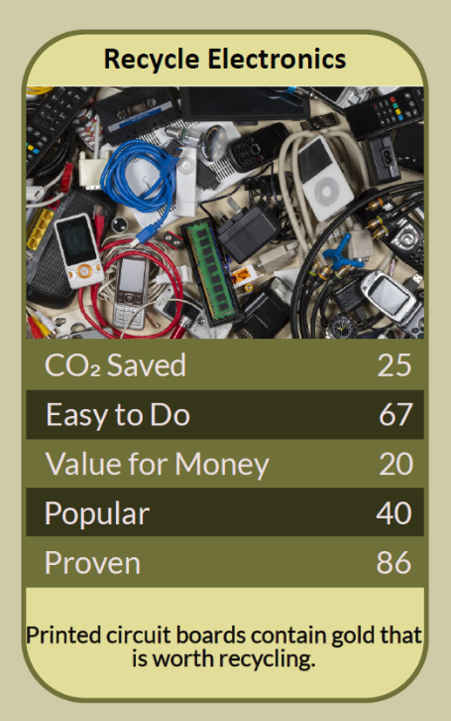


Before you begin  How To Use This Workbook | 

This workbook stands on its own. You need a hunt through your drawers, cupboards and loft, a pen and a few weeks to sort things out, and each part builds on the one before, so work through it in order.
It asks you to write, not just read.
Before you begin, choose one drawer, cupboard or room where old electricals gather. Handle swollen, damaged or leaking batteries with care, don't try to take them out of sealed devices yourself, and never put anything with a battery in a household bin. Wipe your personal data before giving any device away. You'll carry that one place through the exercise.

Write it here, so you have it to hand

Part one  The Teaching | 

The Global E-waste Monitor is produced by the UN Institute for Training and Research (UNITAR) and the International Telecommunication Union, with a research team led by Kees Baldé. Its 2024 edition brought together data from countries around the world to show how much electrical and electronic waste we create, and what happens to it.
The slightly uncomfortable claim underneath it is this: the drawer of old gadgets isn't harmless. Every unused phone and laptop holds metals that had to be mined, often at great human and environmental cost, while new devices are made from freshly mined materials. Keeping it 'just in case' is a slower way of throwing it away.
A mountain growing faster than recycling. The world generated 62 million tonnes of e-waste in 2022, about 7.8 kg for every person on Earth, and only 22.3% was documented as properly collected and recycled. E-waste is rising almost five times faster than formal recycling, and is expected to reach 82 million tonnes a year by 2030.
The UK is near the top. Analysis of earlier Global E-waste Monitor data placed the UK second in the world for electrical waste per person, at around 24 kg a year, behind only Norway. We buy a lot of electricals, and replace them often.
The hoard at home. Material Focus, the UK not-for-profit behind the Recycle Your Electricals campaign, estimated in 2024 that UK households were holding on to around 880 million unused electrical items. It valued the materials in electricals that are thrown away, hoarded, stolen or illegally exported at around £927 million.
Reuse and repair first. Recycling recovers materials, but keeping a device working saves far more. Pass on working phones, laptops and tablets to someone who needs them, sell or donate them, and try a repair café or repair shop for things that are broken but fixable. Recycle only what can't be used again.
Where to take it. Look for the crossed-out wheelie bin symbol, which means an item must not go in household rubbish. When you buy a new electrical item, the shop should take back a similar old one for recycling. Many larger shops also take back small electricals even if you don't buy anything, and council recycling centres accept them too.
Wipe it and watch the battery. Before passing on or recycling a phone, tablet or computer, back up what you need, sign out of your accounts, do a factory reset and remove SIM and memory cards. Electricals with batteries, including vapes, can catch fire if crushed in bin lorries, so they must always go to a proper recycling point.
The practical use of the Global E-waste Monitor is to see our drawers as part of a global problem we can actually do something about. Find what you're hoarding, get working things back into use, and send the rest where its materials can be recovered. Then think twice before buying the next new gadget.

Part two  The Exercise | 

Take the place you chose at the start and carry it through the steps below. You'll need a few weeks. Write in full sentences. Nobody else reads this.
Go on an electricals hunt. List every unused electrical item in the place you chose: phones, chargers, cables, laptops, small appliances, toys, vapes. Then score from one to 10 how much of a difference you think clearing them out would make.
How certain do you feel about that score? ① ② ③ ④ ⑤ ⑥ ⑦ ⑧ ⑨ ⑩

Sort them. Divide your list into three: working items someone could use, broken items that might be fixed, and items that are beyond use. Why have you been keeping each group?
Wipe and prepare. For every phone, tablet and computer, back up anything you need, sign out of accounts, do a factory reset and remove SIM and memory cards. Write down which devices you prepared and anything that was tricky.

Find the routes. Find where each group can go: a friend, charity, donation scheme or resale site for working items; a repair café or shop for fixable ones; a shop take-back or recycling centre for the rest. Write down each route.
Take them. Over the next few weeks, take or send each item to its route. Note what happened, what was easy, what was awkward, and how much space you freed up.

Set a rule for next time. Write a rule for your household about old and new electricals, such as repairing before replacing, or passing on the old item within a month of buying a new one. Explain why you chose it.
And how certain do you feel now? ① ② ③ ④ ⑤ ⑥ ⑦ ⑧ ⑨ ⑩

Part three  Questions For Discussion | 

Work through these questions independently if you must, but they are generally more beneficial when discussed.

- Why do so many of us keep old phones and gadgets we'll never use again?
- Should manufacturers be responsible for collecting and recycling every device they sell?
- Is it right that so much of the world's e-waste ends up in poorer countries, and what should be done about it?
- Should there be a deposit on phones and laptops, refunded when they're returned for reuse or recycling?
- How much should the 'right to repair' go beyond spare parts, to tools, manuals and software?
- What would make recycling electricals as easy and normal as recycling bottles and cans?

Want To Take This Further With Other People?
You've cleared your own drawer. What's missing is everyone else's, and the people who could use a working device that's gathering dust in someone else's home.

Hold an electricals collection  Organise a collection day at work, school or a community venue. Sort what comes in for reuse, repair and recycling, and take it all to the right places. |  | Donate a device  Find a local charity or scheme that passes on wiped phones, laptops and tablets to people who need them, and encourage friends and colleagues to give too.

Find your next challenge

climatechallenge.uk

