

Unplug Your
Chargers
Most homes have a drawer full of chargers and a few more left plugged in by the bed, the sofa and the kitchen counter. Unplugging them is one of the most familiar green tips there is, but the physicist David MacKay, author of Sustainable Energy – Without the Hot Air, compared it to bailing out the Titanic with a teaspoon. He wasn't saying 'don't bother'; he was saying 'look at the bigger numbers'. This workbook asks you to find out what your chargers and gadgets really use, deal with the things that matter, and make your devices last.

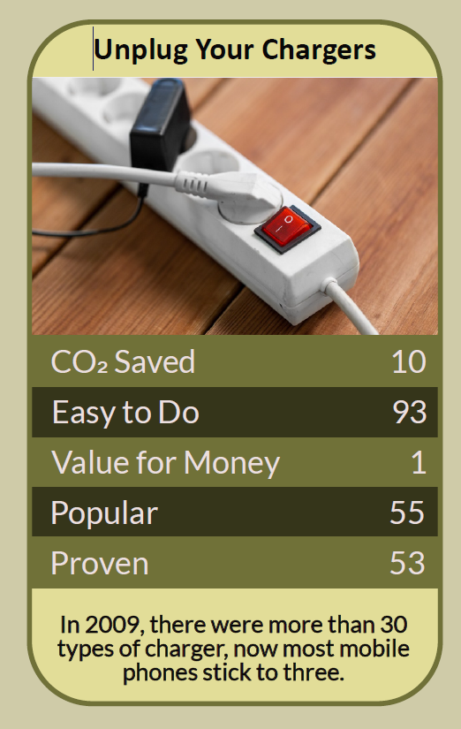

Before you begin  How To Use This Workbook | 

This workbook stands on its own. You need a walk round your home, your drawer of cables, a pen and a week or two of attention, and each part builds on the one before, so work through it in order.
It asks you to write, not just read.
Before you begin, choose one place where gadgets gather. It might be the living room TV corner, a desk, a bedside table or the kitchen counter. Don't switch off fridges, freezers, boilers, alarms or medical equipment, and charge e-bike and e-scooter batteries only with the right charger, while you're awake and nearby. You'll carry that one place through the exercise.

Write it here, so you have it to hand

Part one  The Teaching | 

David MacKay was a Cambridge physicist and later Chief Scientific Adviser to the UK Department of Energy and Climate Change. In 2008 he published Sustainable Energy – Without the Hot Air, a book that set out to replace slogans with numbers. Its most quoted line is a warning: 'If everyone does a little, we'll achieve only a little.'
The slightly uncomfortable claim underneath it is this: unplugging your phone charger, on its own, saves almost nothing. MacKay worked out that a day's saving from a charger left unplugged is about the energy a car uses in one second. Feeling virtuous about the small thing can stop us noticing the big ones. The good news is that the big ones are often sitting right next to the charger.
An empty charger uses very little. Modern chargers are efficient. Ecodesign rules in the UK and EU limit most small chargers to around a tenth of a watt with nothing attached, which adds up to pennies a year. Unplugging them is a fine habit, and safer for old or damaged chargers, but it isn't where the energy goes.
Standby is the bigger drain. TVs, set-top boxes, games consoles, sound bars, printers and computers left on standby use far more than a lonely charger. The Energy Saving Trust has estimated that standby can make up roughly 9 to 16% of a household's electricity, and that switching appliances off standby could save around £55 a year. A switched extension lead for the TV corner turns a dozen small drains into one switch.
Most of a phone's footprint comes before you charge it. Manufacturers' own life-cycle reports put most of a smartphone's lifetime carbon footprint in making it, from mining metals to assembly, not in years of charging. Keeping a phone, tablet or laptop for an extra year or two usually does far more good than any charging habit.
Look after the battery. Batteries wear out with heat and with being held at full charge for long periods. Use your device's battery-care or optimised charging setting, keep it out of hot cars and direct sun, and get a worn battery replaced rather than replacing the whole device.
One cable for most things. Since the end of 2024, new phones and many other small devices sold in the EU have had to use a USB-C socket, and most manufacturers have followed suit elsewhere. That means you probably already own the charger your next device needs, so say no to another one in the box.
Too much e-waste. Analysis of Global E-waste Monitor data put the UK's electrical waste at about 24 kg per person a year, second only to Norway. Old chargers and cables contain copper and other useful materials. Don't bin them: many shops that sell electricals take old ones back, and council recycling centres accept them.
Safe charging matters. Fake and very cheap chargers can overheat and start fires. Use the charger made for your device or a reputable replacement, charge on a hard surface rather than under a pillow or on a bed, and replace any charger or cable that is damaged, scorched or gets unusually hot.
The practical use of MacKay's warning is to put your effort where the numbers are. Unplug what you like, but switch off the big standby gadgets, keep your devices going longer, reuse the chargers you already have and recycle the rest. Small habits are welcome, as long as they lead to the bigger ones.

Part two  The Exercise | 

Take the place you chose at the start and carry it through the steps below. You'll need about two weeks. Write in full sentences. Nobody else reads this.
Make your guess. Write down how much you think the chargers and gadgets in your chosen place cost you in electricity each year. Then score from one to 10 how much difference you think unplugging your chargers would make.
How certain do you feel about that score? ① ② ③ ④ ⑤ ⑥ ⑦ ⑧ ⑨ ⑩

Audit the chargers. Count every charger and cable in your home, including the drawer. How many are in use, how many are spares, and how many belong to devices you no longer own?
Hunt for standby. In your chosen place, list every device that is on standby or shows a light when 'off'. Which ones could safely be switched off at the wall, and which need to stay on?

Make one change. Choose one change for this place, such as a switched extension lead for the TV corner, switching off at the wall at night, or a timer plug. Describe exactly what you'll do and try it for two weeks.
Make it last. Look at the phone or laptop you use most. How old is it? Turn on any battery-care setting, and find out what a battery replacement or repair would cost. How long could you realistically keep it?

Clear the drawer. Sort your spare chargers and cables into keep, give away and recycle. Find where you can take the recycling, then write down what you did and what you'll do when your next device arrives.
And how certain do you feel now? ① ② ③ ④ ⑤ ⑥ ⑦ ⑧ ⑨ ⑩

Part three  Questions For Discussion | 

Work through these questions independently if you must, but they are generally more beneficial when discussed.

- If unplugging chargers saves so little, why do you think it became such a popular green tip?
- Can small habits lead people on to bigger changes, or do they mostly let us feel we've done our bit?
- Should manufacturers be required to make batteries easy to replace and to supply spare parts for many years?
- Is it reasonable to expect people to keep a phone for five years when new models arrive every year?
- Who should pay to collect and recycle electrical waste: the maker, the shop, the council or the buyer?
- What other 'every little helps' tips might be distracting us from the bigger numbers in our lives?

Want To Take This Further With Other People?
You've sorted out one corner of your home. What's missing is everyone else's drawer of cables, and the shared skills that keep devices working for longer.

Run a cable amnesty  Collect spare chargers and cables at work, school or a community group. Test and pass on the ones that work, and take the rest for recycling together. |  | Visit a repair café  Many towns have volunteer repair cafés where people fix phones, laptops and lamps together. Take a device that needs help, or go along to learn and lend a hand.

Find your next challenge

climatechallenge.uk

