

Set Your
Heat Timer
Somewhere in your home there is a little box of buttons that decides when the heating comes on, and a dial that decides how warm it gets, and many of us haven't touched either since the day we moved in. More than three hundred years ago Isaac Newton described a simple rule of cooling that still explains why setting them well saves so much. Get the timer, the thermostat and the radiator valves working together and you can stay just as comfortable while burning less. This workbook asks you to find your controls, understand what each one does, and set them to fit the way you actually live.

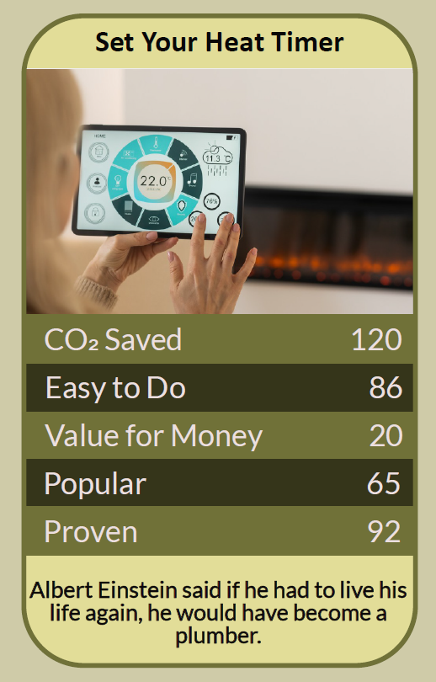

Before you begin  How To Use This Workbook | 

This workbook stands on its own. You need your heating controls, a pen and two weeks of ordinary life, and each part builds on the one before, so work through it in order.
It asks you to write, not just read.
Before you begin, choose one typical weekday in your home. Think about when people get up, go out, come back and go to bed. Only change the controls, never the boiler's insides. If anyone at home is elderly, very young or unwell, keep the rooms they use at 18°C or above. If you have a heat pump or underfloor heating, read the note in Part One before changing anything. You'll carry that one day through the exercise.

Write it here, so you have it to hand

Part one  The Teaching | 

In 1701 Isaac Newton published, anonymously, a short paper in the Philosophical Transactions of the Royal Society about measuring very high temperatures. In it he set out what we now call Newton's law of cooling: the rate at which a warm object loses heat is proportional to the difference between its temperature and that of its surroundings.
The slightly uncomfortable claim underneath it is this: a warm house leaks heat all the time, and the warmer it is compared with outside, the faster the heat pours out. Every hour your home is heated when nobody needs it, or heated a degree warmer than anyone needs, you are paying to warm the street. The controls on your wall are how you stop that.
On low all day isn't cheaper. Many people believe it's cheaper to leave a gas boiler on low all day than to let the house cool and heat it up again. Newton's rule shows why that's usually wrong: a house kept warm while empty loses heat faster, all day long, than one that's allowed to cool. For most homes with a gas or oil boiler, heating only when you need it uses less fuel.
The timer decides when; the thermostat decides how warm. The programmer or timer switches the heating on and off at set times. The room thermostat switches the boiler off once the room reaches the temperature you've set. Turning the thermostat right up doesn't heat the house any faster; it just lets it overshoot and waste heat.
Set the timer to your life. The Energy Saving Trust suggests setting the heating to come on about 30 minutes before you get up and go off about 30 minutes before you go to bed, and switching it off when the house is empty. Most programmers let you set different times for weekdays and weekends.
Find your lowest comfortable temperature. For most people a comfortable room thermostat setting is between 18°C and 21°C. The Energy Saving Trust estimates that turning it down from 22°C to 21°C can save around £120 a year in Great Britain. Try one degree lower for a week and see whether anyone actually notices.
Let each room find its level. Thermostatic radiator valves, the numbered dials on radiators, control each room separately, usually from 0 (off) to 6 (fully open). The Energy Saving Trust suggests 3 to 4 for the rooms you use most and 2 to 3 for bedrooms and rooms used less. Leave the radiator in the room with the main thermostat fully open, or the two controls will fight each other. Used together, a programmer, thermostat and radiator valves can save around £100 a year.
Heat pumps and underfloor heating are different. Heat pumps and underfloor heating work best running steadily at lower temperatures for longer, so the advice to switch off and heat up in short bursts doesn't apply in the same way. Follow your installer's advice, and don't let any home get so cold that damp and mould set in.
The practical use of Newton's law is that heat you don't need is heat you lose. Match the timer to when people are home and awake, set the thermostat to the lowest comfortable temperature, and let each room's valve do its job. Then leave them alone and let the controls work for you.

Part two  The Exercise | 

Take the day you chose at the start and carry it through the steps below. You'll need about two weeks. Write in full sentences. Nobody else reads this.
Find your controls. Find your programmer or timer, your room thermostat and your radiator valves. Write down where each one is and what it's set to now. Then score from one to 10 how well you understand what each one does.
How certain do you feel about that score? ① ② ③ ④ ⑤ ⑥ ⑦ ⑧ ⑨ ⑩

Map your day. For the typical weekday you chose, write down when people get up, go out, come home and go to bed. When is the house empty? Which rooms are used, and when? Do weekends look different?
Set the timer. Set the timer to match your day: on about 30 minutes before people get up, off when the house empties, on again before people come home, and off about 30 minutes before bed. Write down the times you chose.

Set the thermostat and valves. Turn the room thermostat down by one degree, or to the lowest comfortable setting between 18°C and 21°C. Set each radiator valve to suit how its room is used. Write down every setting so you can compare later.
Live with it for two weeks. Keep the new settings for two weeks. Note how comfortable everyone feels, any complaints, and, if you can, your gas meter readings or smart meter figures. Did anyone notice the change?

Review and adjust. Decide what to keep, what to tweak and what to change back, and why. Write a short note of the final settings and put it by the controls so everyone at home knows how they work.
And how certain do you feel now? ① ② ③ ④ ⑤ ⑥ ⑦ ⑧ ⑨ ⑩

Part three  Questions For Discussion | 

Work through these questions independently if you must, but they are generally more beneficial when discussed.

- Why do so many people never change their heating controls after they move in?
- Who should decide the thermostat setting in a shared home, and how should disagreements be settled?
- Should landlords be required to fit and explain proper heating controls in every rented home?
- Is it reasonable to ask people to feel slightly cooler at home to cut emissions, or should the focus be on insulation and new heating systems?
- Smart thermostats learn our habits and can be controlled from a phone. Are they worth the cost, and what do we give up by using them?
- How would you explain Newton's law of cooling to someone who is sure that leaving the heating on low is cheaper?

Want To Take This Further With Other People?
You've set your own controls. What's missing is everyone else who has never touched theirs, and who might be paying for heat they don't need.

Help someone set theirs  Offer to help a parent, grandparent or neighbour find and set their heating controls. Write the settings on a card by the controls so they can change them with confidence. |  | Ask for better controls  If you rent, or your home lacks a timer, thermostat or radiator valves, ask your landlord or housing provider to fit them, and look for local energy advice services that can help.

Find your next challenge

climatechallenge.uk

