

Choose A
Smaller Pet
We love our pets, and we rarely think of them as part of our carbon footprint. In their 2009 book Time to Eat the Dog?, architects Robert and Brenda Vale argued that feeding a medium-sized dog could have an environmental footprint comparable to running a large car. Their comparison is debated, but the point behind it holds: pets eat a lot of meat, and bigger animals eat more. This workbook asks you to look kindly and honestly at the footprint of the pet you have or the one you're planning, and to commit to the next three things you will change.
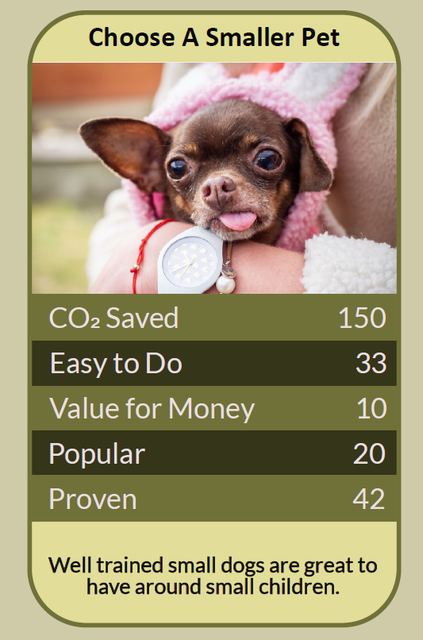


Before you begin  How To Use This Workbook | 

This workbook stands alone. You need nothing else to use it except your pet's food packet, a week of noticing, and, if you're planning a pet, an honest look at your home and routine.
It asks you to write, not just read.
Before you begin, choose one pet: the one you have now, or the one you’re thinking of getting. This workbook is never a reason to give up an animal you already care for; the kindest and greenest thing you can do for a pet you have is to look after it well for its whole life. You'll carry that one pet through the exercise.

Write your first thoughts here, so you can come back to them later

This worksheet is part of the Climate Challenge series of action workbooks.

Part one  The Teaching | 

The idea at the heart of this workbook comes from Robert and Brenda Vale, two architects and sustainability researchers, in their 2009 book Time to Eat the Dog? The Real Guide to Sustainable Living. By estimating how much land it takes to grow the food a pet eats, they argued that the footprint of a medium-sized dog could rival that of a large car driven for a year.
Underneath it sits a slightly uncomfortable claim. Most of a pet's footprint is its food, and most pet food is meat. The size of the animal, and the amount and kind of food it eats, matter far more than anything else we buy for it.
Pets eat meat. Dogs and cats eat a great deal of meat and fish between them. In 2017, Gregory Okin of the University of California, Los Angeles, estimated that cats and dogs in the United States account for around a quarter to a third of the environmental impact of the country's animal farming. Pet food is a meat diet on a national scale.
Size multiplies everything. A bigger animal eats more food every day of its life, and needs more space, bigger beds and more of everything else. A rabbit, guinea pig or small bird eats a plant-based diet in small quantities. Even among dogs, a small breed eats a fraction of what a giant breed does over a lifetime.
Feed right, not more. Many pets in the UK are overweight, which harms their health as well as the planet. Feeding the right amount, by weighing food and following your vet's advice on ideal weight, cuts waste and helps your pet live longer. Premium “human-grade” foods often use cuts of meat people would otherwise eat, while standard foods make use of by-products that would otherwise be wasted.
Count the extras. Beyond food come cat litter, poo bags, toys, accessories and car trips to walks and vets. Flea and tick treatments matter too: researchers at the University of Sussex have found chemicals used in pet flea treatments widely in English rivers. Talk to your vet about treating when it's needed, rather than stopping treatments on your own.
Think about wildlife. Pet cats catch large numbers of birds, small mammals and amphibians each year. Keeping cats in at night, especially around dawn and dusk, and playing with them more can reduce hunting. Dogs off the lead can disturb ground-nesting birds and livestock, so keep them close in the countryside in spring.
The kindest choice is a lasting one. Every pet deserves proper care for its whole life, and small animals have complex needs too: rabbits and guinea pigs need space, company and daily attention. Choosing a smaller pet only makes sense if it suits your home and time. Adopting from a rescue centre, fostering or sharing care of a neighbour's dog can give you animal company without bringing a new animal into the world.
The practical use of the Vales' argument is not guilt but planning. For the pet you have, feed the right amount of a sensible food, cut the extras and protect wildlife. For the pet you're thinking of, choose the smallest animal that genuinely suits your life, consider adopting rather than buying, and be ready to care for it for its whole life. And before changing your pet's diet, never switch a cat to a meat-free diet, and always talk to your vet first.

Part two  The Exercise | 

Take the pet you chose at the start and carry it through the steps below over the coming week. Write in full sentences. Nobody else reads this.
Describe your pet. What kind of animal is it, how big, and how old? Why did you choose it, or why do you want it? What does it give you and your household? Score how much you know about your pet's environmental footprint, from 1 (I've never thought about it) to 10 (I know it well).
How certain do you feel about that score? ① ② ③ ④ ⑤ ⑥ ⑦ ⑧ ⑨ ⑩

Read the food label. What is your pet's food made from, and how much does it eat each day and each week? Weigh a portion and compare it with the feeding guide for your pet's ideal weight. Is your pet being fed the right amount, and is it a healthy weight?

List the extras. For one week, note everything else your pet uses: litter, bags, treats, toys, treatments, car journeys, grooming. Which of these could you cut, swap for a lower-impact version or share with someone else?

Think about wildlife and water. If you have a cat, how often does it bring home prey, and when does it go out? If you have a dog, how do you handle walks, poo and bathing after flea treatment? Write one change that would help local wildlife or rivers.

Plan the next pet. If you're thinking of another pet in future, what would genuinely suit your home, your time, your budget and your footprint? Could you adopt from a rescue, foster, or share care of someone else's animal instead? Write down what you'd look for and what you'd rule out.

Make your plan. Write three actions: one you will do this week, one you will do or discuss with your vet this year, and one decision for the future, such as the size of your next pet. Name who else is involved — household, vet, rescue centre — and when you'll start.

How certain are you that your plan will stick? ① ② ③ ④ ⑤ ⑥ ⑦ ⑧ ⑨ ⑩

Part three  Questions For Discussion | 

Work through these questions independently if you must, but they are generally more beneficial when discussed.

- The Vales compared a dog's footprint to a large car's. Is that a fair comparison, a useful provocation, or both?
- Pets bring companionship, exercise and comfort that many people deeply need. How should those benefits be weighed against their footprint, and who gets to decide?
- Keeping cats indoors protects wildlife but may limit the cat's natural behaviour. Where is the right balance between animal welfare and wildlife?
- Should breeders of very large or fashionable breeds carry some responsibility for the environmental and welfare costs of the animals they produce?
- Is it ever right to feed a meat-eating pet a meat-free diet for the planet's sake? Where do your pet's needs end and your values begin?
- Could sharing pets — fostering, dog-sharing schemes, community animals — meet people's need for animal company with fewer animals? What would be lost?

Want To Take This Further With Other People?
You've done the reading and the thinking on your own. What's missing now is someone who sees your pet, and your choices, differently — and who might share walks, pet-sitting or advice on the animal that would really suit your life.

Share your plan online  Join an online climate action community and post your pet's food and extras review and your three-step plan. Other pet owners will have tried the foods, litters and routines you're considering, and will tell you honestly what worked for their animals. |  | Find people near you  Talk to your vet about your pet's ideal weight and treatments. Visit a local rescue centre to ask about adopting or fostering, and look for dog-sharing or pet-sitting arrangements with neighbours. Join a local wildlife group to learn about the animals around your home.

Find your next challenge

This workbook is general guidance, not veterinary advice. Talk to your vet before changing your pet's diet or treatments.

climatechallenge.uk

