

Grow Your
Veggies
A bag of salad leaves can travel hundreds of miles, sit in a fridge for days, and still end up wilting in the bin. Charles Dowding, a Somerset grower who has gardened without digging since the 1980s, has shown through decades of books and trials that a small no-dig bed can produce heavy crops while keeping carbon locked in the soil. You don't need a farm, or even a garden: a windowsill, a balcony or a corner of a yard is enough to start. This workbook asks you to look at the space you have, and to commit to the first three things you will grow.
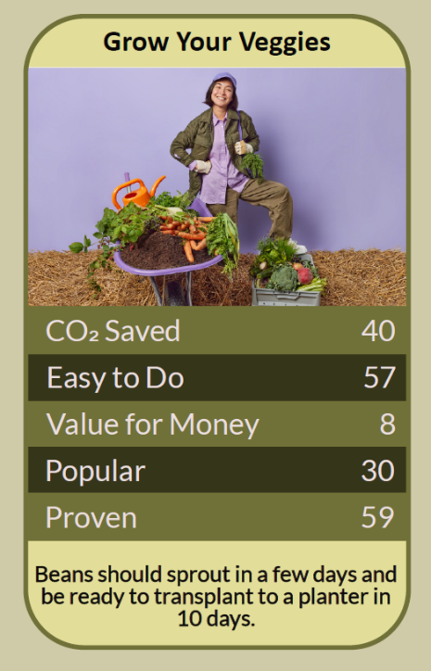


Before you begin  How To Use This Workbook | 

This workbook stands alone. You need nothing else to use it except a space you could grow in and a few minutes over the coming week to watch it.
It asks you to write, not just read.
Before you begin, choose one space you could grow food in. It might be a windowsill, a balcony, a patch of garden, a few pots by the door or an allotment. Choose somewhere you can reach easily and have permission to use. You'll carry that one space through the exercise.

Write your first thoughts here, so you can come back to them later

This worksheet is part of the Climate Challenge series of action workbooks.

Part one  The Teaching | 

The idea at the heart of this workbook is no-dig growing, championed by Charles Dowding, who has run market gardens in Somerset without digging since the 1980s and set out the method in a long series of books and side-by-side trials. Instead of turning the soil each year, you leave it undisturbed and spread compost on top, letting worms and soil life do the work.
Underneath it sits a slightly uncomfortable claim. Much of what we think of as good gardening — digging, tidying, buying in products — is work we don't need to do, and some of it harms the soil we depend on. Growing food can be simpler, smaller and lower-carbon than we expect.
Soil is alive. Healthy soil is full of fungi, bacteria, worms and insects that hold it together, feed plants and store carbon. Digging breaks up that structure, releases carbon and brings weed seeds to the surface. Leaving soil undisturbed and adding compost on top feeds soil life and keeps carbon where it belongs.
Small spaces give real yields. You don't need much room. Research by the University of Sheffield's MYHarvest project has found that home and allotment growers can produce yields per square metre comparable to commercial farms. A single well-tended bed or a few large pots can supply salads, herbs and beans for months.
Watch the hidden costs. Growing your own isn't automatically low-carbon. A 2024 study in Nature Cities found that the materials used to build growing spaces — new raised beds, paths, sheds and plastics — often make up most of their footprint. Reuse what you can, build things to last, and avoid driving to tend your plot.
Go peat-free and make compost. Peat bogs are one of the UK's biggest natural carbon stores, and digging them up for compost releases that carbon. Choose peat-free compost, and make your own from kitchen scraps, garden waste and cardboard. A compost bin or wormery turns waste into the food your plants need.
Grow what's worth growing. Some crops save far more than others. Salad leaves, herbs, beans, tomatoes and soft fruit are expensive, perishable and often wasted when bought, but quick and productive to grow. Potatoes and onions are cheap to buy and take up a lot of space. Grow what you eat, and what you'd otherwise throw away half of.
Work with water and wildlife. Collect rainwater in a water butt, mulch the soil to hold moisture, and water at the roots in the morning or evening. Skip pesticides, plant some flowers among your vegetables, and welcome birds, frogs and insects: they're your pest control and your pollinators.
The practical use of no-dig is to start small and let the soil do the work. Choose one space, cover it with compost or fill a few containers, and grow two or three crops you'll really eat. Reuse materials, make your own compost and collect rainwater. If you have no space at all, put your name down for an allotment, or look for a community garden, where you'll find land, tools and people who'll share what they know.

Part two  The Exercise | 

Take the space you chose at the start and carry it through the steps below over the coming week. Write in full sentences. Nobody else reads this.
Describe your space. Where is it, how big is it, and what's there now: soil, paving, pots, a windowsill? How easily can you reach water? Who else uses it? Score how ready you feel to grow food there, from 1 (not at all) to 10 (I could start tomorrow).
How certain do you feel about that score? ① ② ③ ④ ⑤ ⑥ ⑦ ⑧ ⑨ ⑩

Watch the light. On three different days, check your space in the morning, at midday and in the evening. When does it get direct sun, and for how long? Is it sheltered or windy? Most fruiting crops need six hours of sun; leafy greens and herbs can manage with less.

Choose your crops. List five vegetables, salads or herbs you eat often, buy at a high price or often throw away. Which of them suit your space, light and the time of year? Circle the two or three you'll start with.

Find your materials. What could you reuse: containers, old buckets, cardboard for smothering weeds, kitchen scraps for compost, a water butt? Write down what you already have and the few things you'd genuinely need to buy or borrow.

Plan your calendar. For each crop you've chosen, find out when to sow or plant, and when you'll harvest. What could you sow or plant this month? Write your first sowing date and when you'd expect your first harvest.

Make your plan. Write three actions: one you will do this week, one you will do this season, and one bigger step, such as joining an allotment waiting list, a community garden or a seed swap. Name anyone else involved and when you'll start.

How certain are you that your plan will happen? ① ② ③ ④ ⑤ ⑥ ⑦ ⑧ ⑨ ⑩

Part three  Questions For Discussion | 

Work through these questions independently if you must, but they are generally more beneficial when discussed.

- Allotment waiting lists in many towns run for years. Who should provide land for people to grow food, and should it be a right?
- Should councils turn some parks, verges and unused land over to food growing? What would be gained, and what would be lost?
- Growing your own takes time, space and some money to start. Is it a realistic climate action for everyone, or mainly for people who already have those things?
- During the Second World War, the Dig for Victory campaign turned lawns and parks into vegetable plots. Could a campaign like that work today? What would it need?
- If more people grew their own vegetables, what would that mean for farmers and growers who depend on selling them?
- Is the biggest benefit of growing food the carbon saved, or what it teaches us about where food comes from? Which matters more to you?

Want To Take This Further With Other People?
You've done the looking and the planning on your own. What's missing now is someone who sees your space differently — and who might share seeds, tools, spare plants and the harvest when it comes.

Share your plot online  Join an online climate action community and post your space, your chosen crops and your three-step plan. Other growers will know what thrives on a shady balcony or in a windy yard, and will cheer you on when the first leaves appear. Saying your plan out loud is one of the simplest ways to follow through. |  | Find people near you  Look for an allotment society, community garden, food-growing group or seed swap near you. Ask your council about allotment waiting lists. Neighbours with gardens are often glad to share space, seedlings or a glut of courgettes.

Find your next challenge

This workbook is general guidance. Wear gloves when handling soil and compost, and wash produce before eating.

climatechallenge.uk

