

Take A Virtual
Holiday
You scroll through photos of a beach on the other side of the world and feel the pull to book a flight. In 1794, confined to his room for 42 days, the French writer Xavier de Maistre wrote A Journey Around My Room, a playful argument that the spirit of travel lies in how we look, not how far we go. For people who fly, flights are often the largest single part of their carbon footprint. This workbook asks you to find out what you really want from a holiday, plan one without leaving home, and commit to the next three things you will change.
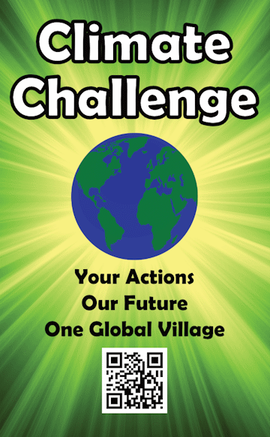
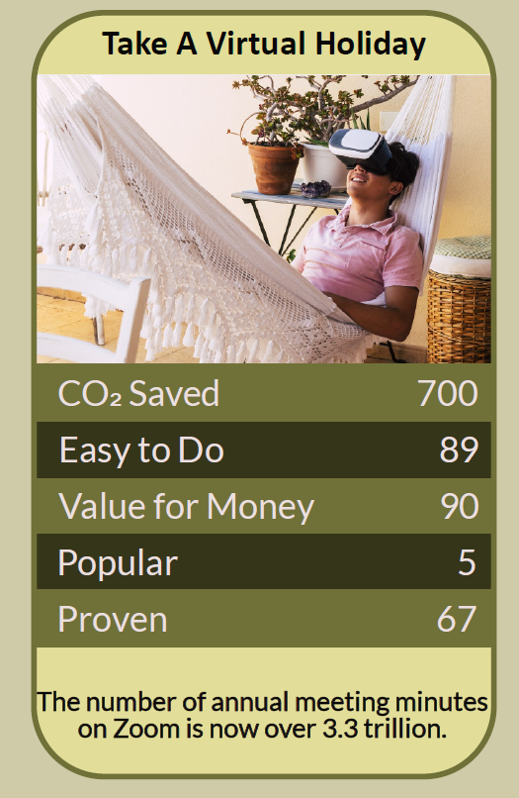

Before you begin  How To Use This Workbook | 

This workbook stands alone. You need nothing else to use it except an internet connection, a few free evenings and some curiosity.
It asks you to write, not just read.
Before you begin, choose one place you would love to visit. It might be a city, a coastline, a mountain range or a whole country. Choose somewhere you'd normally fly to, rather than somewhere you can reach easily by train. You'll carry that one place through the exercise.

Write your first thoughts here, so you can come back to them later

This worksheet is part of the Climate Challenge series of action workbooks.

Part one  The Teaching | 

The idea at the heart of this workbook comes from Xavier de Maistre, a French officer and writer who, placed under house arrest after a duel, spent 42 days exploring his own bedroom and wrote about it in A Journey Around My Room, published in 1794. Two centuries later, Alain de Botton returned to it in The Art of Travel, arguing that what makes travel rewarding is the attentive, curious frame of mind we bring to it.
Underneath it sits a slightly uncomfortable claim. Much of what we want from a holiday — rest, novelty, beauty, learning, time together — doesn't actually require a plane. We fly because it's the familiar way to get those things, not always because it's the only way.
Travel is a state of mind. De Maistre's point was that we notice the world most when we decide to look at it as travellers. The same attention we give a foreign street — to its food, its sounds, its people, its history — can be turned on a place we explore from home, or on the place we already live.
Flying is the big one. For people who take flights, flying is often the largest single part of their personal carbon footprint, and long-haul flights most of all. One fewer flight can save more carbon than many smaller everyday changes put together.
Name the need. Before choosing a holiday, ask what you really want from it. Rest needs quiet and time off. Novelty needs new food, music and ideas. Connection needs time with people you love. Once you know the need, you can look for the lowest-carbon way to meet it.
Anticipation is half the pleasure. A study of Dutch holidaymakers led by Jeroen Nawijn, published in 2010, found that people were happiest before their trips, while looking forward to them, and that the happiness boost after returning faded quickly. Planning, reading and dreaming are a real part of the experience, and they're free of carbon.
Learn from the people who live there. A virtual holiday is most rewarding when it brings you closer to a place's people, not just its postcard views. Read novels by its writers, cook from its cooks, listen to its musicians, watch its films, and learn a few words of its language.
Virtual isn't forever. A virtual holiday doesn't mean never travelling again. It can replace one flight, be a taster that helps you choose a trip worth taking, or make a slower journey by train or ferry feel like part of the adventure. The aim is fewer, longer, better-chosen trips.
The practical use of de Maistre's idea is to plan a holiday as seriously as you would a real one, then take it at home. Choose your place, set the dates, block out the time, and fill each day with a different way in: a meal, a film, a virtual museum, a street-level walk on an online map, a live webcam, a book, a playlist, a few phrases. Then ask what you got, and what you still want from going in person.

Part two  The Exercise | 

Take the place you chose at the start and carry it through the steps below. Write in full sentences. Nobody else reads this.
Describe the dream. Where do you want to go, and why there? What do you picture yourself doing, seeing, eating and feeling? Score how much you believe you need to be there in person to get what you want from it, from 1 (not at all) to 10 (completely).
How certain do you feel about that score? ① ② ③ ④ ⑤ ⑥ ⑦ ⑧ ⑨ ⑩

Name your need. Rank what you want from this holiday: rest, sunshine, novelty, food, culture, nature, adventure, time with others, a story to tell. Which one or two matter most? Which could you meet without flying?

Plan the itinerary. Design a virtual holiday of three to seven days. For each day, choose one way in: a dish to cook, a film or series, a virtual museum or gallery, a street-level walk, a live webcam, a novel or poetry by a local writer, music, or a language lesson. Write out the days.

Set the scene. How will you make it feel like a holiday rather than an evening on the sofa? Decide the dates, who will join you, what you'll switch off, what you'll eat and how you'll mark the start and finish. What will you do with the money you save?

Take it, then reflect. After your virtual holiday, write about it honestly. What did you enjoy, learn or feel? What fell flat? Which of your needs were met, and which still feel unmet?

Make your plan. Write three actions: one you will do this month, one change to how you plan holidays this year, and one decision about your next trip, such as going by train, staying longer or swapping a flight for a virtual or nearer holiday. Name who's involved and when you'll start.

How much do you now feel you need to go there? ① ② ③ ④ ⑤ ⑥ ⑦ ⑧ ⑨ ⑩

Part three  Questions For Discussion | 

Work through these questions independently if you must, but they are generally more beneficial when discussed.

- Many communities around the world depend on income from tourists who arrive by plane. If we fly less, what do we owe them, and how could we support them in other ways?
- Is a virtual holiday a genuine experience, or a poor copy of the real thing? What, if anything, can only be had by being there?
- A small share of people take most of the world's flights. Should frequent flyers pay more, through a levy that rises with each flight they take?
- Could seeing a place on screen make us want to go there more, not less? How would you stop a virtual holiday becoming an advert for a real one?
- Travel has long been seen as a way to understand other cultures. If we travel less, how else can we build that understanding?
- Why do holidays abroad carry so much status? What would it take for a train trip or a staycation to feel just as special?

Want To Take This Further With Other People?
You've done the dreaming and the planning on your own. What's missing now is someone who sees travel differently — and who might cook the food, watch the films or plan the slow journey with you.

Share your itinerary online  Join an online climate action community and post your virtual holiday itinerary and your three-step plan. Others will have favourite virtual tours, films, recipes and train routes to share, and will want to hear what your holiday was like. |  | Find people near you  Invite friends or family to join your virtual holiday for a meal or a film night. Look for a local language café, book club, cultural society or cookery class linked to the place you love. Your library may also offer free online language courses.

Find your next challenge

This workbook is general guidance. Take care online, and never share personal or payment details with sites you don't know.

climatechallenge.uk

