

Wear A
Jumper
It's a chilly evening, you're sitting in a T-shirt, and your hand reaches for the thermostat. In 1970, the Danish engineer Povl Ole Fanger published Thermal Comfort, showing that how warm we feel depends on six things, and that the clothes we wear count just as much as the temperature of the air. Heating whole rooms to summer temperatures is one of the biggest parts of many households' carbon footprint. This workbook asks you to look at how you keep warm at home, and to commit to the next three things you will change.
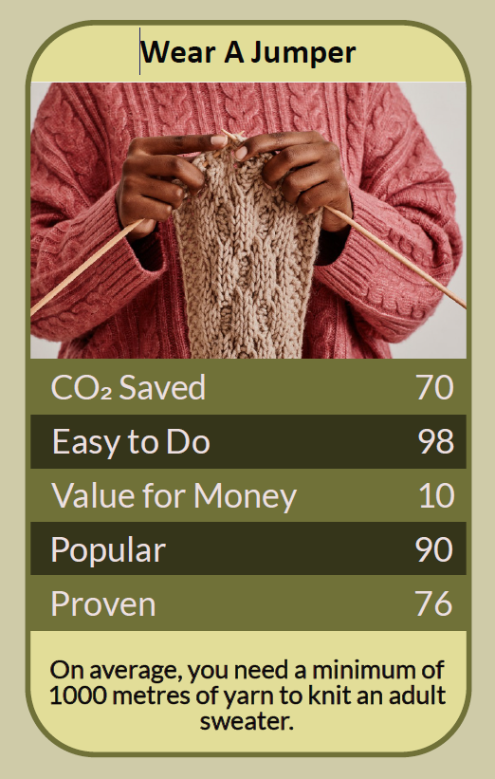


Before you begin  How To Use This Workbook | 

This workbook stands alone. You need nothing else to use it except a room thermometer, your warmest clothes and a week of winter evenings.
It asks you to write, not just read.
Before you begin, choose one room and one time of day. It might be the living room in the evening or a home office during the day. If anyone in your home is very young, older, or has a health condition that makes cold dangerous, keep their rooms warm and check with a health professional before turning the heating down. You'll carry that one room through the exercise.

Write your first thoughts here, so you can come back to them later

This worksheet is part of the Climate Challenge series of action workbooks.

Part one  The Teaching | 

The idea at the heart of this workbook is thermal comfort, as set out by Povl Ole Fanger, a professor at the Technical University of Denmark, in his 1970 book Thermal Comfort. Fanger showed that whether we feel comfortable depends on six factors: air temperature, the temperature of surrounding surfaces, air movement, humidity, how active we are, and what we're wearing. His model still underpins international standards for heating buildings.
Underneath it sits a slightly uncomfortable claim. Much of the time, we heat the whole house to make up for what we're not wearing. A jumper is insulation you carry with you, and it costs nothing to run.
Comfort has six ingredients. Air temperature is only one of Fanger's six factors. You can feel cold in a warm room if you're sitting still by a draughty window in thin clothes, and comfortable in a cooler one if you're dressed warmly, out of draughts and moving about. Change the other ingredients, and you need less heat.
Clothing is insulation you wear. Engineers measure the warmth of clothing in a unit called the clo. Adding a thick jumper, warm socks and slippers raises the clo value of what you're wearing noticeably, which means you can feel just as comfortable with the room a degree or two cooler. Layers work best, because each one traps a layer of still, warm air.
Heat people, not rooms. It takes far less energy to warm a person than to warm a whole room. A hot-water bottle, a blanket, a warm drink, a heated throw or getting up to move around all warm you directly. Heating a whole house so that one person can sit still in a T-shirt is the expensive way round.
Mind the cold surfaces. Cold windows, outside walls and floors draw heat from your body even when the air is warm. Closing curtains at dusk, putting down a rug, blocking draughts and moving your chair away from a cold window can make a room feel warmer without touching the thermostat.
Every degree counts. Heating uses more energy the bigger the difference between inside and outside. The Energy Saving Trust estimates that turning your thermostat down by just one degree can make a real difference to your heating bill and carbon footprint, and most people barely notice the change once they're dressed for it.
Warm enough is a health matter. Cold homes can harm health, especially for babies, older people and anyone who is ill or less mobile. Public health guidance in England suggests keeping the rooms you live in at around 18°C or warmer, and very cold homes are also more prone to damp and mould. The aim is to waste less heat, not to be cold.
The practical use of Fanger's model is to change the easy ingredients first. Dress for the season indoors: a jumper, warm socks and slippers. Cut draughts and close the curtains. Warm yourself directly when you're sitting still. Then, if it's safe for everyone in your home, try turning the thermostat down by one degree and see whether anyone notices. If you're struggling to afford to heat your home, contact your energy supplier or council about the help that's available.

Part two  The Exercise | 

Take the room and time you chose at the start and carry them through the steps below over the coming week. Write in full sentences. Nobody else reads this.
Describe how you keep warm. What is your thermostat set to, and when is the heating on? What do you usually wear at home on a winter evening? Who in your household feels the cold most? Score how much you rely on heating rather than clothing to keep warm, from 1 (mostly clothing) to 10 (entirely heating).
How certain do you feel about that score? ① ② ③ ④ ⑤ ⑥ ⑦ ⑧ ⑨ ⑩

Check the thermometer. Put a room thermometer in your chosen room at sitting height, away from radiators and windows. Read it at the same time each day for a few days. How does it compare with your thermostat setting, and how do you feel at that temperature?

Audit your layers. Write down exactly what you wear in that room at that time. What warm clothes do you already own but rarely wear indoors: jumpers, cardigans, thermals, thick socks, slippers? What one item would make the biggest difference?

Find the cold spots. Sit where you usually sit and notice where cold comes from: a draught, a window, the floor, an outside wall. What could you change — curtains, a rug, a draught excluder, moving your chair — to feel warmer without more heat?

Try one degree lower. If it's safe for everyone in your home, turn the thermostat down by one degree for a week and wear a jumper. Each evening, note how comfortable you felt, what you wore and whether anyone noticed. What happened?

Make your plan. Write three actions: one you will do tonight, one you will do this winter, and one bigger change, such as a new thermostat setting, better curtains or a household agreement about jumpers before heating. Name who else needs to agree, and when you'll start.

How certain are you that your plan will stick? ① ② ③ ④ ⑤ ⑥ ⑦ ⑧ ⑨ ⑩

Part three  Questions For Discussion | 

Work through these questions independently if you must, but they are generally more beneficial when discussed.

- “Just put on a jumper” can sound dismissive to someone who can't afford to heat their home. How can we encourage people to use less heat without blaming those already struggling?
- A 2015 study suggested that office temperature standards were based on the metabolic rate of an average man, leaving many women feeling cold. Who should comfort standards be designed around?
- Many workplaces are heated so that people can wear the same clothes all year round. Should dress codes change with the seasons to save energy?
- When did it become normal to wear a T-shirt indoors in winter? What would it take to change that expectation?
- In a shared household, one person's comfort can be another's discomfort. How should a household decide what temperature to keep?
- If everyone wore warmer clothes indoors, more jumpers would be made and bought. How do we keep warm without simply buying more?

Want To Take This Further With Other People?
You've done the measuring and the thinking on your own. What's missing now is someone who sees warmth differently — and who might lend you a thermometer, knit you a jumper or agree on a household temperature with you.

Share your week online  Join an online climate action community and post your one-degree-lower week and your three-step plan. Others will share the layers, habits and draught fixes that keep them warm, and will cheer you on through the coldest evenings. |  | Find people near you  Look for a knitting group, clothes swap or charity shop for warm second-hand layers. Ask your council or a local energy advice service about help with draughts and heating costs. Check in on older neighbours during cold spells.

Find your next challenge

This workbook is general guidance, not medical advice. Keep living rooms at a safe temperature, especially for babies, older people and anyone unwell.

climatechallenge.uk

