

Conserve
Water
In a rainy country, water can feel endless: you turn the tap, it flows, and you never think about where it came from or where it goes. In 2002, Dutch researcher Arjen Hoekstra introduced the water footprint, a way of counting all the water we use, both from the tap and hidden in the food and goods we buy. Parts of England already face water stress, and heating water is one of the biggest energy uses in many homes. This workbook asks you to measure your own water use, and to commit to the next three things you will change.
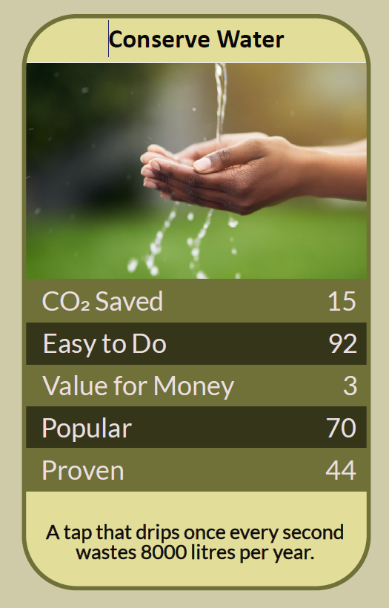


Before you begin  How To Use This Workbook | 

This workbook stands alone. You need nothing else to use it except a one-litre jug, a timer, your water meter if you have one, and a week of noticing.
It asks you to write, not just read.
Before you begin, choose one daily water routine. It might be your shower, flushing the toilet, washing up, doing the laundry or watering the garden. Choose something you do most days and could realistically change. You'll carry that one routine through the exercise.

Write your first thoughts here, so you can come back to them later

This worksheet is part of the Climate Challenge series of action workbooks.

Part one  The Teaching | 

The idea at the heart of this workbook is the water footprint, introduced in 2002 by Arjen Hoekstra, a professor of water management at the University of Twente in the Netherlands, who later founded the Water Footprint Network. It counts not only the water we use directly at home, but also the water used to grow our food and make the things we buy.
Underneath it sits a slightly uncomfortable claim. The water we see is only a small part of the water we use. Most of our footprint is hidden in our shopping, and much of the water we do see from the tap is heated, pumped and treated using energy we never think about.
Know your daily use. On average, each person in England uses roughly 140 litres of water a day at home, and the government has set a target of bringing that down to 110 litres by 2050. Showers, toilets, washing machines and taps make up most of it. You can't cut what you haven't measured, and a water meter or a simple jug-and-timer test shows you where yours goes.
Hot water is energy. Heating water is one of the largest uses of energy in many homes, after space heating. A long, hot shower uses both water and the gas or electricity to heat it. Shorter showers, efficient shower heads and full loads in the washing machine cut both at once.
Clean water costs energy too. Every litre from your tap has been collected, treated, pumped and tested, and every litre down the drain has to be pumped and treated again. Saving cold water saves the energy and carbon that go into that whole system.
Leaks waste quietly. A dripping tap or a toilet that leaks into the bowl can waste a surprising amount of water every day, often without anyone noticing. Many leaks are easy and cheap to fix, and water companies will investigate leaks on their side of the meter.
Most water is hidden. Hoekstra's work showed that the water used to produce food and goods dwarfs what we use at home. A single cotton T-shirt can take thousands of litres to grow and make, and meat, especially beef, has a far larger water footprint than most plant foods. Much of this water comes from countries that are already short of it.
Water is shared with nature. England's rivers, including its rare chalk streams, and the wildlife that depends on them, need water too. The Environment Agency has warned that England faces a growing gap between the water available and the water needed by the middle of the century unless we use less and waste less.
The practical use of the water footprint is to look at both the water you see and the water you don't. At home, measure your use, fix leaks, shorten showers, run full loads and collect rainwater for the garden. Many water companies offer free water-saving devices, such as shower timers and cistern bags. Beyond the home, buy fewer new clothes, waste less food and choose foods with smaller water footprints when you can.

Part two  The Exercise | 

Take the routine you chose at the start and carry it through the steps below over the coming week. Write in full sentences. Nobody else reads this.
Describe your water day. Walk through an ordinary day and list every time you use water: showers, toilets, taps, cooking, washing up, laundry, garden, car. Which uses do you think are biggest? Score how well you know how much water you use, from 1 (no idea) to 10 (I could tell you in litres).
How certain do you feel about that score? ① ② ③ ④ ⑤ ⑥ ⑦ ⑧ ⑨ ⑩

Read the meter. If you have a water meter, read it first thing one morning and again the next morning. How many litres did your household use in a day, and how much is that per person? If you don't have a meter, estimate from the steps below.

Measure your routine. Time how long it takes your shower or tap to fill a one-litre jug, and work out its flow in litres per minute. Then time your usual shower, washing-up or other routine. How many litres does it use each time, each week and each year?

Hunt the leaks. Check every tap for drips. Put a few drops of food colouring in your toilet cistern and wait fifteen minutes without flushing: if colour appears in the bowl, the cistern is leaking. If you have a meter, read it last thing at night and first thing in the morning without using any water. What did you find?

Look at the hidden water. Think about one week's food and one recent clothing purchase. Which items are likely to have the largest water footprints? Write down one swap you could make in your shopping that would cut your hidden water use.

Make your plan. Write three actions: one you will do today, one you will do this month, and one bigger change, such as a water meter, a water butt, an efficient shower head or a household shower-time agreement. Name who else needs to agree, and when you'll start.

How certain are you now about your water use? ① ② ③ ④ ⑤ ⑥ ⑦ ⑧ ⑨ ⑩

Part three  Questions For Discussion | 

Work through these questions independently if you must, but they are generally more beneficial when discussed.

- Water companies lose large amounts of water through leaking pipes. Is it fair to ask households to save water while that continues? Who should act first?
- Water meters help people save, but can cost more for large families. How could metering be made fair for everyone?
- Should every new home be built to collect rainwater and reuse water from sinks and showers? Who should pay for it?
- In a drought, should water go first to homes, farms, businesses or rivers and wildlife? How would you decide?
- The UK imports food and clothes grown with water from countries that are short of it. What responsibility do we have for that hidden water?
- Water feels cheap and endless in a rainy country. What would it take for people to value it more, without making it unaffordable?

Want To Take This Further With Other People?
You've done the measuring and the thinking on your own. What's missing now is someone who sees water differently — and who might share a water butt, a shower timer challenge or the job of fixing a dripping tap.

Share your numbers online  Join an online climate action community and post your daily litres, your leak hunt and your three-step plan. Others will share the devices, habits and garden tricks that cut their use. Saying your plan out loud is one of the simplest ways to make sure you follow through. |  | Find people near you  Ask your water company about free water-saving devices and home water checks. Look for a local river trust or wildlife group protecting your nearest stream. Share water butts, rain gardens and tips with neighbours and community gardens.

Find your next challenge

This workbook is general guidance. Leave anything beyond simple plumbing jobs to a qualified plumber, and report leaks outside your home to your water company.

climatechallenge.uk

