

Install A
Heat Pump
Most of us only think about our heating when the boiler breaks down, and then we replace it like for like, locking in another fifteen years of burning gas. In 1852, the physicist William Thomson, later Lord Kelvin, described a machine that could warm a building by moving heat from the outside air rather than burning fuel. Today's heat pumps do exactly that, delivering around three units of heat for every unit of electricity they use. This workbook asks you to find out whether your home is ready for one, and to commit to the next three steps.

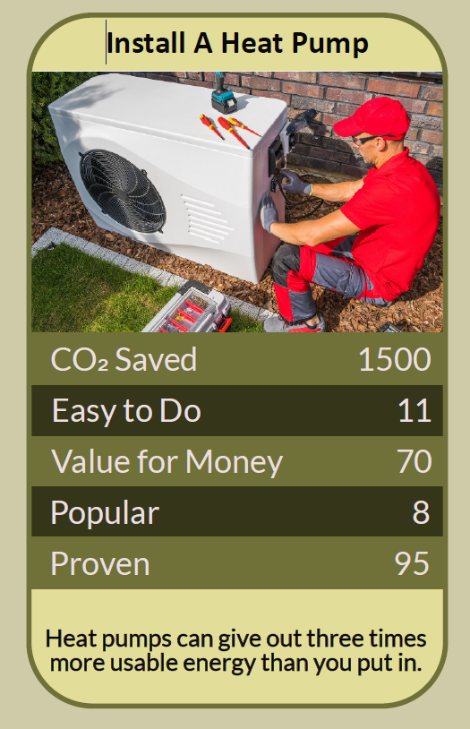

Before you begin  How To Use This Workbook | 

This workbook stands alone. You need nothing else to use it except your energy bills, a look at your boiler and radiators, and a few hours over the coming weeks.
It asks you to write, not just read.
Before you begin, choose one home. Usually this will be your own. If you rent, choose your home anyway: much of this workbook is about understanding and asking, and the answers are useful to your landlord too. You'll carry that one home through the exercise.

Write your first thoughts here, so you can come back to them later

This worksheet is part of the Climate Challenge series of action workbooks.

Part one  The Teaching | 

The idea at the heart of this workbook is the heat pump, first proposed in 1852 by William Thomson, the Belfast-born physicist later known as Lord Kelvin, in a paper on heating and cooling buildings using currents of air. He showed that a machine could move heat from a cold place to a warmer one using far less energy than it would take to create that heat directly.
Underneath it sits a slightly uncomfortable claim. Burning gas to keep warm is an old habit, not the best technology. The same principle that keeps your fridge cold can keep your home warm, and it has been understood for more than 170 years.
Move heat, don't make it. A heat pump works like a fridge in reverse. It draws heat from the outside air, the ground or water, even on cold days, concentrates it and pumps it into your home. A well-designed system typically delivers around three units of heat for every unit of electricity it uses, which is why it can cut carbon so sharply compared with a gas boiler.
Fabric first. A heat pump works best in a home that holds on to its heat. Insulating the loft and walls, fixing draughts and fitting good curtains reduce the amount of heat you need, so a smaller, cheaper heat pump can do the job and run more efficiently.
Low and slow. Gas boilers usually heat radiators quickly to very high temperatures. Heat pumps are most efficient sending water around at lower temperatures for longer, keeping rooms steadily warm rather than blasting heat in short bursts. Some radiators may need to be larger to give out enough heat at lower temperatures.
It works in more homes than you think. Heat pumps are not just for new-build houses. Large UK trials, including the Electrification of Heat project run by Energy Systems Catapult, have installed them successfully in a wide range of homes, from Victorian terraces to flats. What matters most is good design and installation.
Plan before the boiler breaks. Replacing a boiler in an emergency leaves no time to plan a heat pump. Most homes need a hot water cylinder and space outside for the unit, and a good installer will carry out a room-by-room heat-loss survey. Starting the research while your boiler still works gives you time to do it properly.
Use the help available. In England and Wales, the Boiler Upgrade Scheme offers grants of up to £7,500 towards a heat pump, and some energy suppliers offer tariffs designed for heat pump owners. Always use an MCS-certified installer, get more than one quote, and ask what flow temperature the system is designed to run at.
The practical use of Kelvin's idea is a plan, not a panic. Improve your home's fabric first. Learn how your current heating works, and try running it at a lower temperature to see how your home copes. Find out what grants and tariffs are available, talk to people who already have a heat pump, and get properly designed quotes from certified installers. Then, when your boiler reaches the end of its life, you'll be ready to replace it with something better.

Part two  The Exercise | 

Take the home you chose at the start and carry it through the steps below over the coming weeks. Write in full sentences. Nobody else reads this.
Describe your heating now. How is your home heated, and how is your hot water made? How old is your boiler, and how warm and comfortable is your home in winter? Score how ready you think your home is for a heat pump, from 1 (not at all) to 10 (ready now).
How certain do you feel about that score? ① ② ③ ④ ⑤ ⑥ ⑦ ⑧ ⑨ ⑩

Know your boiler. Find your boiler's age and model, and look at your bills to see how many kWh of gas or oil you used last year. When is your boiler likely to need replacing? What would happen if it broke down this winter?

Check the fabric. Look up your home's Energy Performance Certificate on the government's “Find an energy certificate” service. What does it say about your loft, walls, floors, windows and heating? Which improvements could you make before, or alongside, a heat pump?

Try running cooler. If you have a combi boiler, ask how to lower the temperature of the water going to your radiators, often called the flow temperature, to around 60°C or less. Don't change the temperature of a stored hot water cylinder. Over a week, note which rooms stay comfortable and which radiators struggle.

Find the space and the people. Where could an outdoor unit and a hot water cylinder go? Find someone who already has a heat pump — a friend, a neighbour, or through an open-home scheme — and ask what it's like. Contact two or three MCS-certified installers and ask about a heat-loss survey.

Make your plan. Write three actions: one you will do this month, one you will do this year, and the decision you'll make when your boiler needs replacing. Name who else needs to agree — household, landlord, installer — and when you'll start.

How certain are you now about your home? ① ② ③ ④ ⑤ ⑥ ⑦ ⑧ ⑨ ⑩

Part three  Questions For Discussion | 

Work through these questions independently if you must, but they are generally more beneficial when discussed.

- In the UK, electricity costs several times more per unit than gas, partly because of the policy costs added to electricity bills. Should those costs be moved, and who would pay instead?
- Renters and people in flats often have little say over how their homes are heated. How could they share in the switch to heat pumps?
- Should the sale of new gas boilers be phased out, as is planned for new petrol and diesel cars? What would make that fair?
- There aren't yet enough trained heat pump installers. Whose job is it to train them, and how quickly could it be done?
- Some argue hydrogen boilers could replace gas without changing how we heat our homes; others say heat pumps are the only realistic option. How would you weigh the evidence?
- A heat pump costs more to install than a boiler but can cost less to run. How should we think about spending more now to pollute less for years to come?

Want To Take This Further With Other People?
You've done the research and the thinking on your own. What's missing now is someone who sees your home differently — and who might show you their heat pump, share an installer's name or plan a street-wide switch with you.

Share your plan online  Join an online climate action community and post your home's heating story and your three-step plan. Heat pump owners will tell you honestly about installation, running costs and comfort, and will help you ask the right questions of installers. |  | Find people near you  Look for open-home events where heat pump owners show their systems, or a community energy group running a local scheme. Ask neighbours with similar homes whether they'd like to compare quotes. Ask your council about local energy advice.

Find your next challenge

This workbook is general guidance, not financial or technical advice. Use an MCS-certified installer, and keep stored hot water at a safe temperature.

climatechallenge.uk

