

Shop
Local
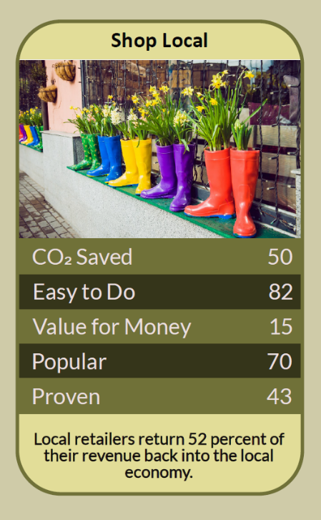

A parcel on the doorstep, a trolley in an out-of-town car park, a tap on a phone: most of what we buy now comes from businesses that have never heard of our street. In 2002 Justin Sacks of the New Economics Foundation devised a simple way to follow the money, and found that a pound spent with a local business can be worth far more to a community than the same pound spent with a distant one. Shopping locally also means walking more, driving less and keeping the high street alive. This workbook asks you to follow your own money, find what's on your doorstep, and move one regular purchase closer to home.

Before you begin  How To Use This Workbook | 

This workbook stands on its own. You need a look at last month's spending, a walk round your area, a pen and a few weeks of ordinary shopping, and each part builds on the one before, so work through it in order.
It asks you to write, not just read.
Before you begin, choose one thing you buy regularly. It might be bread, fruit and vegetables, coffee, books, haircuts or household basics. Keep your bank statements and receipts private, and if money is tight, remember that shopping locally doesn't have to cost more: markets, charity shops and repair services are often cheaper. You'll carry that one purchase through the exercise.

Write it here, so you have it to hand

Part one  The Teaching | 

In December 2002 the New Economics Foundation and the Countryside Agency published The Money Trail by Justin Sacks. It set out LM3, the Local Multiplier 3: a way of measuring how much money stays in an area by following it through three rounds of spending, from the customer to the business, and from the business to its local staff and suppliers, and on again.
The slightly uncomfortable claim underneath it is this: where you spend your money matters as much as how much you spend. Money spent with a business that buys locally, banks locally and employs local people goes round again and again. Money spent with a distant company mostly leaves the area at once, and the shop on your street closes.
The leaky bucket. Sacks compared two imaginary towns. In 'Localton', where 80% of each pound was spent locally, a £10 gift generated about five times its value as it circulated. In 'Leakyville', where only 20% stayed local, the same £10 generated only about 1.25 times its value. The difference was not the amount spent, but how much leaked away.
Real places, real numbers. In the report's pilots, money spent with a local contractor by North Norfolk District Council generated £2.15 for the local economy for every £1, against £1.23 for a non-local contractor. Organic veg box schemes were found to generate about twice as much for the local economy as supermarkets. A community project in Sheffield scored 1.67.
Walk, don't drive. Local shops are usually within walking or cycling distance, while out-of-town retail parks are built around the car. Doing more of your shopping on foot cuts traffic and emissions, gets you moving, and means you meet the people who live around you.
Local isn't automatically greener. Shopping locally helps your community, but it doesn't make every product low-carbon. For food, what you buy matters far more than how far it travelled. The greenest local shopping combines local businesses with good choices: fewer, better things, second-hand, repaired and refilled.
More than shops. Local spending includes markets, cafés, repairers, tailors, charity shops, refill shops, independent bookshops, local tradespeople and community-owned pubs and shops. Many of these help you buy less and make things last, which is good for the planet as well as the high street.
Use it or lose it. Every empty shop was once someone's livelihood and a reason to walk into town. The businesses that survive are the ones people choose to use, often enough, for ordinary things, not just at Christmas.
The practical use of Sacks's work is that you don't need to change how much you spend to make a difference, only where. Follow your money, find the local businesses that keep it circulating, and move one regular purchase their way. Then another.

Part two  The Exercise | 

Take the purchase you chose at the start and carry it through the steps below. You'll need about a month. Write in full sentences. Nobody else reads this.
Follow your money. Look back over last month's spending and sort it roughly into local independent businesses, chains and online shops. What share went where? Then score from one to 10 how much of your spending you think stays in your area.
How certain do you feel about that score? ① ② ③ ④ ⑤ ⑥ ⑦ ⑧ ⑨ ⑩

Walk your patch. Walk or cycle around everywhere within about fifteen minutes of home. List the independent shops, markets, cafés and services you find. Which ones had you never noticed before?
Switch one purchase. Choose a local place to buy the item you picked at the start, and buy it there. Note the price, the quality, how you got there and how it compared with where you usually buy it.

Ask about the money trail. Next time you're there, ask the owner or staff where they get their stock, whether they use local suppliers or trades, and how long they've been there. Write down what you learn.
Keep it up for a month. Buy that item locally for a month. Note any extra cost or time, any savings, and anything that surprised you, such as conversations, advice or discoveries. Did it get easier?

Plan your next switch. Decide which purchase you'll move to a local business next, and which you'll keep buying elsewhere and why. Write down your plan.
And how certain do you feel now? ① ② ③ ④ ⑤ ⑥ ⑦ ⑧ ⑨ ⑩

Part three  Questions For Discussion | 

Work through these questions independently if you must, but they are generally more beneficial when discussed.

- Is it fair to ask people to pay a little more to shop locally, when many are struggling with the cost of living?
- Should councils and public bodies be required to spend more of their budgets with local businesses?
- What does a high street give a community that online shopping can't?
- When is a chain store part of the local economy, and when isn't it?
- Should out-of-town retail parks pay more towards the roads and car use they depend on?
- What would make your local high street a place people want to spend time, not just money?

Want To Take This Further With Other People?
You've followed your own money. What's missing is the rest of your neighbourhood, and the businesses that need more than one loyal customer to survive.

Make a local map  With friends, a school or a residents' group, map the independent shops, markets and services in your area and share it, on paper or online, so more people know what's there. |  | Back a local business  Choose a local business to champion: shop there often, leave good reviews, recommend it, and look out for community share offers that let local people own a stake.

Find your next challenge

climatechallenge.uk

