

Switch To A
Green Bank
You recycle, walk more and turn the heating down, but your savings may be quietly funding new oil and gas fields. Since 2020, a coalition of campaign groups led by the Rainforest Action Network has published Banking on Climate Chaos, an annual report tracking how much the world's largest banks lend to fossil fuel companies; the totals run into trillions of dollars since the Paris Agreement. Where you keep your money is one of the most powerful climate choices you can make, and one of the easiest to change. This workbook asks you to find out what your money is doing, and to commit to your next three steps.

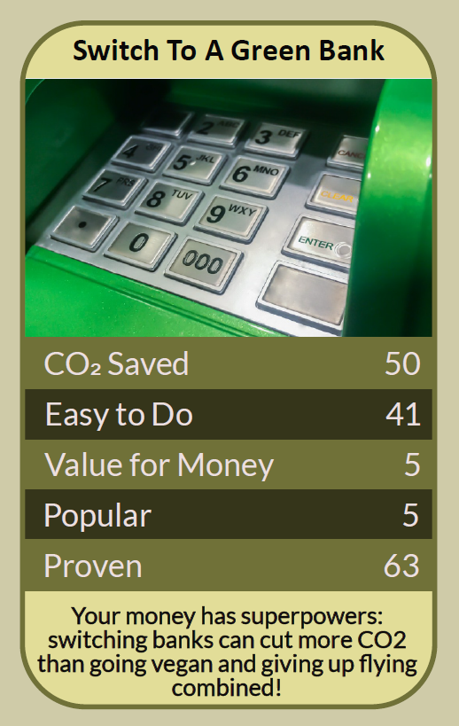

Before you begin  How To Use This Workbook | 

This workbook stands alone. You need nothing else to use it except your bank details, your latest pension statement if you have one, and an hour of research.
It asks you to write, not just read.
Before you begin, choose one account. It might be your current account, a savings account, an ISA or a workplace pension. Choose one you have real control over. You'll carry that one account through the exercise.

Write your first thoughts here, so you can come back to them later

This worksheet is part of the Climate Challenge series of action workbooks.

Part one  The Teaching | 

The idea at the heart of this workbook comes from Banking on Climate Chaos, an annual report first published under that name in 2020 by the Rainforest Action Network together with partners including BankTrack, the Sierra Club and Indigenous Environmental Network. Each year it adds up the money the world's largest banks have provided to companies that extract, transport and burn fossil fuels.
Underneath it sits a slightly uncomfortable claim. Money in the bank isn't neutral. Your bank uses the deposits it holds to lend and invest, and some of the biggest banks are still among the largest funders of new fossil fuel projects. You may be paying for the problem you're working to solve.
Your money doesn't sit still. When you deposit money, your bank doesn't keep it in a vault. It uses its deposits to lend to households and businesses and to invest. That's how banks work, and it means your savings help decide which companies and projects get funded.
Follow the money. Reports such as Banking on Climate Chaos, together with independent ratings from groups such as Ethical Consumer and Bank.Green, show how much different banks lend to fossil fuel companies and what their climate policies actually say. Look past the green adverts to the lending.
What makes a bank green. Greener banks and building societies typically refuse to lend to fossil fuel companies, publish what they lend to, and focus on things like renewable energy, sustainable housing and social enterprises. Some belong to the Global Alliance for Banking on Values, a network of banks committed to using finance for social and environmental good.
Pensions matter even more. For many people, the biggest pot of money they own is a pension, and it's invested on their behalf in companies around the world. The campaign group Make My Money Matter has estimated that moving a pension to a sustainable fund can cut far more carbon than many lifestyle changes combined. Many workplace schemes offer greener fund options.
Switching is easier than you think. In the UK, the Current Account Switch Service moves your balance, direct debits and standing orders to a new bank in seven working days, and guarantees to refund any charges if something goes wrong. Before you move, check that your new bank is protected by the Financial Services Compensation Scheme.
Tell them why. When you leave a bank, tell it why, in writing. When you stay, ask questions about its fossil fuel lending. Banks track why customers leave, and pension providers listen when members ask about their investments. Your voice adds weight to your choice.
The practical use of Banking on Climate Chaos is to follow your own money. Find out what your bank funds. Compare it with greener alternatives that offer the features and protection you need. Switch the account you have most control over, check your pension's investments, and tell both your old bank and your pension provider why you're acting. For pensions and larger investments, consider regulated financial advice before you move.

Part two  The Exercise | 

Take the account you chose at the start and carry it through the steps below. Write in full sentences. Nobody else reads this.
Describe your money. Where do you bank, save and hold your pension? When and why did you choose each one? Have you ever asked what they do with your money? Score how much you know about what your bank funds, from 1 (nothing at all) to 10 (I know in detail).
How certain do you feel about that score? ① ② ③ ④ ⑤ ⑥ ⑦ ⑧ ⑨ ⑩

Follow your bank's money. Look up your bank in the latest Banking on Climate Chaos report or on an independent rating site. What does it lend to fossil fuel companies, and what does its own climate policy promise? Write down what you found and how it made you feel.

Compare the alternatives. Find two or three greener banks or building societies. Compare what matters to you: the type of account, app and branches, fees, interest, overdraft and FSCS protection. Which would best suit your needs?

Check your pension. Find your pension provider and the fund your money is in. Look up its holdings or ask the provider directly whether it invests in fossil fuel companies, and whether a sustainable or climate-focused fund is available.

Name the barriers. What might stop you switching: direct debits, a mortgage or overdraft, loyalty, the time it takes, worries about a smaller bank, or not knowing where to start? For each barrier, write one way around it.

Make your plan. Write three actions: one you will do this week, one switch you will make this month, and one bigger step, such as moving your pension, writing to your bank or talking to your employer about greener pension options. Note when you'll start.

How certain are you that your plan will happen? ① ② ③ ④ ⑤ ⑥ ⑦ ⑧ ⑨ ⑩

Part three  Questions For Discussion | 

Work through these questions independently if you must, but they are generally more beneficial when discussed.

- Does moving your money away from a bank change what it does, or is it more powerful to stay and push for change from inside? What are the strongest arguments each way?
- Should governments and regulators restrict banks from funding new fossil fuel projects, or should that be left to customers and shareholders?
- Some greener banks have fewer branches and services than the big high-street banks. Is switching a realistic choice for everyone, and how could it become one?
- Many people have never chosen their pension fund; it was chosen for them. Who should be responsible for making sure pensions are invested responsibly?
- Funds labelled “sustainable” or “ESG” don't always avoid fossil fuels. How can ordinary savers tell the difference between real change and greenwashing?
- Fossil fuel companies still provide jobs, energy and pension returns. How should those benefits be weighed against their role in climate change?

Want To Take This Further With Other People?
You've done the research and the thinking on your own. What's missing now is someone who sees money differently — and who might switch alongside you, compare pensions with you or ask your employer the right questions together.

Share your findings online  Join an online climate action community and post what you found about your bank and pension, and your three-step plan. Others will have switched banks or pensions and will tell you honestly what it involved. Saying your plan out loud makes you more likely to follow through. |  | Find people near you  Talk to colleagues about asking your employer for greener pension options; requests carry more weight together. Look for a local climate group running money or pension campaigns. Ask friends and family what their money is funding.

Find your next challenge

This workbook is general guidance, not financial advice. Check FSCS protection and terms before switching, and consider regulated advice for pensions and investments.

climatechallenge.uk

