

Take Shorter
Showers
The hot water feels wonderful on a cold morning, so you stay under it a few minutes longer than you need, every single day. Stanford researcher BJ Fogg, author of Tiny Habits, has shown that behaviour happens when motivation, ability and a prompt come together, and that lasting change starts small. A shower uses both water and the energy to heat it, so a few minutes less each day adds up over a year. This workbook asks you to look at your own shower routine, and to commit to the next three things you will change.

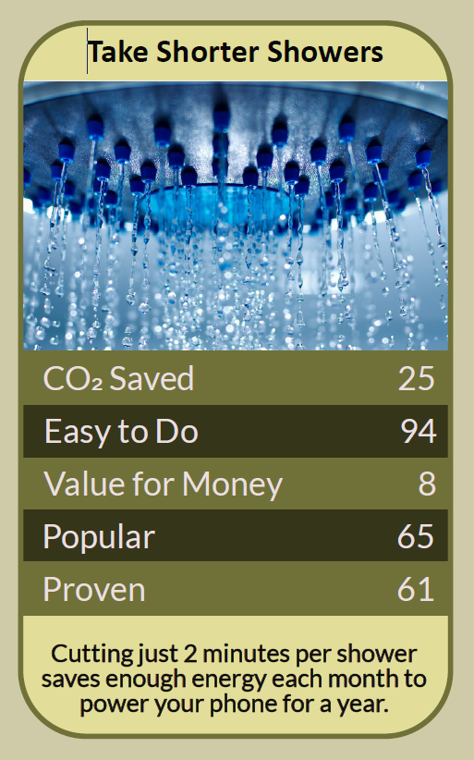

Before you begin  How To Use This Workbook | 

This workbook stands alone. You need nothing else to use it except a timer, a one-litre jug and a week of your own showers.
It asks you to write, not just read.
Before you begin, choose one shower routine: usually your own daily shower. Some people need longer showers for health, disability, skin conditions or religious practice; if that's you, focus on the changes that suit you, such as temperature or an efficient shower head. You'll carry that one routine through the exercise.

Write your first thoughts here, so you can come back to them later

This worksheet is part of the Climate Challenge series of action workbooks.

Part one  The Teaching | 

The idea at the heart of this workbook is the Fogg Behavior Model, developed by BJ Fogg, founder of the Behavior Design Lab at Stanford University, and set out for general readers in his 2019 book Tiny Habits. Fogg showed that a behaviour happens when three things come together at the same moment: motivation to do it, the ability to do it, and a prompt that reminds you to do it.
Underneath it sits a slightly uncomfortable claim. Long showers aren't usually a choice we make; they're a habit we drift into. Willpower alone rarely changes a habit, but redesigning the routine around it often does.
Showers use water and energy. Every minute under the shower uses several litres of hot water, and heating that water takes gas or electricity. In many homes, heating water is one of the largest uses of energy after heating rooms, so shorter showers cut carbon and bills as well as water.
Not all showers are equal. Electric showers heat water as it flows and use a lot of electricity while running. Mixer showers take hot water from a boiler or cylinder. Power showers pump water out at a high rate and can use more water than a bath. Knowing your type helps you work out what your shower really costs.
Motivation, ability, prompt. Fogg's model explains why good intentions often fail. You may want shorter showers (motivation), but if the shower is warm and there's nothing to tell you when to stop (prompt), you'll stay in. Changing the prompt or making the new behaviour easier usually works better than trying harder.
Start tiny. Fogg recommends starting with a change so small it feels almost too easy, such as cutting just one minute, or turning the water off while you shampoo. Tiny changes are easy to repeat, and once they become automatic, they can grow.
Anchor it and celebrate. Fogg suggests attaching a new habit to something you already do: “After I step into the shower, I'll start a four-minute song.” When you stick to it, celebrate in a small way, even with a smile or a quiet “yes”. Good feelings help a new habit stick.
Make the kit help you. A shower timer, a waterproof clock or a short playlist gives you a clear prompt. An efficient, aerating shower head can cut the water you use without spoiling the shower, though check that it suits your shower type first; many water companies offer them free.
The practical use of Fogg's model is to design your shower routine rather than rely on willpower. Measure what you do now. Find which of motivation, ability or prompt is missing. Start with one tiny change, anchor it to something you already do, give yourself a clear prompt, and celebrate when you manage it. Once the shorter shower is automatic, look at the next step, such as a cooler temperature or a more efficient shower head.

Part two  The Exercise | 

Take the shower routine you chose at the start and carry it through the steps below over the coming week. Write in full sentences. Nobody else reads this.
Describe your shower. What kind of shower do you have: electric, mixer or power? When do you shower, how hot do you like it, and roughly how long do you stay in? What do you enjoy about it? Score how easy it would be to make your shower shorter, from 1 (very hard) to 10 (very easy).
How certain do you feel about that score? ① ② ③ ④ ⑤ ⑥ ⑦ ⑧ ⑨ ⑩

Time it and measure it. Time your next shower from turning the water on to turning it off. Then time how long your shower takes to fill a one-litre jug, and work out its flow in litres per minute. How many litres does one shower use? How many in a week and a year?

Find the missing piece. Using Fogg's model, which is weakest for you right now: your motivation to shorten your shower, your ability to do it easily, or a prompt that tells you when to stop? What gets in the way most?

Design a tiny habit. Write your new habit in Fogg's form: “After I [something I already do], I will [tiny new behaviour].” Then decide how you'll celebrate when you do it. Keep it small enough that you could do it even on a bad day.

Try it for a week. Each day this week, time your shower and note whether you kept to your tiny habit. How did it feel? What helped, and what got in the way? Did anything surprise you?

Make your plan. Write three actions: the habit you'll keep from now on, one change to your kit, such as a timer or an efficient shower head, and one way to involve your household. Name anyone else involved and when you'll start.

How certain are you that your new habit will stick? ① ② ③ ④ ⑤ ⑥ ⑦ ⑧ ⑨ ⑩

Part three  Questions For Discussion | 

Work through these questions independently if you must, but they are generally more beneficial when discussed.

- Is cutting a few minutes from a shower a meaningful climate action, or a distraction from bigger changes? Could it be a first step towards them?
- In shared households, one person's long shower can mean cold water for the next. How should households agree on fair use of hot water?
- Daily showering is a fairly recent habit in many countries. How much of what feels “clean” is really about habit and culture?
- Some people need longer or more frequent showers for health, disability or religious reasons. How can water-saving campaigns avoid making them feel judged?
- Should water and energy companies do more to show people what each shower costs, for example with displays or smart meters?
- Fogg argues that tiny habits can lead to bigger change. Has a small habit ever changed something bigger in your life? What could that look like for the climate?

Want To Take This Further With Other People?
You've done the timing and the thinking on your own. What's missing now is someone who sees your routine differently — and who might share a four-minute playlist, a shower-timer challenge or the household's hot water fairly with you.

Share your habit online  Join an online climate action community and post your shower times, your tiny habit and your three-step plan. Others will share their favourite short songs, timers and tricks for making a short shower feel just as good. |  | Find people near you  Set a friendly shower challenge with your household, friends or colleagues. Ask your water company whether it offers free shower timers or efficient shower heads. Share what works with neighbours and local community groups.

Find your next challenge

This workbook is general guidance. Check that any new shower head suits your type of shower, and adapt the steps to any health or personal needs.

climatechallenge.uk

