

Household
Recycling
You rinse the yoghurt pot, hesitate over the crisp packet, and drop the battery in the bin without a second thought. In their 2002 book Cradle to Cradle, the architect William McDonough and the chemist Michael Braungart argued that most recycling is really “downcycling”, and that materials should be kept in endless loops of high quality. Recycling done well saves energy, raw materials and landfill; done badly, it can spoil a whole lorry-load. This workbook asks you to get your household's recycling right, and to commit to the next three things you will change.
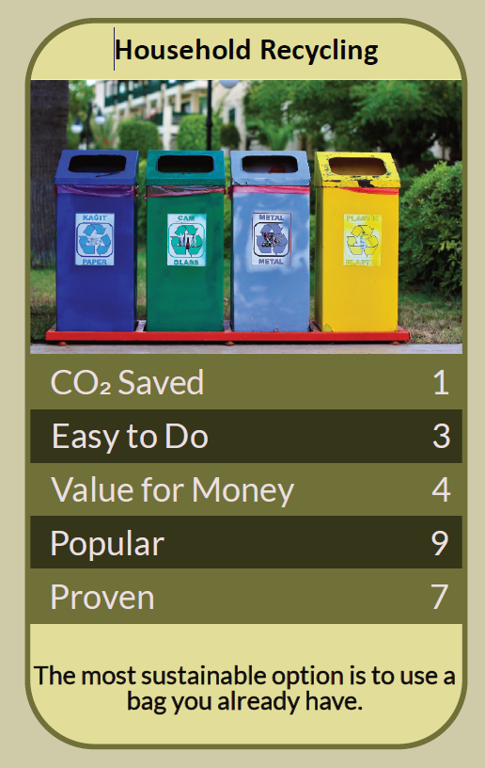


Before you begin  How To Use This Workbook | 

This workbook stands alone. You need nothing else to use it except your council's recycling guide, a pair of gloves and a week of noticing what goes in your bins.
It asks you to write, not just read.
Before you begin, choose one bin in your home. Usually this will be the kitchen bin, where most household waste begins. Choose the bin that fills fastest or causes the most confusion. You'll carry that one bin through the exercise.

Write your first thoughts here, so you can come back to them later

This worksheet is part of the Climate Challenge series of action workbooks.

Part one  The Teaching | 

The idea at the heart of this workbook comes from William McDonough and Michael Braungart's 2002 book Cradle to Cradle: Remaking the Way We Make Things. They argued that instead of a “cradle to grave” system, where products end up as waste, materials should cycle endlessly: “biological nutrients” returning safely to the soil, and “technical nutrients” such as metals being remade again and again without losing quality.
Underneath it sits a slightly uncomfortable claim. Much of what we call recycling is really downcycling: each time a material is reprocessed, it loses quality, until it can't be used again. Recycling is worth doing well, but it can't make up for buying things that were never designed to be recycled.
Some materials loop, others don't. Aluminium and steel cans, and glass bottles and jars, can be recycled again and again without losing quality. Paper and card fibres shorten each time they're recycled, so they can only go round a limited number of times. Many plastics can be recycled only once or twice, if at all, and mixed materials are often impossible to separate.
Contamination spoils the load. Putting the wrong things in the recycling, sometimes called “wish-cycling”, can contaminate a whole load and send it to landfill or incineration. Food-soiled items, plastic bags in the wrong bin and items your council doesn't accept are common culprits. Empty, clean and dry is the rule; if in doubt, check.
Know your council's rules. What can be recycled depends on where you live, because councils use different collection systems and processing contracts. The government's Simpler Recycling reforms are bringing more consistent collections across England, including food waste, but it's still worth checking your own council's guide.
Food waste matters. Food waste sent to landfill rots and releases methane, a powerful greenhouse gas. Collected separately, it can be turned into biogas and fertiliser through anaerobic digestion. Using your food caddy, or composting at home, keeps food out of the general bin.
Some things must never go in the bin. Batteries, vapes and small electricals can start fires in bin lorries and recycling centres when they're crushed. Take them to battery collection points in shops, electrical take-back schemes or your local recycling centre. Paint, chemicals and light bulbs also need special disposal.
Design decides what's possible. McDonough and Braungart's central point is that recyclability is decided when a product is designed, not when it's thrown away. Choosing products made from materials that recycle well, in simple packaging, makes your recycling far more effective than any amount of careful sorting.
The practical use of Cradle to Cradle is to get both ends right. At the bin, learn your council's rules, keep recycling clean, empty and dry, use your food caddy, and take hazardous items to the right place. At the shop, choose things made from materials that loop well, such as glass, metal and card, and avoid packaging that mixes materials. The best recycling starts before you buy.

Part two  The Exercise | 

Take the bin you chose at the start and carry it through the steps below over the coming week. Write in full sentences. Nobody else reads this.
Describe your bins. What bins and boxes does your household have, and how often are they collected? Who usually sorts the recycling, and where do things go when you're unsure? Score how confident you are about your council's recycling rules, from 1 (I guess) to 10 (I know them well).
How certain do you feel about that score? ① ② ③ ④ ⑤ ⑥ ⑦ ⑧ ⑨ ⑩

Audit your bin. For one week, note everything that goes into your chosen bin. At the end of the week, mark the items that could have been recycled, composted or avoided altogether. What made up the largest share?

Check the rules. Read your council's recycling guide, online or on the bin. Which items surprised you, either because they can be recycled or because they can't? Which mistakes has your household been making?

Find the hazards. Look around your home for batteries, old phones, vapes, chargers, light bulbs, paint and small electricals. Find out where each can be taken locally, such as shop collection points, take-back schemes or the recycling centre. Write down where they'll go.

Set up the system. How could you make recycling easier for everyone in your home? Think about where bins sit, clear labels, a food caddy by the sink, a box for hazardous items and who empties what. Sketch or describe your new set-up.

Make your plan. Write three actions: one you will do today, one change to your household's routine this month, and one change to what you buy, such as choosing glass, metal or card over mixed or hard-to-recycle packaging. Name anyone else involved and when you'll start.

How confident are you now about the rules? ① ② ③ ④ ⑤ ⑥ ⑦ ⑧ ⑨ ⑩

Part three  Questions For Discussion | 

Work through these questions independently if you must, but they are generally more beneficial when discussed.

- Should packaging that can't be recycled be banned, or should producers simply pay more for it? Who would gain and who would lose?
- Some of the UK's plastic waste has been shipped abroad for recycling, where it isn't always processed well. Should countries deal with all their own waste at home?
- Does recycling make people feel they've done their bit, so they worry less about how much they buy? How could we avoid that trap?
- Is burning waste to generate electricity a sensible alternative to landfill, or does it discourage recycling and reduction?
- Recycling rules vary from place to place, which confuses many people. How much should be the same everywhere, and who should decide?
- McDonough and Braungart argue that waste is a design failure. Whose responsibility is it to design waste out: manufacturers, retailers, governments or shoppers?

Want To Take This Further With Other People?
You've done the sorting and the thinking on your own. What's missing now is someone who sees waste differently — and who might share a battery run to the recycling centre, a compost bin or a campaign for less packaging with you.

Share your bin audit online  Join an online climate action community and post your bin audit, your surprises and your three-step plan. Others will share their best tips for sorting, composting and cutting packaging, and will help you check the trickier items. |  | Find people near you  Look for a local zero-waste or refill shop, a community composting scheme or a litter-picking group. Ask your council about recycling centre tours or talks. Share what you've learned with neighbours, especially if your street shares bins.

Find your next challenge

This workbook is general guidance. Wear gloves when sorting waste, never put batteries or vapes in household bins, and follow your council's rules.

climatechallenge.uk

