

Take The
Tram
The tram glides past while you sit in traffic, and you wonder, not for the first time, whether it would have been quicker. In his 2011 book Human Transit, the transport planner Jarrett Walker argued that “frequency is freedom”: public transport that turns up often lets people go where they want, when they want, without a car. Trams run on electricity, carry large numbers of people and produce no exhaust in the street. This workbook asks you to try one journey by tram, and to commit to the next three things you will change.

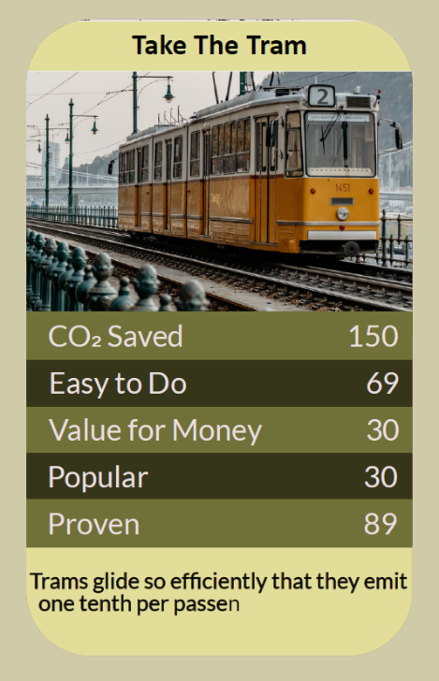

Before you begin  How To Use This Workbook | 

This workbook stands alone. You need nothing else to use it except a journey planner, your local tram network's website or app, and one regular journey.
It asks you to write, not just read.
Before you begin, choose one regular journey you usually make by car or taxi that could be made by tram. It might be to work, the city centre, a station, a hospital or a friend's home. If there's no tram where you live, choose a journey you could make by bus or train instead. You'll carry that one journey through the exercise.

Write your first thoughts here, so you can come back to them later

This worksheet is part of the Climate Challenge series of action workbooks.

Part one  The Teaching | 

The idea at the heart of this workbook comes from Jarrett Walker, an international public transport consultant, in his 2011 book Human Transit: How Clearer Thinking about Public Transit Can Enrich Our Communities and Our Lives. Walker's best-known principle is that “frequency is freedom”: when a service runs every few minutes, you don't need a timetable; you just turn up and go.
Underneath it sits a slightly uncomfortable claim. Many of us drive not because public transport can't get us there, but because we've never really tried it, or tried it once on a bad day. A tram that comes every few minutes can be more convenient than a car you have to park.
Frequency is freedom. Walker's point is that how often a service runs matters as much as how fast it is. If a tram comes every ten minutes or less, you spend little time waiting and never need to plan around a timetable. Check how often trams run on your route at the times you travel.
Trams are clean and efficient. Trams run on electricity, so they produce no exhaust in the street, and as the grid gets cleaner, so do they. Steel wheels on steel rails roll easily, and a single tram can carry as many people as a long queue of cars, using far less road space and energy per passenger.
Count the whole journey. Compare door to door: walking to the stop, waiting, riding and walking from the stop at the other end, against getting the car out, driving, finding a parking space and walking from the car park. For many journeys into busy centres, the tram is quicker than it looks.
Know the tickets. Many tram networks offer contactless payment, daily or weekly caps, season tickets and discounts for young people, older people and disabled passengers. Some combine trams, buses and trains on one ticket. Knowing the cheapest ticket for your journey removes one of the biggest barriers.
Combine your journey. Trams work best as part of a chain. Park-and-ride sites let you leave the car at the edge of town, and many tram stops are near bus stops, stations and cycle routes. Walking or cycling to the stop adds healthy activity to your day.
Time you get back. On a tram, someone else does the driving. You can read, listen, reply to messages, rest or simply look out of the window. Low-floor trams with step-free boarding also make travel easier for people using wheelchairs, pushchairs or walking aids.
The practical use of Walker's idea is to find the journeys where frequent public transport can set you free from the car. Choose one regular journey, check how often the tram runs, compare the door-to-door time and cost honestly, and try it. If it works, make it your normal way of making that journey, and look for the next one.

Part two  The Exercise | 

Take the journey you chose at the start and carry it through the steps below over the coming week. Write in full sentences. Nobody else reads this.
Describe the journey. Where do you go, how often, at what times, and with whom? How do you travel now, and why? Have you ever made this journey by tram? Score how likely you are to use the tram for this journey, from 1 (very unlikely) to 10 (very likely).
How certain do you feel about that score? ① ② ③ ④ ⑤ ⑥ ⑦ ⑧ ⑨ ⑩

Plan it. Use a journey planner to find your nearest tram stops at each end, how often trams run at your usual times, and the total door-to-door time. How does it compare with your usual way of travelling?

Count the cost. Find the cheapest tram ticket for this journey, including any day, week or season tickets you might use. Compare it with what the journey costs by car, including fuel, parking and wear and tear. What's the difference over a month?

Ride it. Make the journey by tram at least once this week. How long did it take, door to door? How easy was it to buy a ticket and find the stop? How did you feel during and after the journey? What surprised you?

Solve the snags. List anything that might stop you using the tram regularly for this journey: walking to the stop in bad weather, late-night services, feeling safe, carrying things, children, accessibility. For each, write one solution you could try.

Make your plan. Write three actions: one journey you will make by tram this week, how often you'll use it from now on, and one bigger change, such as buying a season ticket, using park and ride or giving up a second car. Name who's involved and when you'll start.

How likely are you now to take the tram? ① ② ③ ④ ⑤ ⑥ ⑦ ⑧ ⑨ ⑩

Part three  Questions For Discussion | 

Work through these questions independently if you must, but they are generally more beneficial when discussed.

- Should public transport be paid for mainly by the people who use it, through fares, or by everyone, through taxes? What difference would each make?
- Some UK tram networks have moved from private operators back into public control. Does it matter who runs a tram network, as long as it runs well?
- Trams are expensive to build but can carry many people and last for decades. Should cities invest in more trams, or in cheaper, more flexible buses?
- Many people say they would use public transport more if it ran more often, especially in the evenings and at weekends. Who should pay for that?
- Should city centres be closed to most cars if good trams and buses are available? Who would gain and who would lose?
- Some people don't feel safe on public transport, especially at night. What would make trams feel safe and welcoming for everyone?

Want To Take This Further With Other People?
You've done the planning and the thinking on your own. What's missing now is someone who sees travel differently — and who might ride with you, share the commute or campaign for more frequent services alongside you.

Share your journey online  Join an online climate action community and post your tram journey, your door-to-door comparison and your three-step plan. Others will share the tickets, routes and tips that make public transport work for them. |  | Find people near you  Invite a colleague, friend or neighbour to try the tram with you. Look for a local public transport users' group or campaign for better services. Give feedback to your tram operator or transport authority about what would help you travel more.

Find your next challenge

This workbook is general guidance. Check timetables, fares and accessibility before you travel, and take care crossing tram tracks, especially on a bike.

climatechallenge.uk

