

Unplug
TV

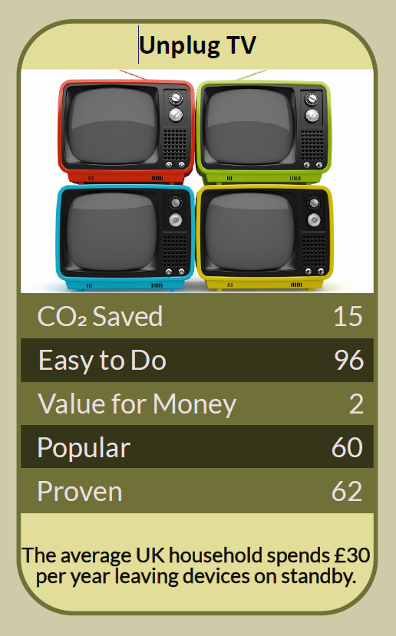
The evening ends, the remote clicks, and the little red standby light glows on until morning, next to the set-top box, the games console and the sound bar. In 2000 the political scientist Robert Putnam argued in Bowling Alone that television was one of the main reasons people had drifted away from clubs, neighbours and community life. Today the average person in the UK spends about four and a half hours a day watching TV and video at home. This workbook asks you to switch your TV kit off properly, use less energy when you do watch, and win back some of those hours for the people and things you care about.

Before you begin  How To Use This Workbook | 

This workbook stands on its own. You need your TV corner, a pen and two weeks of ordinary evenings, and each part builds on the one before, so work through it in order.
It asks you to write, not just read.
Before you begin, choose one regular evening in your home. Pick an ordinary weekday evening when the TV usually goes on. Before switching any box off at the wall, check it doesn't need to stay on to record programmes or install updates, and never switch off a fridge, freezer, alarm or medical equipment on the same extension lead. You'll carry that one evening through the exercise.

Write it here, so you have it to hand

Part one  The Teaching | 

In 2000 Robert Putnam, a political scientist at Harvard University, published Bowling Alone: The Collapse and Revival of American Community. Drawing on decades of surveys, he showed that Americans were joining fewer clubs, seeing friends less and taking part less in community life, and he estimated that television accounted for around a quarter of that decline.
The slightly uncomfortable claim underneath it is this: the biggest cost of the TV isn't on the electricity bill, it's in our diaries. Every hour in front of a screen is an hour not spent with neighbours, in a group, outdoors or making something. Unplugging the TV saves a little energy and frees a lot of time.
Hours, not just watts. Ofcom found that in 2024 people in the UK spent an average of 4 hours 30 minutes a day watching TV and video at home, including broadcast TV, streaming and online video. Even a small cut, say one evening a week without the TV, frees more time than most hobbies ask for.
The screen uses most of the energy. In 2020 George Kamiya of the International Energy Agency worked out that streaming an hour of video caused about 36 g of carbon dioxide on the world's average electricity, far less than some headlines had claimed. Around 72% of that energy is used by the screen itself, not the internet or data centres, and a 50-inch television uses about 100 times as much electricity as a smartphone and about five times as much as a laptop.
Standby adds up. TVs, set-top boxes, games consoles and sound bars left on standby use power all day and night. The Energy Saving Trust has estimated that switching appliances off standby could save a typical household around £55 a year. A switched extension lead turns the whole TV corner off with one switch.
Settings make a difference. Most modern TVs have an eco or energy-saving mode that dims the screen to suit the room, and an automatic switch-off if nobody presses a button for a few hours. Turn them on. Watching on a smaller screen when you're on your own also uses less energy.
Keep the TV you've got. Making a new television takes energy and materials, and old ones add to the UK's mountain of electrical waste. A working TV doesn't need replacing just because a bigger or sharper one is on offer, and a bigger screen will use more electricity every hour it's on.
Fill the time with people. Putnam also pointed to ways back: joining groups, volunteering, playing games, eating together and getting to know the neighbours. These are the same connections that help communities act together on climate change.
The practical use of Putnam's warning is to treat TV time as something you choose rather than something that happens. Switch the kit off properly when you're done, watch more efficiently when you do, and give at least one evening a week back to the people around you.

Part two  The Exercise | 

Take the evening you chose at the start and carry it through the steps below. You'll need about two weeks. Write in full sentences. Nobody else reads this.
Count your hours. For one week, note how long the TV or other screens are on for watching in your home each day. Then score from one to 10 how much of that viewing you think you'd genuinely miss.
How certain do you feel about that score? ① ② ③ ④ ⑤ ⑥ ⑦ ⑧ ⑨ ⑩

Map the kit. List every device in your TV corner: TV, boxes, console, sound bar, streaming stick. Which ones show a standby light when 'off', and which need to stay on for recordings or updates?
Switch off properly. Set up a way to switch the whole TV corner off at night, such as a switched extension lead or a timer plug, and turn on the TV's eco and auto-off settings. Write down what you changed.

Choose a screen-free evening. Pick one evening a week to keep the TV off. Tell the people you live with, and agree what you'll do instead. What do you expect to miss?
Fill the time. On your screen-free evenings for the next two weeks, note what you did instead and who with: a walk, a game, cooking, a club, calling a friend. How did the evenings feel compared with usual?

Set your own rules. Decide on the TV habits you want to keep: switching off at the wall, a weekly screen-free evening, watching on smaller screens alone, or something else. Write them down and say why.
And how certain do you feel now? ① ② ③ ④ ⑤ ⑥ ⑦ ⑧ ⑨ ⑩

Part three  Questions For Discussion | 

Work through these questions independently if you must, but they are generally more beneficial when discussed.

- Putnam blamed television for part of the decline in community life. Do phones and streaming make that better or worse?
- Is watching TV together as a family a form of connection, or a way of avoiding it?
- Should TV makers be required to ship sets in their lowest-energy settings, with auto-off switched on?
- Why do people replace working TVs, and should we feel differently about it?
- What gets in the way of joining a local group or club, and how could that be made easier?
- If everyone on your street gave up one evening of TV a week, what could you do together?

Want To Take This Further With Other People?
You've won back some evenings for yourself. What's missing is other people to spend them with, and the groups that make a neighbourhood feel like a community.

Host a screen-free evening  Invite friends or neighbours for a board games night, shared meal, quiz or skills swap. Make it a regular date so the habit sticks. |  | Join something local  Use one of your new free evenings to try a local club, choir, sports team, community garden or volunteering group. Bring a friend if it helps.

Find your next challenge

climatechallenge.uk

