

Use Your
Library
A new book arrives in the post, is read once and joins a shelf of others, while a few streets away the library lends the same title for free. In his 2018 book Palaces for the People, the sociologist Eric Klinenberg argued that libraries are vital “social infrastructure”: shared places that make communities stronger, fairer and more resilient. Borrowing instead of buying means fewer things made and more shared. This workbook asks you to rediscover your local library, and to commit to the next three things you will change.

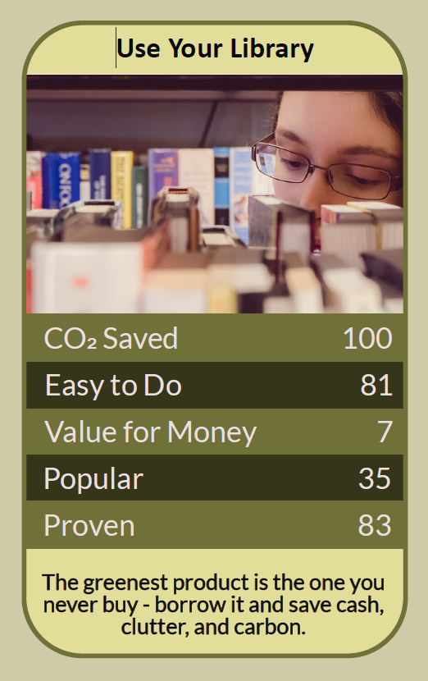

Before you begin  How To Use This Workbook | 

This workbook stands alone. You need nothing else to use it except your nearest library's website, a library card or the details to join, and an hour to visit.
It asks you to write, not just read.
Before you begin, choose one thing you usually buy or do elsewhere that a library could offer. It might be books, audiobooks, magazines, newspapers, films, a quiet place to work, Wi-Fi, or activities for children. Choose something you do regularly. You'll carry that one thing through the exercise.

Write your first thoughts here, so you can come back to them later

This worksheet is part of the Climate Challenge series of action workbooks.

Part one  The Teaching | 

The idea at the heart of this workbook comes from Eric Klinenberg, a sociologist at New York University, in his 2018 book Palaces for the People: How Social Infrastructure Can Help Fight Inequality, Polarization, and the Decline of Civic Life. Klinenberg argued that shared physical places, above all public libraries, shape how people connect, support one another and cope with crises.
Underneath it sits a slightly uncomfortable claim. We have come to treat libraries as old-fashioned, buying our own copies of things we use once, while one of the best low-carbon, sharing institutions ever invented sits underused down the road.
Libraries are social infrastructure. Klinenberg showed that places like libraries, parks and community centres help people meet, trust and look out for each other. During heatwaves and other crises, neighbourhoods with strong social infrastructure fared better. A well-used library is part of what makes a community resilient.
Borrowing beats buying. Every book, film or magazine made uses paper, plastic, energy and transport. When one copy is shared by dozens of readers, its footprint is spread across all of them. Borrowing instead of buying means fewer things made, less clutter at home and no cost to you.
More than books. Most UK libraries now lend ebooks, audiobooks, digital magazines and newspapers through free apps, alongside printed books. Many offer computers and Wi-Fi, printing, study space, children's activities, reading groups, local history and help with digital skills. Some lend seeds, energy monitors or other useful things.
Shared warmth and space. In recent winters, many libraries have acted as warm spaces, where people can sit, read and work in the warmth without heating their own homes. A shared space, heated once, is more efficient than many homes heated separately, and libraries can be welcoming places to spend time.
Free knowledge for everyone. Libraries are among the few indoor public places where anyone can spend time without paying. Librarians can help you find reliable information on anything, including climate change, energy saving and local action, at a time when misinformation spreads easily.
Use it or lose it. Hundreds of UK public libraries have closed or been handed to volunteers since 2010, as budgets have been cut. Library usage figures help decide which branches stay open. Joining, visiting and borrowing is a simple way to keep your library alive.
The practical use of Klinenberg's idea is to make the library part of your ordinary life again. Join, or renew your membership. Before buying a book, film or magazine, check whether you can borrow it, in print or digitally. Use the library as a place to work, learn and meet, and bring others with you. A library that's busy is a library that stays open.

Part two  The Exercise | 

Take the thing you chose at the start and carry it through the steps below over the coming weeks. Write in full sentences. Nobody else reads this.
Describe your library use. When did you last visit a library, and what for? Do you have a library card? What do you usually buy or do elsewhere that a library could provide? Score how much you use your library now, from 1 (never) to 10 (every week).
How certain do you feel about that score? ① ② ③ ④ ⑤ ⑥ ⑦ ⑧ ⑨ ⑩

Count your buying. Look back over the last year. How many books, audiobooks, magazines, films or similar items did you buy, and roughly what did they cost? How many have you used more than once, and how many could you have borrowed?

Explore the offer. Visit your library's website or a local branch. List everything it offers, in person and online, from ebooks and newspapers to events, study space and lending schemes. What surprised you most?

Join and borrow. If you're not a member, join. Borrow at least one item this week in your chosen category, and try the library's free app for ebooks or audiobooks. How easy was it, and how did it compare with buying?

Find the community. Look at the library's events and groups: reading groups, talks, children's sessions, craft or repair clubs, climate or local history groups. Which one would you like to try, and who could you take with you?

Make your plan. Write three actions: one thing you will borrow instead of buy this month, one regular way you'll use the library, and one way to support it, such as joining a group, volunteering or telling others. Name who's involved and when you'll start.

How certain are you that your plan will happen? ① ② ③ ④ ⑤ ⑥ ⑦ ⑧ ⑨ ⑩

Part three  Questions For Discussion | 

Work through these questions independently if you must, but they are generally more beneficial when discussed.

- Many libraries have closed or are run by volunteers because of funding cuts. Should library funding be protected, and what should be cut instead?
- Klinenberg calls libraries “palaces for the people”. What other places in your area work as social infrastructure, and are they thriving or struggling?
- When libraries open as warm spaces in winter, is that a sign of community strength or a sign that something has gone wrong? Can it be both?
- Authors in the UK receive a small payment each time their book is borrowed, through the Public Lending Right. Is borrowing fair to writers, and how could it be fairer?
- Should libraries lend far more than books, such as tools, games, instruments and equipment? What would that change?
- In an age of misinformation, what role should libraries play in helping people find reliable information about climate change?

Want To Take This Further With Other People?
You've done the exploring and the thinking on your own. What's missing now is someone who sees your library differently — and who might join a group with you, share a reading list or help keep your branch busy and open.

Share your finds online  Join an online climate action community and post what you discovered at your library and your three-step plan. Others will share their favourite library apps, services and reads, including books on climate and sustainable living. |  | Find people near you  Join a reading group, talk or club at your library, or start one. Ask whether your library has a Friends group or needs volunteers. Take a friend, neighbour or child along and help them join too.

Find your next challenge

This workbook is general guidance. Library services, opening hours and membership rules vary from place to place, so check with your local library.

climatechallenge.uk

