

Use Eco
Cleaning Products
Open the cupboard under the sink and count the bottles: a spray for the kitchen, another for the bathroom, one for glass, one for the floor, each promising a fresher home. Researchers at the University of Bergen studied about 6,000 adults and found that people who had cleaned regularly for twenty years had reduced lung function, with sprays singled out as the main problem. Their advice was surprisingly simple: most cleaning needs far fewer chemicals than we use. This workbook asks you to look hard at your own cleaning cupboard, see past the green labels, and make one swap you can keep.
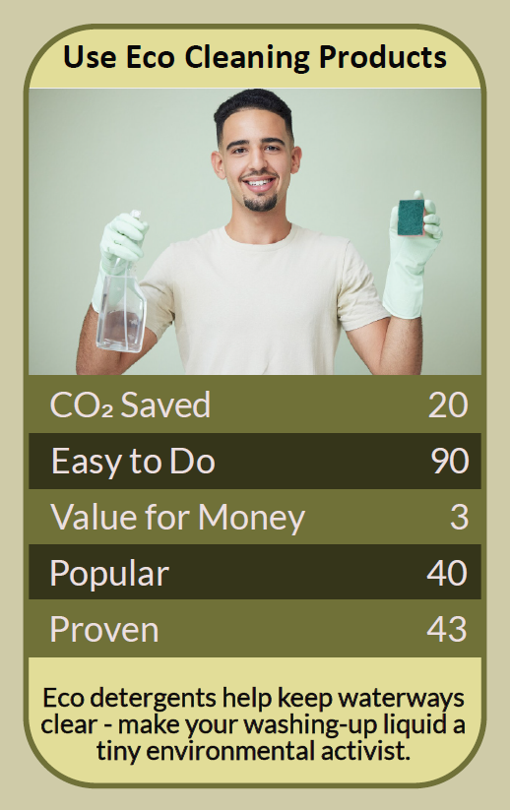


Before you begin  How To Use This Workbook | 

This workbook stands on its own. You need your cleaning cupboard, a pen and two weeks of ordinary cleaning, and each part builds on the one before, so work through it in order.
It asks you to write, not just read.
Before you begin, choose one room you clean regularly. The kitchen or bathroom works best, because that's where most products end up. Never mix cleaning products, and above all never mix bleach with vinegar, other acids or ammonia, because together they give off toxic gases. You'll carry that one room through the exercise.

Write it here, so you have it to hand

Part one  The Teaching | 

In 2018 a team at the University of Bergen, led by Øistein Svanes and supervised by Professor Cecilie Svanes, published a study in the American Journal of Respiratory and Critical Care Medicine. Using data from about 6,000 people in the European Community Respiratory Health Survey, they found that people who had cleaned at home or as cleaners for twenty years had reduced lung function, a decline the researchers compared to smoking 20 cigarettes a day over the same period.
The slightly uncomfortable claim underneath it is this: the greenest cleaning product is very often the one you don't buy. Swapping one brand of spray for another with a leaf on the label changes less than using fewer products, fewer sprays and more water, cloth and effort.
Sprays are the problem. The Bergen researchers singled out cleaning sprays. A spray turns liquid into a fine mist that can hang in the air for hours and be breathed deep into the lungs. The same liquid poured onto a cloth does the same job with far less of it in the air. Professor Svanes's own suggestion was a bucket of water and soap, adding that microfibre cloths may work just as well for most jobs.
Clean air indoors is clean air outdoors. Cleaning products don't stay in the house. A 2018 study in Science, led by Brian McDonald of the US National Oceanic and Atmospheric Administration, found that in the United States, chemical products such as cleaners, paints, perfumes and lotions now produce about as much of the volatile organic pollution in city air as vehicle fuels do, and around twice as much of the emissions that form fine particles. As car exhausts have become cleaner, the products in our cupboards matter more.
Fragrance is part of the pollution. That 'fresh' smell is chemicals evaporating into the air you breathe. A clean surface doesn't need to smell of anything, and fragrance-free versions of everyday products are easy to find.
A green label isn't proof. Words such as 'eco', 'natural' and 'kind to the planet' cost a manufacturer nothing. The UK's Competition and Markets Authority published its Green Claims Code in 2021, saying environmental claims must be truthful, clear, specific and backed by evidence. Look for a precise claim you could check, such as the share of recycled plastic in the bottle, rather than a vague promise and a picture of a leaf.
Most of what you carry home is water. Ready-to-use sprays are mostly water, shipped in a new plastic bottle every time. Concentrates you dilute at home, and refill shops where you bring your own container, cut both the plastic and the weight being transported.
A small kit does most jobs. Hot water, washing-up liquid, a few microfibre cloths, bicarbonate of soda for scouring and white vinegar for limescale will clean most homes. Vinegar can damage natural stone such as marble and granite, so check before you use it, and keep a proper disinfectant for the jobs that really need one, such as raw meat spills or illness in the house.
The practical use of all this is to clean with less, not to clean less. Take stock of what you have, use it up or dispose of it safely, and replace it with fewer, simpler products. Your lungs, the air outside and your bin will all notice the difference.

Part two  The Exercise | 

Take the room you chose at the start and carry it through the steps below. You'll need about two weeks of ordinary cleaning. Write in full sentences. Nobody else reads this.
Take stock. List every cleaning product you use in the room you chose, and count how many are sprays. Then score from one to 10 how eco-friendly you think your current cleaning routine is.
How certain do you feel about that score? ① ② ③ ④ ⑤ ⑥ ⑦ ⑧ ⑨ ⑩

Read the labels. Pick three products and read the back, not the front. Note any hazard symbols, warnings and fragrance, and copy down any green claim. Is each claim specific enough that you could check it, or is it just a feeling?
Notice the air. Next time you clean the room, pay attention to the smell and how long it lingers. Do you open a window or run a fan? Does anyone in the house cough, sneeze or complain? Write down what you notice.

Make one swap. Choose one change for this room, such as pouring onto a cloth instead of spraying, a microfibre cloth and water instead of a product, a concentrate or refill instead of a new bottle, or a fragrance-free version. Describe exactly what you'll do.
Try it for two weeks. Use the swap every time you clean that room for two weeks. Was the room as clean? Did it take longer, cost less or smell different? What surprised you?

Clear the cupboard. Decide what happens to the products you no longer need: use them up, give them away or take them to your local household waste recycling centre, rather than pouring them down the drain. Then write a short shopping list for next time, and say why each item is on it.
And how certain do you feel now? ① ② ③ ④ ⑤ ⑥ ⑦ ⑧ ⑨ ⑩

Part three  Questions For Discussion | 

Work through these questions independently if you must, but they are generally more beneficial when discussed.

- Why do so many of us feel a home isn't really clean unless it smells of cleaning products?
- Should products that are mostly water, sold in single-use plastic, be taxed, banned or simply left to shoppers to choose?
- If a cleaning product is bad for the person using it every day, who is responsible: the maker, the shop, the employer or the user?
- Is buying 'eco' cleaning products a real change, or a way of feeling better while carrying on as before?
- Paid cleaners breathe in far more cleaning products than most of us. What do households and employers owe them?
- How would you persuade someone you live with, who loves their favourite spray, to try a different way?

Want To Take This Further With Other People?
You've changed one room on your own. What's missing is the people you live and work with, who share the air and the cupboard and will notice what you've stopped noticing.

Find your nearest refill shop  Many towns now have refill shops or market stalls where you bring your own bottles for cleaning liquids. Visit one with a friend, compare prices with the supermarket, and share what you find. |  | Make it a group challenge  Run the two weeks with the people you live or work with. Agree one swap together, clear out the cupboard as a team, and talk about what everyone noticed at the end.

Find your next challenge

climatechallenge.uk

