

Check Gas Use
At Home
The heating clicks on, the hob is lit, and weeks later a bill arrives that feels more like weather than a choice. Gas is invisible, so most of us never see how much we burn or where it goes. A typical UK home now uses around 9,500 kWh of gas a year, roughly 1.7 tonnes of carbon dioxide, and most of it goes on heating and hot water rather than cooking. This workbook asks you to read your own meter, find out where your gas really goes, and change one habit you can measure.

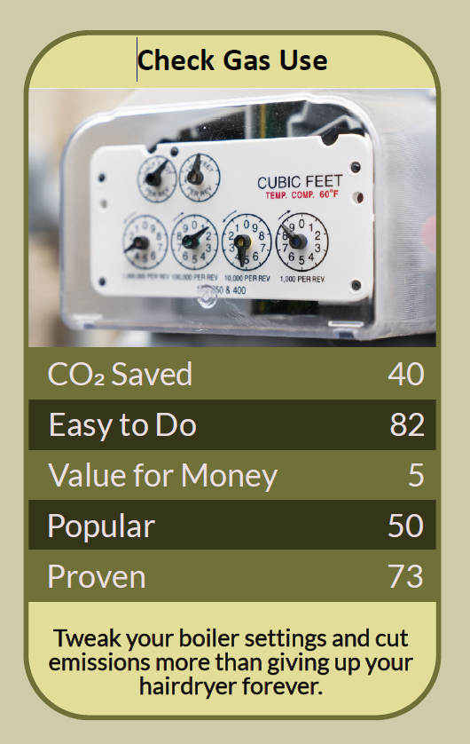

Before you begin  How To Use This Workbook | 

This workbook stands on its own. You need your gas meter, a pen and two weeks of attention, and each part builds on the one before, so work through it in order.
It asks you to write, not just read.
Before you begin, choose one way your household uses gas. Pick something ordinary that happens again and again, such as the evening heating, the morning showers or how the pasta gets cooked. Only ever change the settings on the controls; never open up the boiler or the gas pipework. If you smell gas, open doors and windows, don't use electrical switches, and call the National Gas Emergency Service on 0800 111 999. You'll carry your one example through the exercise.

Write it here, so you have it to hand

Part one  The Teaching | 

Gas is the fuel you never see. It arrives through a pipe, burns out of sight in a boiler or under a pan, and turns up weeks later as a number on a bill. That invisibility is the problem this workbook sets out to fix, because a habit you can't see is a habit you can't change.
The slightly uncomfortable claim underneath it is this: most of us have strong opinions about saving gas and almost no evidence. We turn the hob off a minute early and leave the thermostat at 22°C. We feel thrifty about small things and never look at the boiler. The meter settles the argument.
The meter tells the truth. Your gas meter is the only honest witness in the house. A metric meter counts cubic metres; an older imperial meter counts hundreds of cubic feet. To turn cubic metres into kilowatt-hours (kWh), the unit on your bill, multiply by about 11.2. For an imperial meter, multiply the hundreds of cubic feet by 2.83 first, then by 11.2. Your bill shows the exact conversion your supplier uses. Read the meter at the same time each day for a week and you'll have something no advert, neighbour or hunch can argue with.
Heating is the elephant in the room. In most homes with a gas boiler, space heating takes by far the largest share, hot water comes second, and cooking trails a long way behind, often only a few per cent of the total. That doesn't make cooking irrelevant, but it does mean an hour spent perfecting your hob technique saves less than ten minutes spent with the heating controls.
Comfort isn't the same as temperature. We heat rooms, but what we actually want is to feel warm. Draughts, cold floors and damp air make 20°C feel chilly; thick socks, a closed door and drawn curtains make a cooler room feel fine. Every degree on the thermostat costs gas for every hour the heating runs, so turning it down by one degree and living with it for a week is one of the cheapest experiments in the house. If anyone at home is elderly, very young or unwell, keep the rooms they use at 18°C or above.
The boiler has a setting most people never touch. A condensing boiler works at its best only when the water returning to it is cool enough to condense the steam in its exhaust and recover that heat. Nesta reports that most boilers in the UK are set with a flow temperature of 70–80°C, too high for that to happen, and that optimising boiler settings could cut gas use by around 8%. On many combi boilers the radiator flow temperature is a dial or button on the front, and turning it down to around 60°C is something you can try yourself; rooms simply take a little longer to warm up. If you have a hot water cylinder, keep the stored water at 60°C or above to control bacteria, and ask a Gas Safe registered engineer before changing that setting.
Hot water is heating in disguise. Every shower, bath and running hot tap burns gas. A shorter shower, a washing-up bowl instead of a running tap, and a fixed dripping hot tap all show up on the meter, often more clearly than people expect.
Cooking is small, but it's close. The hob uses relatively little gas, but it's the one place you burn it in the same room you breathe in. Burning gas releases nitrogen dioxide and other pollutants indoors, so run the extractor fan or open a window while you cook. To save the gas itself, put lids on pans, keep the flame under the pan rather than licking up its sides, boil only the water you need, and fill the oven rather than heating it for one dish.
The practical use of all this is measurement, not guilt. Read the meter, change one thing, read the meter again. If the number falls, keep the change. If it doesn't, you've still learned something, and you can try the next one. The way out isn't to sit cold in the dark; it's to stop paying for heat you neither notice nor need.

Part two  The Exercise | 

Take the gas habit you chose at the start and carry it through the steps below. You'll need about two weeks: one to measure and one to test a change. Write in full sentences. Nobody else reads this.
Make your guess. Before you take a single reading, write down how you think your household's gas divides between heating, hot water and cooking, as rough percentages. Then score from one to 10 how large a part of your gas you think your chosen habit uses.
How certain do you feel about that guess? ① ② ③ ④ ⑤ ⑥ ⑦ ⑧ ⑨ ⑩

Find and read your meter. Note where the meter is, whether it's metric or imperial, and today's reading. Read it at the same time every day for seven days and write each reading down. If you have a smart meter, use its display or app too, but still write the numbers down yourself.
Convert and compare. Work out each day's use in kWh. Which day was highest, and what was different about it: the weather, who was home, a bath night, a Sunday roast? Look for the moment your chosen habit shows up in the numbers.

Change one thing. Choose one change that bears directly on your habit, such as a degree off the thermostat, a lower boiler flow temperature, a shorter shower or lids on pans. Describe exactly what you'll do and for how long. Change only one thing, or you won't know what worked.
Measure again. Keep reading the meter daily for a second week with the change in place, and work out each day's kWh. Note whether the week was colder or milder than the first, because a cold snap can hide a real saving.

Weigh what it cost you. What did the change actually feel like? Was anyone colder, slower or more irritated, and did that fade? Decide whether to keep it, adjust it or try a different change, and say why.
And how certain do you feel now? ① ② ③ ④ ⑤ ⑥ ⑦ ⑧ ⑨ ⑩

Part three  Questions For Discussion | 

Work through these questions independently if you must, but they are generally more beneficial when discussed.

- Most of us guess wrongly about where our gas goes. Why do small, visible habits feel more important than large, invisible ones?
- Who in a household should decide how warm the home is kept, and what should happen when people disagree?
- Is it fair to ask households to cut their gas use when the biggest savings, such as insulation or a heat pump, cost money many people don't have?
- Cooking on gas is part of many people's culture and craft. How much weight should that carry against the indoor air pollution it causes?
- Would you be happy for your energy supplier, landlord or council to see your daily gas use if it helped them help you? Where is the line?
- If every home on your street halved its gas use, what would change beyond the bills?

Want To Take This Further With Other People?
You've done the measuring alone. What's missing is someone whose meter tells a different story, and who'll notice what you've stopped noticing.

Make it a household challenge  Share your readings with everyone you live with and agree one change together. Put the daily numbers somewhere visible, like the fridge door, and talk them through once a week. |  | Compare notes with neighbours  Homes on the same street share the same weather, so they make fair comparisons. Run the two weeks with a few neighbours, a community group or a workplace team, then meet to compare what worked.

Find your next challenge

climatechallenge.uk

