

Eat Seasonal
Vegetables
The same vegetables sit on the supermarket shelves in January as in July, and it's easy to forget that they ever had a season. In her 2007 book Animal, Vegetable, Miracle, the novelist Barbara Kingsolver described a year in which her family ate food grown locally and in season, rediscovering the rhythm of the growing year. Vegetables grown in season need no heated greenhouses or air freight, and usually taste better and cost less. This workbook asks you to cook with the seasons, and to commit to the next three things you will change.
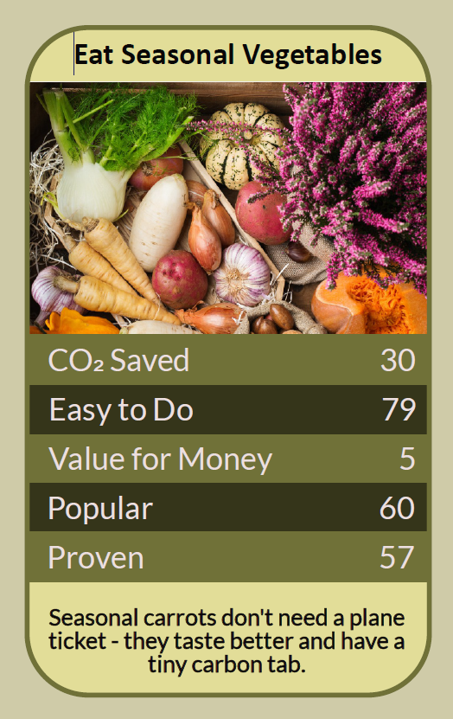


Before you begin  How To Use This Workbook | 

This workbook stands alone. You need nothing else to use it except a week of your own shopping, the labels on your vegetables and a seasonal food calendar.
It asks you to write, not just read.
Before you begin, choose one meal you cook regularly. It might be a weekly stir-fry, a salad, a soup, a curry or a Sunday roast. Choose a meal you enjoy that uses several vegetables. You'll carry that one meal through the exercise.

Write your first thoughts here, so you can come back to them later

This worksheet is part of the Climate Challenge series of action workbooks.

Part one  The Teaching | 

The idea at the heart of this workbook comes from Barbara Kingsolver's 2007 book Animal, Vegetable, Miracle: A Year of Food Life, written with her husband Steven Hopp and daughter Camille Kingsolver. The family spent a year eating only food produced in their own region or grown themselves, and the book follows the seasons from the first spring asparagus to the stored squash of winter.
Underneath it sits a slightly uncomfortable claim. We've come to expect every vegetable to be available all year, without asking what it takes to make that happen. Eating with the seasons means accepting that some foods have their time, and enjoying them all the more when it comes.
Eat with the calendar. Every vegetable has a season when it grows naturally where you live. In the UK, that means asparagus and new potatoes in spring, salads, beans and courgettes in summer, squash and leeks in autumn, and cabbages, kale and root vegetables through winter. A seasonal food calendar shows what's at its best each month.
Heat and flights add up. Out of season, many vegetables are grown in heated greenhouses or flown in from far away. Tomatoes, peppers and cucumbers grown under heat in winter, and fragile crops such as green beans, mangetout and asparagus flown in out of season, can carry a far larger footprint than the same vegetables grown in their natural season.
Winter has its own harvest. Roots, cabbages, leeks, squash, onions and potatoes either grow through the cold months or store well for months after harvest. A winter diet built around them can be varied, filling and very low in carbon, especially in soups, stews, roasts and bakes.
Mind the hungry gap. In the UK, the hungry gap is the stretch in spring, roughly April to early June, when stored crops are running out and new ones aren't ready. It's the hardest time to eat locally. Stored, frozen, preserved and early greens, along with sea-freighted imports in season elsewhere, can carry you through.
Preserve the plenty. When vegetables are plentiful and cheap, preserve some for later. Freezing, pickling, fermenting, making chutney and drying all stretch the season. Sauerkraut and kimchi, for example, turn autumn cabbages into food that lasts for months.
Cook what you find. Seasonal eating works best when you start with what's available, not a fixed recipe. Veg boxes, farmers' markets and greengrocers make this easier, and many good cookbooks and websites are organised by season.
The practical use of Kingsolver's year is to let the season shape your shopping and cooking. Check what's in season this month, build your meals around it, and save heated and air-freighted vegetables for occasional treats. Store and preserve the gluts, plan ahead for the hungry gap, and get to know the people who grow and sell your food.

Part two  The Exercise | 

Take the meal you chose at the start and carry it through the steps below over the coming week. Write in full sentences. Nobody else reads this.
Describe your vegetable habits. Which vegetables go into your chosen meal, and where do you buy them? Do they change through the year, or stay the same? Score how seasonal you think your vegetable eating is, from 1 (the same all year) to 10 (it changes with every season).
How certain do you feel about that score? ① ② ③ ④ ⑤ ⑥ ⑦ ⑧ ⑨ ⑩

Read the labels. For one week, note the country of origin of every vegetable you buy. Which were grown in the UK, which came from elsewhere, and which might have been grown under heat or flown in? What surprised you?

Make a seasonal list. Using a seasonal food calendar, list the vegetables that are in season in the UK this month and next. Which of them do you already eat? Which have you never cooked, or not cooked for a long time?

Cook a seasonal version. Make your chosen meal using only vegetables that are in season now, swapping out any that aren't. What did you change, how did it taste, and what did it cost compared with usual?

Plan for the hungry gap. Think ahead to next spring's hungry gap. What could you store, freeze or preserve now to eat then? Which early spring greens could you look out for? Write a simple plan.

Make your plan. Write three actions: one you will do on your next shop, one seasonal meal you'll add to your regular cooking, and one bigger step, such as a veg box, a farmers' market visit or learning to pickle or ferment. Name anyone else involved and when you'll start.

How certain are you that your plan will stick? ① ② ③ ④ ⑤ ⑥ ⑦ ⑧ ⑨ ⑩

Part three  Questions For Discussion | 

Work through these questions independently if you must, but they are generally more beneficial when discussed.

- Kingsolver's family could choose to spend a year eating locally. How realistic is seasonal eating for people with little time, money or cooking space? What would help?
- Many families cook dishes from cuisines rooted in other climates, which rely on vegetables that don't grow here. How can seasonal eating respect and include those food traditions?
- Should supermarkets stock fewer out-of-season vegetables, or label which have been grown under heat or flown in? How would shoppers react?
- Should school and hospital meals be planned around seasonal, locally grown vegetables? What would it take to make that happen?
- Climate change is already shifting growing seasons and harvests in the UK. How might seasonal eating change in the years ahead?
- Eating seasonally means sometimes going without favourite foods. Does waiting for them make them more special, or is that a luxury view?

Want To Take This Further With Other People?
You've done the label-reading and the cooking on your own. What's missing now is someone who sees food differently — and who might share a veg box, a recipe, a glut or an afternoon of pickling with you.

Share your recipes online  Join an online climate action community and post your seasonal meal, your label-reading results and your three-step plan. Others will share their favourite seasonal recipes and tips for getting through the hungry gap. |  | Find people near you  Look for a farmers' market, veg box scheme, greengrocer or community-supported farm near you. Join or start a cooking or preserving group. Share surplus vegetables with neighbours, friends and community fridges.

Find your next challenge

This workbook is general guidance. Wash vegetables before eating, and follow safe methods for fermenting, pickling and storing food.

climatechallenge.uk

