

Go
Underground
You're standing at a London bus stop or sitting in traffic on the Euston Road, while a few metres below your feet a train carries hundreds of people across the city in minutes. The transport economist J. Michael Thomson, building on the work of Anthony Downs, showed why that matters to everyone: in a big city, traffic on the roads only moves as fast as the trains and buses do. This workbook asks you to take one real journey, compare the Tube with the alternatives in time, money and carbon, and decide for yourself when to go underground.
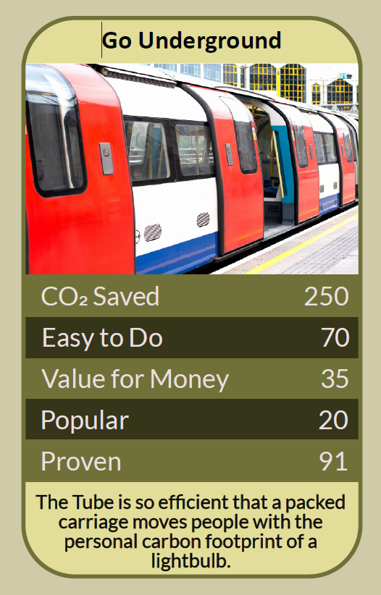


Before you begin  How To Use This Workbook | 

This workbook stands on its own. You need one regular journey, a journey planner such as TfL's, a pen and one trip on the Tube, and each part builds on the one before, so work through it in order.
It asks you to write, not just read.
Before you begin, choose one journey you make, or could make, in London. Pick an ordinary trip, such as to work, college, the shops or a friend's home, rather than a one-off. If you don't live in London, choose a journey in your own town that could be made by train, tram or bus instead of by car. You'll carry that one journey through the exercise.

Write it here, so you have it to hand

Part one  The Teaching | 

In 1962 the American economist Anthony Downs described what he called the law of peak-hour expressway congestion: build a new road and new traffic soon fills it. In 1977 the British transport economist J. Michael Thomson took the idea further in his book Great Cities and Their Traffic. Together their work became known as the Downs–Thomson paradox: in a large city, the speed of car travel tends to settle at the door-to-door speed of the same journey by public transport.
The slightly uncomfortable claim underneath it is this: you can't fix a city's traffic by building for cars. If the train is slow, drivers have no better option and the roads clog until driving is just as slow. Make the train faster and more reliable, and enough people switch that the roads move better too. Every person on the Tube is quietly helping the person stuck in traffic above.
The world's first. The Metropolitan Railway opened between Paddington and Farringdon on 10 January 1863, the world's first underground passenger railway. In 1890 the City & South London Railway, now part of the Northern line, became the first deep-level tube. Today the London Underground has 11 lines, 272 stations and 402 km of route, and in 2024/25 it carried about 1.2 billion passenger journeys. Despite the name, only about 45% of it actually runs underground.
About a tenth of the carbon. Because Tube trains run on electricity and carry many people at once, UK government conversion factors put a Tube journey at roughly 15 g of carbon dioxide per passenger per kilometre, against about 162 g for one person driving a petrol car. Swap a 10 km car commute for the Tube and you cut that journey's emissions by around nine-tenths.
Space the city can't spare. A single train carries as many people as a long queue of cars, in a tunnel that takes up no street at all. Every journey moved underground frees road space for buses, deliveries, bikes and people on foot.
Cleaner air above, but watch the air below. Electric trains put no exhaust into the streets. Underground, though, studies have found fine dust from brakes, wheels and rails in some deep tunnels at higher levels than at busy roadsides, and TfL has been working to reduce it. Honest benefits come with honest trade-offs.
Even the heat is useful. Tube tunnels are warm, and in 2020 Islington Council's Bunhill 2 energy centre began using warm air drawn from the Northern line, through a fan in the disused City Road station, to heat around 1,350 homes, a school and two leisure centres. It was described as the first scheme of its kind in the world.
Not yet open to everyone. Many stations still have only stairs between street and platform, peak trains can be crowded, and fares are a real cost for people on low incomes. A network that only some people can use easily delivers only some of its benefits.
The practical use of the Downs–Thomson idea is that your choice of how to travel is not just private. Each time you take the train you add to the case for faster, better public transport, and the city moves a little better for everyone. The way to use it is to compare honestly, journey by journey, and go underground when it wins.

Part two  The Exercise | 

Take the journey you chose at the start and carry it through the steps below. You'll need a journey planner and one trip. Write in full sentences. Nobody else reads this.
Map your journey. Describe the journey you chose: where from, where to, how often, and how you usually make it now. Then score from one to 10 how likely you think it is that the Tube or another train is the best way to make it.
How certain do you feel about that score? ① ② ③ ④ ⑤ ⑥ ⑦ ⑧ ⑨ ⑩

Time it both ways. Using a journey planner, find the door-to-door time by Tube or train, including the walk at each end and any waiting. Compare it with how long the journey usually takes you now, including parking or traffic.
Count the carbon. Find the distance in kilometres. Multiply it by 15 for the Tube and by 162 for driving alone in a petrol car to get grams of carbon dioxide. Then multiply by the number of times you make the journey in a year.

Count the hidden costs. List what each option really costs: fares or fuel, parking, wear on the car, stress, and the time you can or can't use to read, rest or work. Which costs had you never counted before?
Take the journey. Make the journey by Tube at least once, ideally at the time you would normally travel. Write down what it was actually like: the crowds, the air, the walk, the waiting, and anything that surprised you.

Name the barriers. What stops you, or someone you know, from going underground more often? It might be steps, cost, crowding, safety or late-night services. Name one barrier, and who has the power to remove it.
And how certain do you feel now? ① ② ③ ④ ⑤ ⑥ ⑦ ⑧ ⑨ ⑩

Part three  Questions For Discussion | 

Work through these questions independently if you must, but they are generally more beneficial when discussed.

- If the Downs–Thomson paradox is right, should cities stop building new roads altogether?
- Should public transport be free at the point of use, paid for by everyone, or should the people who use it pay for it?
- Is it fair to encourage people onto the Tube when many stations are still impossible for some disabled people to use?
- The Tube was dug in the Victorian era at great cost and disruption. Would a project that big be allowed today, and should it be?
- Should drivers pay more to use city roads, as the Congestion Charge asks, to fund better trains and buses?
- What would your town or city look like if half of today's car journeys moved underground or onto rails?

Want To Take This Further With Other People?
You've tested one journey on your own. What's missing is the people who travel with you, and those who find the network harder to use than you do.

Plan a car-free day out  Pick a place you'd normally drive to and plan the whole trip by Tube, train and foot with friends or family. Compare notes afterwards on time, cost and how it felt. |  | Travel with someone new  Offer to make a first Tube journey with someone who finds it daunting, such as an older neighbour, a newcomer to the city or a young person, and hear what gets in their way.

Find your next challenge

climatechallenge.uk

