

Check
Electricity Use
We're often told to switch off phone chargers and lights, but rarely shown which appliances really matter. In 2008, the Cambridge physicist David MacKay published Sustainable Energy – Without the Hot Air, urging people to do the arithmetic and focus on the big things, because “if everyone does a little, we'll achieve only a little”. A simple check of your appliances shows where your electricity actually goes. This workbook asks you to rank your home's electricity users, and to commit to the next three things you will change.
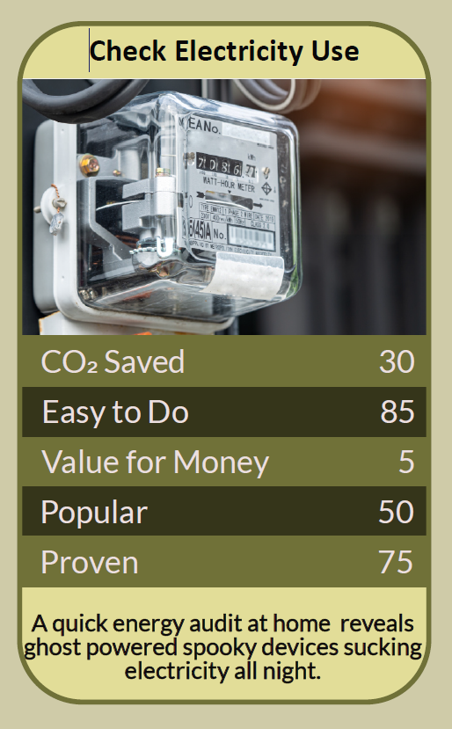


Before you begin  How To Use This Workbook | 

This workbook stands alone. You need nothing else to use it except a calculator, a torch for reading rating plates, your electricity bill and, if you can borrow one, a plug-in energy monitor.
It asks you to write, not just read.
Before you begin, choose one room to check first. The kitchen or utility room is usually the best place to start, because that's where many of the biggest appliances live. Never open appliances, plugs, sockets or meters. You'll carry that one room through the exercise, then widen out to the rest of your home.

Write your first thoughts here, so you can come back to them later

This worksheet is part of the Climate Challenge series of action workbooks.

Part one  The Teaching | 

The idea at the heart of this workbook comes from David MacKay, Professor of Natural Philosophy at the University of Cambridge's Cavendish Laboratory, whose 2008 book Sustainable Energy – Without the Hot Air set out to cut through vague talk about energy with clear numbers. MacKay went on to become Chief Scientific Adviser to the Department of Energy and Climate Change.
Underneath it sits a slightly uncomfortable claim. Many of the energy-saving habits we're proudest of make almost no difference, while the big users go unnoticed. MacKay's answer to “every little helps” was blunt: every BIG helps.
Count in kilowatt-hours. MacKay measured everything in kilowatt-hours (kWh), the same unit on your electricity bill, and often per person per day. A 1,000-watt appliance running for an hour uses one kWh. Using one unit for everything lets you compare a kettle with a fridge, or a light bulb with a tumble drier, on equal terms.
Every BIG helps. MacKay famously compared obsessively switching off a phone charger to bailing out the Titanic with a teaspoon: a charger left plugged in uses a tiny amount compared with heating, hot water or a tumble drier. Small actions aren't worthless, but they shouldn't distract from the big ones.
Power times time. To estimate what an appliance uses, multiply its power in watts by the hours it runs, and divide by 1,000 to get kWh. A powerful appliance used briefly, such as a kettle, can use less in a day than a modest one that runs constantly, such as an old fridge-freezer.
Find the big users. In most homes, the biggest electricity users are anything that heats or cools: electric heaters, immersion heaters, electric showers, tumble driers, ovens, fridges and freezers. If you have electric heating or an electric car, those will usually dwarf everything else.
Check, don't guess. Rating plates give an appliance's maximum power, but real use can differ. A plug-in energy monitor, available to borrow from many libraries and energy groups, shows exactly what an appliance uses. Reading your meter before and after running a big appliance works too.
Change the big things, wisely. Once you know your biggest users, focus there: use them less, use them better, and when they wear out, replace them with efficient models. Don't replace a working appliance too early, though, because making a new one has its own footprint.
The practical use of MacKay's approach is to do the sums for your own home. List your appliances, find their power, estimate their daily kWh and rank them. Check the top few with a monitor or your meter. Then put your effort where the numbers say it counts, and let go of the guilt over the teaspoon-sized savings.

Part two  The Exercise | 

Take the room you chose at the start and carry it through the steps below, then widen out to the rest of your home. Write in full sentences. Nobody else reads this.
Make your guess. Before measuring anything, write down the three appliances you think use the most electricity in your home, and the three energy-saving habits you're proudest of. Score how confident you are that you know where your electricity goes, from 1 (no idea) to 10 (certain).
How certain do you feel about that score? ① ② ③ ④ ⑤ ⑥ ⑦ ⑧ ⑨ ⑩

List your appliances. Go round your chosen room, then the rest of your home, and list every appliance that plugs in or is wired in. For each, find its power in watts from the rating plate, the manual or the maker's website.

Estimate kWh per day. For each appliance, estimate how many hours a day it runs, multiply by its watts and divide by 1,000. Rank your appliances from highest to lowest daily kWh. Which are your top five?

Check the top few. Use a plug-in energy monitor, or read your meter before and after use, to check the real use of your top few appliances. How close were your estimates? Did anything surprise you?

Sort BIG from small. Compare your ranking with your first guesses and the habits you were proudest of. Which actions would make a big difference, and which are teaspoons? Write down the two or three changes that would matter most.

Make your plan. Write three actions: one change to how you use your biggest appliance, starting this week, one habit you'll drop or keep in proportion, and one bigger decision for when an appliance needs replacing. Name who else needs to agree, and when you'll start.

How confident are you now? ① ② ③ ④ ⑤ ⑥ ⑦ ⑧ ⑨ ⑩

Part three  Questions For Discussion | 

Work through these questions independently if you must, but they are generally more beneficial when discussed.

- MacKay argued that “every BIG helps” matters more than “every little helps”. Are small actions still worth doing because they build habits and awareness, or do they distract from what matters?
- Most people find energy numbers confusing. Should appliances show their running cost in pounds per year, not just an energy rating?
- MacKay wanted public debate about energy to be based on numbers rather than slogans. Where do you see slogans winning over numbers today?
- If your biggest electricity user is something you rely on, such as heating or a medical device, how should you weigh comfort and health against carbon?
- When should you replace an old, inefficient appliance, and when is it better to keep using it? What would help people make that decision well?
- Personal changes add up across millions of homes, but national choices about power stations and grids matter too. How should we balance the two?

Want To Take This Further With Other People?
You've done the sums and the thinking on your own. What's missing now is someone who sees your numbers differently — and who might lend you an energy monitor, check your workings or compare rankings with you.

Share your ranking online  Join an online climate action community and post your appliance ranking, your surprises and your three-step plan. Others will share their own numbers and help you spot the big wins in your home. |  | Find people near you  Borrow a plug-in energy monitor from your library, council or community energy group. Compare appliance rankings with friends or neighbours in similar homes. Ask a local energy advice service to help with the biggest changes.

Find your next challenge

This workbook is general guidance. Never open appliances, plugs, sockets or meters, and use plug-in monitors only as the maker directs.

climatechallenge.uk

