

Compost
Waste
Peelings, tea leaves, eggshells, the last of the salad and the lawn clippings: every week most homes throw away a bin bag's worth of things that were recently alive. A century ago the British botanist Sir Albert Howard watched farmers in India turn exactly this kind of waste into rich, dark soil, and the method he developed there still shapes how we compost today. Sent to landfill, the same waste rots without air and gives off methane; composted, it feeds the soil. This workbook asks you to look at what you throw away, waste less food, and turn the rest into something useful.

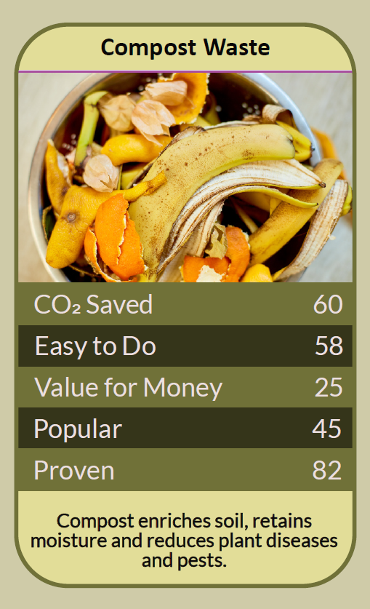

Before you begin  How To Use This Workbook | 

This workbook stands on its own. You need your kitchen bin, a little outdoor space or a council food caddy, a pen and about a month, and each part builds on the one before, so work through it in order.
It asks you to write, not just read.
Before you begin, choose one week of your household's waste. Pick an ordinary week, not one with a party or a clear-out. Wear gloves when handling compost or potting mix, avoid breathing in the dust, and wash your hands afterwards. You'll carry that one week through the exercise.

Write it here, so you have it to hand

Part one  The Teaching | 

Sir Albert Howard was a British botanist who directed the Institute of Plant Industry at Indore in India from 1924 to 1931. Building on traditional Indian practice, he developed what became known as the Indore method of composting, set out in The Waste Products of Agriculture, written with Yeshwant Wad in 1931, and later in An Agricultural Testament in 1940. His central idea was simple: waste from plants and animals should go back to the soil it came from.
The slightly uncomfortable claim underneath it is this: there is no such thing as food 'waste', only food in the wrong place. The best food waste is food that's eaten. The next best is food that's composted. The worst is food that rots in a bin bag, because in landfill it breaks down without air and releases methane, a powerful greenhouse gas.
Less waste comes first. WRAP estimated that UK households throw away around 6.6 million tonnes of food a year, and that about 4.5 million tonnes of it could have been eaten, costing an average family with children around £700 a year. Planning meals, checking the fridge before shopping and using leftovers do more good than any compost bin.
Greens and browns. Howard's method layered different materials so the heap would heat up and break down evenly. At home, aim for roughly equal amounts of 'greens', such as fruit and vegetable scraps, tea leaves, coffee grounds and grass cuttings, and 'browns', such as cardboard, paper, egg boxes, dry leaves and woody prunings. Too many greens make a slimy, smelly heap; too many browns make it slow.
Air and water. Compost needs air and moisture, like a wrung-out sponge. Turning or mixing the heap now and then lets air in, which keeps it from smelling and speeds things up. Depending on the materials and the weather, compost can take anywhere from about six months to two years to be ready.
What goes where. Keep meat, fish, dairy, cooked food, pet poo and diseased plants out of a home compost heap, because they attract rats or spread disease. Council food waste collections can usually take all food, including meat, bones and leftovers. Check whether your tea bags are plastic-free before composting them.
Every home in England should have a food caddy. Under the government's Simpler Recycling reforms, councils in England were required to offer weekly household food waste collections by 31 March 2026, unless a transitional arrangement applies. If you have no garden, a council caddy, a wormery or a community compost scheme can still keep your food out of the bin.
Black gold. Finished compost is dark, crumbly and smells of earth. Spread it on beds, mix it into pots or use it as a mulch. It feeds the soil, helps it hold water, and means buying less bagged compost, much of which has been made with peat dug from carbon-rich bogs.
The practical use of Howard's idea is to close the loop in your own home. Waste less food, compost what's left, and return it to the soil, whether in your garden, a community plot or through your council's caddy. What once went to landfill becomes the start of next year's growth.

Part two  The Exercise | 

Take the week you chose at the start and carry it through the steps below. You'll need about a month. Write in full sentences. Nobody else reads this.
Look in the bin. For the week you chose, keep a note of the food and garden waste you throw away, and roughly how much. Then score from one to 10 how much of your household's rubbish you think could be composted.
How certain do you feel about that score? ① ② ③ ④ ⑤ ⑥ ⑦ ⑧ ⑨ ⑩

Sort the avoidable. Divide your list into food that could have been eaten, such as leftovers and forgotten vegetables, and food that couldn't, such as peelings, bones and tea leaves. What one change would cut the avoidable waste?
Choose your system. Decide how you'll deal with the waste that's left: a council food caddy, a compost bin or heap, a wormery, a bokashi bin or a community scheme. Write down why that system suits your home.

Set it up. Set up your system and start filling it. If you're making compost, plan where your browns will come from, such as cardboard and egg boxes. Write down what you did and anything you needed to buy or borrow.
Run it for a month. Keep it going for a month. Note what went in, any problems such as smells, flies or a heap that isn't breaking down, and how you fixed them. How much less went in your general rubbish bin?

Plan the harvest. Decide where your compost will go when it's ready: your garden, pots, a neighbour's allotment or a community garden. If you use a council caddy, find out where your food waste goes. Write down your plan.
And how certain do you feel now? ① ② ③ ④ ⑤ ⑥ ⑦ ⑧ ⑨ ⑩

Part three  Questions For Discussion | 

Work through these questions independently if you must, but they are generally more beneficial when discussed.

- If most food waste could have been eaten, why is composting often promoted more than wasting less?
- Should every household be required to separate its food waste, or should it stay a choice?
- Is it better to compost at home or to send food waste to a council collection, and why?
- Supermarket offers and 'best before' dates can encourage waste. Who is responsible for food that's thrown away?
- Albert Howard believed waste should always return to the soil. How far could that idea go in a town or city?
- What would your street or school need to make composting as normal as putting out the recycling?

Want To Take This Further With Other People?
You've started closing the loop at home. What's missing is the people around you who have spare peelings, spare space or a need for good soil.

Join a community compost  Find or start a shared compost scheme at an allotment, school, church or community garden, so people without gardens can compost too. |  | Grow something together  Use your finished compost to grow food or flowers with neighbours, a school or a local group, and show how yesterday's peelings become tomorrow's harvest.

Find your next challenge

climatechallenge.uk

