

Use An
Electric Bike
The journey is too far to walk, too hilly to cycle comfortably, and so the car comes out again. In 2022, researchers Ian Philips, Jillian Anable and Tim Chatterton at the University of Leeds estimated that replacing car journeys with electric bikes could cut England's carbon emissions by up to about 24 million tonnes a year, with the biggest gains in rural areas and on the edges of towns. An e-bike flattens hills and stretches distances while you still pedal. This workbook asks you to test one journey by e-bike, and to commit to the next three things you will change.

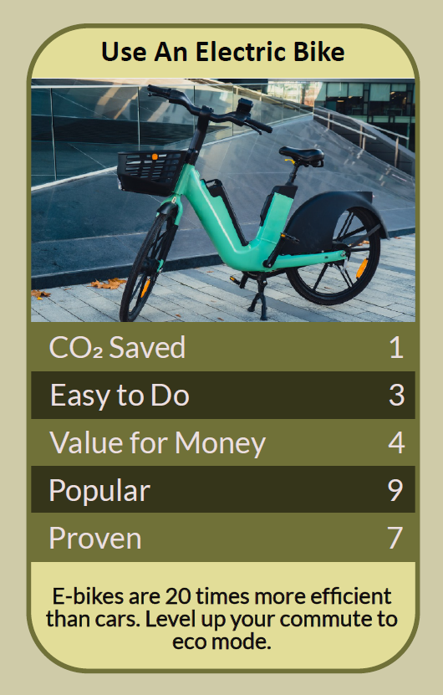

Before you begin  How To Use This Workbook | 

This workbook stands alone. You need nothing else to use it except an online map, one regular journey and, ideally, the chance to borrow, hire or test-ride an e-bike.
It asks you to write, not just read.
Before you begin, choose one regular car journey of roughly three to ten miles. It might be a commute, a school run, a trip to the shops or a visit to family, especially one with hills or too far to walk. Choose a journey you make at least once a week. You'll carry that one journey through the exercise.

Write your first thoughts here, so you can come back to them later

This worksheet is part of the Climate Challenge series of action workbooks.

Part one  The Teaching | 

The idea at the heart of this workbook comes from Ian Philips, Jillian Anable and Tim Chatterton of the Institute for Transport Studies at the University of Leeds, published in 2022 in the journal Transport Policy as “E-bikes and their capability to reduce car CO2 emissions”. Modelling journeys across England, they found that e-bikes could replace a large share of car miles, and that people in rural areas and on the fringes of towns and cities had the most to gain per person.
Underneath it sits a slightly uncomfortable claim. Many of the car journeys we think are too far or too hilly for a bike are well within reach of an e-bike. What holds us back is often habit, cost worries and unsafe roads, not distance.
Hills and distance, solved. An e-bike adds power when you pedal, so hills feel gentle and longer journeys take less effort. Trips of five or ten miles become realistic for many people who would never cycle them on an ordinary bike, and you arrive without being exhausted or soaked in sweat.
The biggest gains are outside cities. The Leeds research found that people living in the countryside and on the edges of towns, where car use is highest and public transport thinnest, could save the most carbon per person by switching some journeys to e-bikes. E-bikes aren't just for city commuters.
Know the rules. In Great Britain, an electrically assisted pedal cycle can be ridden like an ordinary bike, without a licence, tax or insurance, by anyone aged 14 or over. The motor must be no more than 250 watts and must stop helping when you reach 15.5 miles per hour, and you have to pedal for the motor to assist. Anything more powerful counts as a motor vehicle.
Battery safety matters. E-bike batteries hold a lot of energy, and poor-quality or damaged ones can catch fire. Buy bikes, batteries and chargers from reputable sellers, use the right charger, avoid cheap conversion kits, and don't charge batteries unattended, overnight or near your escape route from home.
Cheaper than you think. An e-bike costs more than an ordinary bike, but far less to run than a car. Employer Cycle to Work schemes can spread the cost and save tax, and some areas offer e-bike loans, hire schemes or try-before-you-buy libraries. Compare the total with what your car journeys cost you.
Still good exercise. Riding an e-bike is still physical activity: you pedal the whole time, and studies suggest e-bike riders often travel further and more often than people on ordinary bikes. You can choose how much help to take, and use less as you get fitter.
The practical use of the Leeds research is to test it on your own journeys. Choose one regular car trip, plan a safe route, and try it on a borrowed, hired or test-ride e-bike. Work out the costs honestly, solve the practical bits such as storage, security and charging, and if it works, make it your normal way of making that journey.

Part two  The Exercise | 

Take the journey you chose at the start and carry it through the steps below over the coming weeks. Write in full sentences. Nobody else reads this.
Describe the journey. Where do you go, how often, how far, and what do you carry? Are there hills? Why do you usually drive? Score how possible it feels to make this journey by e-bike, from 1 (impossible) to 10 (easy).
How certain do you feel about that score? ① ② ③ ④ ⑤ ⑥ ⑦ ⑧ ⑨ ⑩

Map the route. Use an online map to plan a cycle route, looking for quieter roads, cycle paths and the gentlest hills. How long is it, and how long would it take by e-bike? How does that compare with driving and parking?

Try one. Borrow, hire or test-ride an e-bike, ideally on part or all of your journey. How did it feel on the hills and over the distance? What surprised you? What would you want in an e-bike of your own?

Count the cost. Find the price of a suitable e-bike, and whether a Cycle to Work scheme, loan or hire option is available to you. Compare it with what this journey costs by car each year, including fuel, parking and wear and tear.

Solve the snags. List everything that might stop you: storage at home and at your destination, theft, charging safely, weather, clothing, carrying things, feeling safe on the road. For each, write one solution you could try.

Make your plan. Write three actions: one step you will take this month, such as a test ride or a route trial, one journey you'll aim to switch, and one bigger decision, such as buying, leasing or sharing an e-bike. Name who's involved and when you'll start.

How possible does it feel now? ① ② ③ ④ ⑤ ⑥ ⑦ ⑧ ⑨ ⑩

Part three  Questions For Discussion | 

Work through these questions independently if you must, but they are generally more beneficial when discussed.

- Some people say riding an e-bike is “cheating”. Why do you think that view exists, and does it matter if more people get out of their cars?
- Some countries offer grants towards buying an e-bike, as they do for electric cars. Should the UK do the same? Who should benefit most?
- Battery fires from poor-quality e-bikes and conversion kits have caused deaths and injuries. How should the sale of e-bikes, batteries and chargers be regulated?
- Many people say they would cycle more if roads felt safer. Is buying an e-bike enough, or do councils need to build better routes first?
- Illegal high-powered electric motorbikes are sometimes confused with legal e-bikes. How can the rules be made clearer and better enforced?
- Electric cargo bikes can carry children, shopping and deliveries. Could they replace many car and van journeys in your area? What would need to change?

Want To Take This Further With Other People?
You've done the planning and the thinking on your own. What's missing now is someone who sees travel differently — and who might lend you an e-bike, ride the route with you or campaign for safer cycling alongside you.

Share your ride online  Join an online climate action community and post your route, your test-ride experience and your three-step plan. E-bike riders will share their favourite bikes, routes, locks and tips for riding in all weathers. |  | Find people near you  Look for an e-bike loan, hire or try-before-you-buy scheme near you, and ask your employer about Cycle to Work. Join a local cycling group or ride with a friend. Ask your council about cycle training and safer routes.

Find your next challenge

This workbook is general guidance. Buy e-bikes, batteries and chargers from reputable sellers, never charge unattended or near exits, and check current rules.

climatechallenge.uk

