

Ride A
Push Bike
Somewhere in your shed, hallway or memory there is a bicycle, and a short journey you make by car most weeks that it could easily handle. In 2017 a team at the University of Glasgow led by Carlos Celis-Morales followed more than 260,000 people and found that those who cycled to work had a 41% lower risk of dying early than those who drove or took public transport. The bike may be the cheapest health, climate and transport tool most of us already own. This workbook asks you to choose one real journey, get yourself and your bike ready, and ride it.
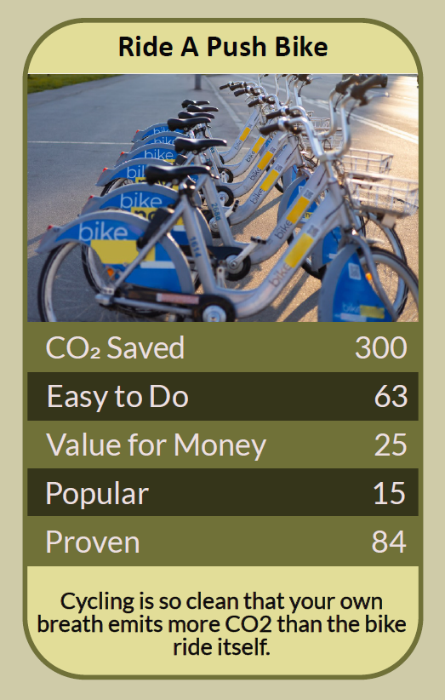


Before you begin  How To Use This Workbook | 

This workbook stands on its own. You need a bike, borrowed, hired or your own, a pen and two weeks of ordinary journeys, and each part builds on the one before, so work through it in order.
It asks you to write, not just read.
Before you begin, choose one short journey you make regularly. Somewhere within a few miles works best, such as the shops, work, school or a friend's home. If you haven't ridden for a long time, have a health condition, or feel unsure in traffic, start on quiet paths or book some cycle training first. You'll carry that one journey through the exercise.

Write it here, so you have it to hand

Part one  The Teaching | 

In April 2017 the BMJ published a study by Carlos Celis-Morales, Jason Gill and colleagues at the University of Glasgow. Using UK Biobank data on 264,337 people followed for about five years, they compared people who commuted by bike, on foot or in mixed ways with those whose commute was non-active, by car or public transport.
The slightly uncomfortable claim underneath it is this: for most of us, the thing standing between us and the bike isn't fitness, cost or distance, but fear and habit. The health benefits of regular cycling are large, and studies weighing them against the risks of riding in traffic consistently find the benefits come out well ahead. The roads still need to get safer, but staying in the car carries risks of its own.
The health dividend. Cycle commuters in the Glasgow study had a 41% lower risk of dying from any cause over the study period, a 45% lower risk of developing cancer and a 46% lower risk of heart disease than non-active commuters. Those are bigger effects than many medicines can claim, and you get them on the way to somewhere you were going anyway.
Zero exhaust. A push bike runs on breakfast. It produces no exhaust at the roadside, makes almost no noise, and takes up a fraction of the road and parking space of a car. Driving alone in a petrol car produces around 160 g of carbon dioxide for every kilometre; the bike produces none from the journey itself.
Many trips are bike-sized. In England, cars carried 58% of all trips in 2025, and many of those were short local journeys to shops, schools and stations. A distance that feels like a drive often turns out to be a 15 or 20-minute ride, and it usually takes about the same time door to door once you count parking.
The Highway Code is on your side. Since January 2022 the Highway Code has set out a hierarchy of road users: those who can do the most harm have the most responsibility to look out for others. Drivers should leave at least 1.5 metres when overtaking a cyclist at up to 30 mph, and should not cut across a cyclist going straight ahead at a junction. Cyclists may ride in the centre of their lane on quiet roads, in slow traffic and at junctions when that is safer, moving over to let faster traffic pass when it is safe to do so.
Confidence is a skill. Nobody is born confident in traffic. Free Bikeability training is offered to many schoolchildren, and many councils run adult cycle training. Start with quiet streets, parks and cycle paths, ride at quieter times, and build up. If hills or distance put you off, an electric bike or an adapted cycle can open up riding for people who thought it wasn't for them.
A small amount of kit matters. After dark the law requires a white front light, a red rear light and a red rear reflector, and pedal reflectors on bikes made since 1985. A good lock keeps your bike yours. Before each ride, do the ABC check: air in the tyres, brakes that work, and a chain that runs smoothly. A helmet isn't a legal requirement in the UK, but many riders choose to wear one.
The practical use of all this is to make cycling ordinary, not heroic. Pick one journey, get the bike and yourself ready, and ride it until it stops feeling like an event. The way out of the car isn't a lifestyle overhaul; it's one short trip, repeated.

Part two  The Exercise | 

Take the journey you chose at the start and carry it through the steps below. You'll need a bike and about two weeks. Write in full sentences. Nobody else reads this.
Pick your journey. Describe the journey you chose: where from, where to, how far, how often, and how you make it now. Then score from one to 10 how confident you feel about cycling it.
How certain do you feel about that score? ① ② ③ ④ ⑤ ⑥ ⑦ ⑧ ⑨ ⑩

Plan the route. Use a map or journey planner to find the quietest reasonable route, even if it is a little longer. Note cycle lanes, quiet streets, paths and any junctions that worry you. Where will you leave the bike at the other end?
Get the bike ready. If you have a bike, do the ABC check and note anything that needs fixing. If you don't, write down where you could borrow, hire or buy one, second-hand or through your employer. Check you have lights and a lock.

Practise first. Ride the route, or part of it, at a quiet time such as a weekend morning, or book a training session. Write down what felt easy, what felt hard, and what you would change.
Ride it for two weeks. Make the journey by bike as often as you can for two weeks. Record each ride's time and how you felt before, during and after. What happened to your mood, your energy and the time it took?

Name the barriers. What still stops you, or someone you know, from riding more? It might be a dangerous junction, nowhere safe to park, no shower at work, cost or weather. Name one barrier, and who has the power to remove it.
And how certain do you feel now? ① ② ③ ④ ⑤ ⑥ ⑦ ⑧ ⑨ ⑩

Part three  Questions For Discussion | 

Work through these questions independently if you must, but they are generally more beneficial when discussed.

- If cycling is so good for health, why do so few adults in the UK ride regularly?
- Should road space be taken from cars to build protected cycle lanes, even where drivers object?
- Is it fair to encourage people to cycle before the roads are made safe for them?
- Should employers be expected to provide secure bike parking and showers, as many provide car parks?
- Is an electric bike still 'proper' cycling, and does the answer matter?
- What would your street look and sound like if half of today's short car trips were made by bike?

Want To Take This Further With Other People?
You've tested one journey on your own. What's missing is company: people to ride with, and people who will push for safer streets alongside you.

Ride with others  Join a local cycling group or community ride, or start a bike bus to school with other families. Riding in a group builds confidence quickly and makes the habit stick. |  | Make work bike-friendly  Ask whether your employer offers the Cycle to Work scheme, secure parking and somewhere to change. Share your two weeks of rides to show what is possible.

Find your next challenge

climatechallenge.uk

