

Plant Trees
Where You Live
Look out of your window and count the trees. For some of us the answer is a dozen; for many, in the streets that most need shade and cleaner air, it is none. The urban forester Cecil Konijnendijk turned that difference into a simple test, the 3–30–300 rule, which shows how green a neighbourhood really is and who is missing out. This workbook asks you to measure your own street against it, choose the right tree for the right place, and plan how to keep it alive long after planting day.
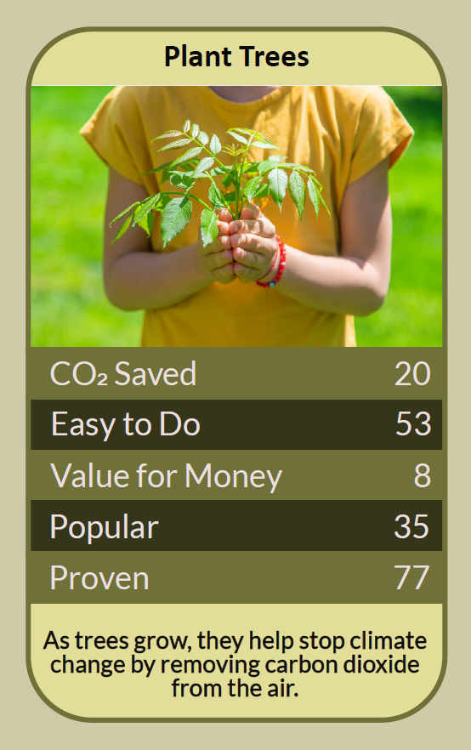
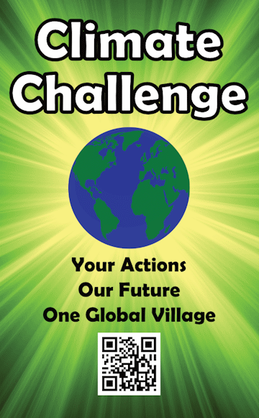

Before you begin  How To Use This Workbook | 

This workbook stands on its own. You need a window, a short walk, a pen and some honest planning, and each part builds on the one before, so work through it in order.
It asks you to write, not just read.
Before you begin, choose one place where a tree could grow. It might be your garden, a school field, a street verge, a churchyard or a patch of community land. Only ever plant with the landowner's permission, which for streets and verges usually means the council, and check for buried pipes and cables before anyone digs. You'll carry that one place through the exercise.

Write it here, so you have it to hand

Part one  The Teaching | 

In 2023 Cecil Konijnendijk, an urban forester who has advised cities around the world, published a short rule of thumb in the Journal of Forestry Research. He called it the 3–30–300 rule, and it has since been taken up by councils, planners and tree charities as a quick way to judge whether a neighbourhood has enough trees for the people who live there.
The slightly uncomfortable claim underneath it is this: planting a tree is the easy part, and the photograph is the least important moment in its life. What matters is where the tree goes, who can see it, and whether anyone is still looking after it three summers later.
Three trees in view. Every home, school and workplace should have at least three well-established trees in view. Seeing trees from where we live and work is linked to better mental health and wellbeing, and it is the part of the rule you can check in thirty seconds from a window. A tree in a back garden that only one household sees does less of this work than a tree on a street that a hundred people pass each day.
Thirty per cent canopy. Every neighbourhood should have at least 30% of its area covered by tree canopy, the leafy crown seen from above. Canopy cools streets in heatwaves, slows rainwater before it floods drains, filters some air pollution and gives wildlife somewhere to live. For comparison, woodland covers about 14% of the UK's land and only about 10% of England's, so many towns fall far short of 30%.
Three hundred metres. Everyone should live within 300 metres of a public park or green space, roughly a five-minute walk. Further than that and most people simply don't go. The three numbers together show something a single count of trees hides: green space is not shared fairly, and the poorest streets usually have the least.
Right tree, right place. A tree that grows too big for its spot, dries out in a sunny verge or lifts a pavement will be cut down. Before choosing, look at the space overhead and underground, the soil, the light and how close it is to buildings and drains. Native species such as rowan, hawthorn, silver birch and field maple suit small spaces and feed local wildlife; oaks and beeches need room to become the giants they want to be. Don't plant on ground that is already valuable for wildlife, such as wildflower meadows, heathland or bog.
Planting is the start, not the finish. Most young trees that die do so in their first few summers, usually from drought or from grass and weeds taking their water. Plant in the dormant season, from November to March, when bare-root trees are cheap and settle in easily. Then keep a circle of bare or mulched ground around the stem, check the stake and guard, and water deeply in dry spells for at least the first three summers.
A tree is not a carbon offset. Trees do store carbon, but one garden tree takes decades to store a meaningful amount and can't cancel out a flight or a car. Plant trees for shade, wildlife, water, beauty and the people who will live alongside them, and keep cutting your own emissions as well.
The practical use of the rule is that it turns a vague wish for more greenery into three things you can measure and argue for. Count the trees you can see, look at the canopy above your street, time the walk to the nearest park. Then plant where it closes the biggest gap, and plan for the tree to outlive you, because with care it very likely will.

Part two  The Exercise | 

Take the place you chose at the start and carry it through the steps below. You'll need one short walk and some honest planning. Write in full sentences. Nobody else reads this.
Count your trees. Stand at your front window, or the main window where you work or study, and count the well-established trees you can see. Write down what they are, if you know, and how far away. Then score from one to 10 how green you think your neighbourhood is.
How certain do you feel about that score? ① ② ③ ④ ⑤ ⑥ ⑦ ⑧ ⑨ ⑩

Walk your three hundred metres. Find your nearest public park or green space and walk there, timing it. Note what you pass on the way: street trees, bare verges, car parks, gardens paved over. Which streets nearby look the hottest and barest in summer?
Look at the place you chose. Describe the place you picked at the start: who owns it, how much room there is above and below, the soil, the sun and shade, and what is already growing there. Who would see a tree there every day?

Choose the right tree. Name one or two species that would suit that place at their full grown size, and say why. Note where you could get them, such as a local tree nursery, your council's tree scheme or a charity, and whose permission you need first.
Plan three summers. Write down when you'll plant, who will help, and who will water the tree in dry weather for the next three summers. Be specific: names, days and what happens when someone is away. A tree with no aftercare plan is not finished yet.

Look beyond your own patch. Using what you found on your walk, where in your area is the biggest gap between how things are and the 3–30–300 rule? Name one person or group, such as the council, a school or a residents' association, you could ask to help close it, and what you would ask them.
And how certain do you feel now? ① ② ③ ④ ⑤ ⑥ ⑦ ⑧ ⑨ ⑩

Part three  Questions For Discussion | 

Work through these questions independently if you must, but they are generally more beneficial when discussed.

- Should a neighbourhood with few trees get new planting before one that already has plenty, even if the greener area asks louder?
- Is it better to plant one large, long-lived tree or ten small ones that will be cheaper and quicker to establish?
- Who should be responsible for watering a street tree in a drought: the council, the nearest household or nobody?
- When a large old tree causes problems, such as blocked light, falling leaves or cracked paving, when is felling it justified?
- Tree planting is popular and photogenic. Can it distract people and organisations from harder changes, such as cutting their own emissions?
- If the trees you plant today will mostly benefit people not yet born, what do you think you owe them?

Want To Take This Further With Other People?
You've done the looking and planning alone. What's missing is the people who will dig with you, water with you and keep the tree safe when you're not there.

Plant with your community  The Woodland Trust gives free tree packs to schools and community groups; check its website for the current round. Many councils also run street-tree and tree-warden schemes that welcome volunteers. |  | Look after the trees you've got  Join or start a friends-of-the-park group, or a street watering rota for young trees in dry summers. Keeping existing trees alive and healthy is as valuable as planting new ones.

Find your next challenge

climatechallenge.uk

